July 25, 2021

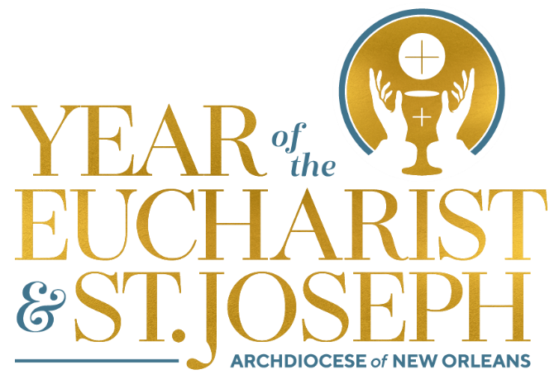

Monthly Explanation of the Mass

The Presentation of the Gifts and Preparation of the Altar

- Following the Prayers of the Faithful each week, the collection begins and then all that is collected along with the bread and wine are brought forward to the altar. This is a prayer – it is an incredibly significant part of the Mass and one that calls for the full, conscious, and active participation of the assembly.

- This is the time when we prayerfully gather up all our gifts – our sacrifices from the week, our monetary contributions, our pains, our joys, and our thanksgivings – and we present these along with the central gifts of bread and wine. The bread and wine are central for they are what Jesus offered at the Last Supper and asked us to continue to do in memory of Him. In connecting our gifts (our very lives!) to the gifts of bread and wine which will be transformed into the Body and Blood of Christ, we, too, seek to have our lives (with our joys and pains) transformed and offered wholly to God.

- So each week when we come to Mass, we cannot come unprepared or empty-handed. We must bring our whole selves which we truly place on the altar of our Lord! We bring all that we are – even when that might not seem to be enough – and we trust that as the Lord joins our offering to His own, that we will be acceptable to God and transformed by his life-giving Body and Blood.

