January 2, 2022

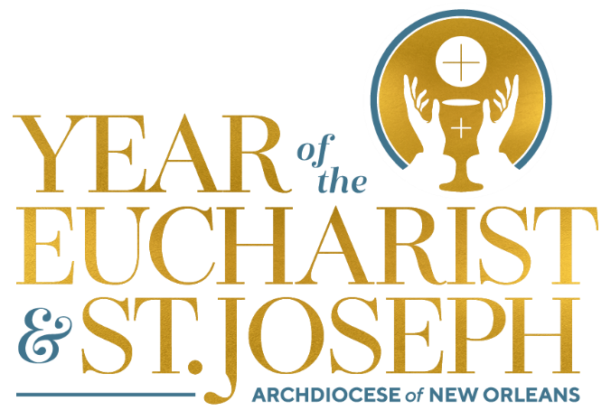

Monthly Explanation of the Mass

Blessing and Dismissal

- Having been fed by the Lord from the table of His living Word and from the altar of His Body and Blood, the celebration of the Mass draws to a close in a way similar to how we began, namely, with the Sign of the Cross – the priest does this by invoking the blessing of Almighty God (the Father, and the Son, and the Holy Spirit) while making the Sign of the Cross over the people in blessing.

- People and things are blessed for a purpose. When God called Abraham, God blessed him so that he would be a blessing to all families of the earth (Genesis 12). For us as Christian people, blessing takes on new significance with Christ in and through whom we have been baptized and become sharers in the Divine life: “it is no longer I who live, but Christ who lives in me” (Galatians 2:20).

- This powerful truth of Divine life within us is precisely why the Catechism states clearly that “every baptized person is called to be a blessing and to bless” (CCC, 1669). The blessing of Almighty God, therefore, is invoked at the end of Mass to further aid us in our identity/call to be a blessing – to allow Christ to live and act more fully through us in our daily lives.

- Immediately following the blessing, the deacon (or priest) proclaims the dismissal, which always begins with the word GO! – just as the risen Christ sent his disciples, so He now sends us (Mt 28:20). In fact, our whole celebration of worship gets its name Mass from the dismissal (Ite missa est – Go, you are dismissed/sent), but we have not gathered simply to be sent; it is only after we have encountered Christ alive among us and have been nourished by Him (through Word and Sacrament) that we are blessed and sent to live what we have just celebrated, to fulfill God’s will in our daily lives (CCC, 1332).

