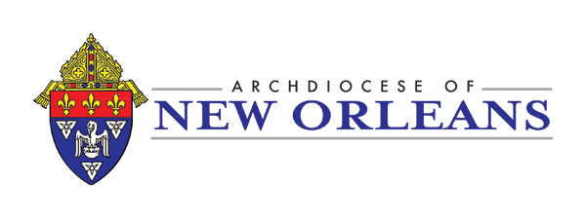Archdiocese of New Orleans
U.S.C.C.B. Safe Environment Plan Child Protection Catechesis

Record of Safe Environment Classes

July 1, 2025 – June 30, 2026

Parish/School/Ministry __________________________________________________________ Deanery _____________________
SITE ADMINISTRATOR: Enter the data from this form onto Virtus under Education tab, Step #5
We are teaching Virtus Lesson 1 this year. Send form to Safe Environment Office with Administrator Report
Date class  was taught | Grade level  taught | Number of students who  received lesson | Number of students who have  not received lesson | Name of person who taught lesson | Signature of person who taught lesson | Person’s Title

Signature of person completing form _________________________________________Title _________________________________________

