Boys Cat & Jack Uniform additions

Boys' Short-Sleeve Pique Uniform Polo Shirt (Unisex)
UPC: 195995829399
Item Number (DPCI): 325-01-9925
Colors: Red, White, and Black

Boys' Flat Front Uniform Shorts
UPC: 195995755513
Item Number (DPCI): 325-01-9591

Color: Khaki

Boys' Straight Fit Uniform Pants
UPC: 196983503628
Item Number (DPCI): 325-01-0545
Color: Khaki

Girls Uniform Additions

Girls' Short Sleeve Interlock Uniform Polo Shirt - Cat & Jack
UPC: 195995810014
Item Number (DPCI): 325-01-7845
Colors: Red, White, and Black

Girls' Uniform Chino Shorts – Cat & Jack
UPC: 195995748638
Item Number (DPCI): 325-01-8070
Color: Beige

Girls' Straight Fit Uniform Pants – Cat & Jack
UPC: 196983502829
Item Number (DPCI): 325-01-0733
Color: Beige

Girls' Pleated Twill Uniform Skort – Cat & Jack
UPC: 195995750969
Item Number (DPCI): 325-01-8354
Color: Beige

Girls’ Plaid Jumper and Plaid Skort— Top Of The Knee — Land’s End

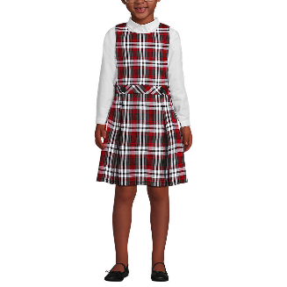
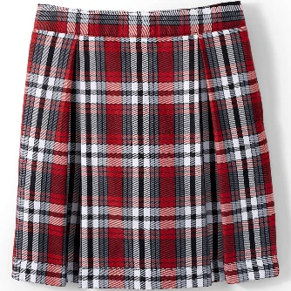
COLORS -Red/Graphite Plaid

Girls' Sizing Available in Sizes 2-16

