Sanctity of Life Awareness and Unity Day Mass
Wednesday, January 28, 2026, 12 Noon
Cathedral Basilica of St. Francis of Assisi, Santa Fe
Sponsored by the New Mexico Conference of Catholic Bishops
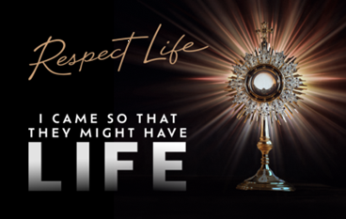

Note: Participants are asked to bring baby items like diapers, blankets, bottles and/or socks and toiletries for the elderly to be collected at the Mass and distributed to organizations that provide support to expectant mothers in need or nursing homes.
For more information, call the Archdiocese of Santa Fe
Office of Social Justice and Respect Life at 505-831-8208.

Pray to Protect Human Life: Join the Novena January 16-24, 2026!

Join thousands of Catholics nationwide in the annual Respect Life Novena, 9 Days for Life, from the USCCB Pro-Life Secretariat.

How to Participate:
Each day’s intention is accompanied by a short reflection and suggested actions to help build a culture of life. 9 Days for Life is designed so that Catholics across the nation can unite their prayers for life together. Sign up for daily reflections here: https://www.respectlife.org/9-days-signup.

