St. Francis of Assisi Parish

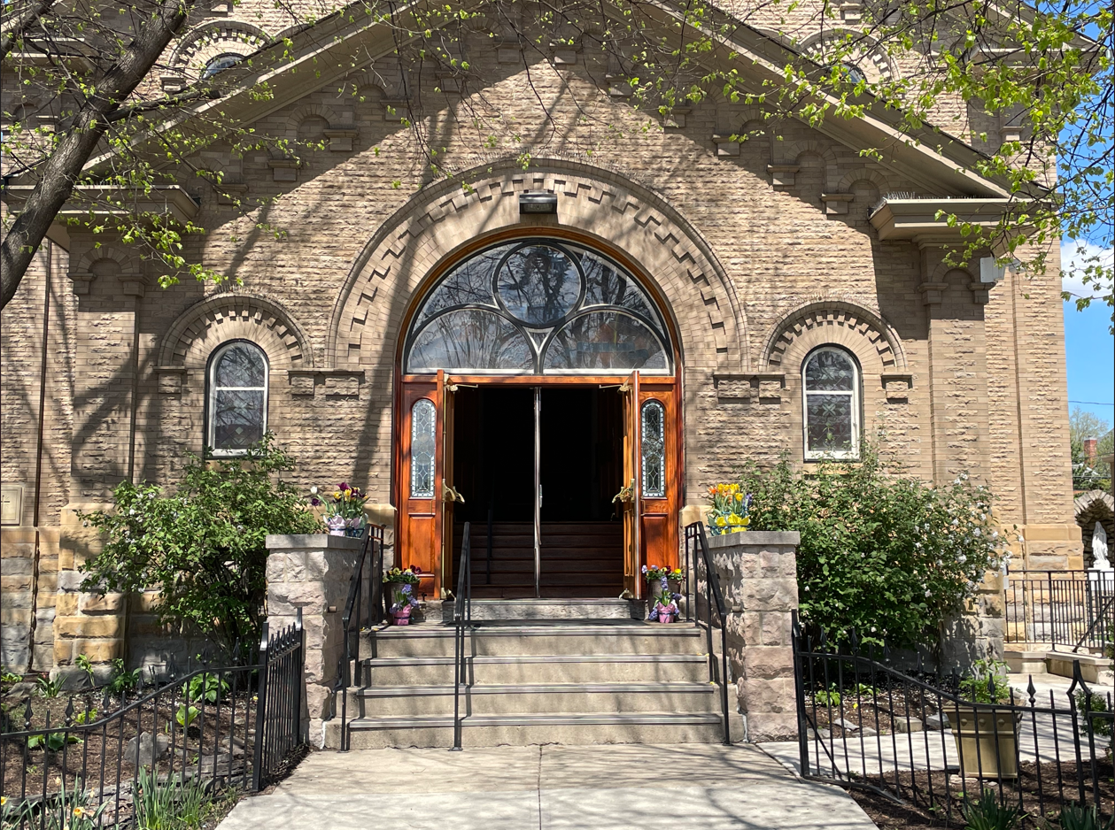
Parish Goals
2025-2029

“Lord, help me to live this day, quietly, easily. To lean upon Thy great strength, trustfully, restfully. To wait for the unfolding of Thy will, patiently, serenely. To meet others, peacefully, joyously. To face tomorrow, confidently, courageously.” St. Francis of Assisi
The Process
A Clear Vision
No two parishes are the same. While they all engage in many of the same activities around faith formation, the Sacraments and a host of other activities, every parish has different needs and unique challenges. Working together to create parish goals for the next three years, by discussing our current parish activities and where we could improve in bringing the Gospel message of Jesus Christ to our parish family and the community.

First Step:
On October 15, 2024 35 members of the parish participated in a parish meeting to provide input on the following discussion questions.
- Why does St Francis of Assisi Parish exist?
- If your Parish were able to do everything possible, with no limitations on time, energy, or resources, what would it look like? For example, space, programming, liturgy, etc.
- What makes St. Francis of Assisi parish different than the next parish over?
- How is the parish meeting our Mission Statement?

Step Two:
Members of the Leadership Team (Chairs and Co-Chairs from Finance Council, Pastoral Council, Stewardship Council and Liturgy Committee) as well as volunteers from the above Councils and Committees along with volunteers from the parish will review the information gathered from the parish meeting to draft a three-year plan by using S.M.A.R.T. (Specific, Measurable and meaningful, Attainable, Realistic, Time-based) goals for the parish.

Working Group
Father Antony Rachel Beebe Patrick Cassidy
Doug Cluxton Frank Conway Jeanna Diederich
Adriana Gambach Richard Hicks Diane Keenan
Philip Lipetz Chris Meacham Renee Morkassel
Brad Roberts Louis Schulte Paula Vasey

Parish Strengths/Culture to be Maintained:

The October 15, 2024 meeting participants were asked to identify the strengths of the parish. Below is a summary of the eighty positive comments.

-celebrating diversity & welcoming all
-strong involvement in the Mass (full, conscious & active participation)
-rich liturgy and music ministry
-beautiful grounds and church
-year-round catechumenate that meets people where they are
-legacy church in a growing community area
-strong lay leadership
-bring heart, soul and hands of Christ
-place of safety and refuge for those who have had personal or spiritual
crises
-nonjudgemental environment

Goal Statement:
Explore the Franciscan charism and how it can further enhance our parish.
Strategies:
- Focus yearly on a particular Franciscan charism that can be incorporated into our parish.
- Explore offering field trips to parishioners to various religious sites in Columbus/Ohio.
Performance Measures:
  - Over the next 3 years create a specific study and focus on creation, peace and human dignity.
*Focus on creation/environmentalism in Prayers of the Faithful
*Rosary prayer bowls (with marbles) for the environment
*Add USCCB Laudato si’ bulletin insert
*Explore Laudato si’ Caring for Our Common Home discussion guide/group
*Add prayer to Care for Our Common Home (USCCB)
  - Focus on the Incarnational aspect of the Franciscans.
  - Explore interest in starting a Laudato si’ Creation Care Parish Team. (2025)
  - Commemorate the 10th anniversary of Laudato si’.
  - Possible pilgrimages to Franciscan shrines in Ohio.
  - Catechesis on the history of our church building/windows/organ.

Status Update:
  - Durning the month of October (2025) Pastoral Council members
are writing intentions to be a part of the Prayer of the Faithful for Sunday Masses. The intentions will highlight themes of care for creation, stewardship of the earth’s resources, ecology, care for the poor, etc.
2.1 A pilgrimage to Our Lady of Consolation in Cary, Ohio has been
planned by the Pastoral Council for October 25, 2025.

Goal Statement:
Increase focus on social justice organizations in the parish.
Strategies:
- Request increased feedback to the parish from social justice organizations as to impact of donations/volunteer efforts.
- Review and update the goals of each social justice group.
Performance Measures:
  - Generate 26 bulletin updates each year to run 2x/year providing feedback about their social justice impact. (2025/Stewardship)
  - Promote feedback on social justice impacts on website/social media. (2025/Leadership)
  - Provide a year-end summary to the parish of social justice impacts (dollars raised, volunteer hours provided, people served, etc.) (2025/Leadership)
  - Goals of each social justice organization to be submitted to Pastoral
Council to determine if we can further support and assist them. (2025 Leadership)
Status Update:

Goal Statement:
Increase evangelization and outreach to the community.
Strategies:
- Increase involvement and outreach to the Westminster-Thurber community.
- Increase outreach to young professionals/grad students living near SFA.
Performance Measures:
  - Encourage and advertise the monthly Westminster-Thurber Mass and Bible Study participation. (2025/Pastoral)
  - Explore having Westminster-Thurber provide transportation to Sunday Mass for residents.
2.1 Advertise in The Lantern to inform OSU students about SFA.
(2025/Pastoral)
2.2 Develop and drop off flyers in the Short North/Victorian
Village/Harrison West neighborhoods that inform about SFA.
(2025/Pastoral)
2.3 Encourage unregistered parishioners to register by having a
registration drive.

Status Update:
  - July 15, 2025 Pastoral Council reported a flyer had been
developed to select sites in the Victorian Village neighborhood e.g.
coffee shops, condo and apartment community residences (in the
common areas, not door-to-door), library, etc. The flyer highlighted
the new Mass times and invites people to visit and join us.

Goal Statement:
Improve parishioners’ awareness and knowledge about the many educational, spiritual and liturgical opportunities our parish offers.
Strategies:
- Create quarterly insert that focuses on a particular parish arena to increase parishioners’ knowledge and awareness of religious education, spiritual and liturgical programs. (2025/Diane & OCIA)
- Encourage parish organization members make a concerted effort to extend personal invitations to 1-2 parishioners to join or assist in educational, spiritual or liturgical activities.
- Create a volunteer board that is available year-round indicating where assistance is most urgently needed in various ministries.(2025/Stewardship)
- Identify or create video resources to link to the website to provide education to liturgical ministers. (2025/Frank Conway)
- Develop a new parish directory that includes parish history.(2025/Jeanna)
Performance Measures:
  - Periodic updates on numbers of Religious Education students, OCIA candidates/catechumens, number of students preparing for sacraments.
*Bulletin Blurb updating Religious Education student progress; OCIA; Breaking Open the Word; St. Vincent DePaul (funds collection, households assisted); BREAD (meetings held, ideas proposed); NNEMAP (needs); Kairos Prison Ministry
  - Post photos of the children’s work/pictures on the Power Point so parishioners can see their progress.
2.1 Encourage hospitality ministers to greet and welcome everyone and
put out the ‘visitor’ mugs and encourage their use.
3.1 Identify location for volunteer board and put it up.
3.2 Ask Religious Educations, liturgical and other groups to post and
monitor listings of their needs.
4.1 Link or create educational videos re: use of AED (Automated
External Defibrillators), fire extinguishers, use of the lift, and
security measures so that greeters and wedding hostesses are
trained in their use.
Status Update:
  - July 10, 2025 Religious Education reports (Youth & OCIA) were
submitted to the Leadership Team. The reports will be a bulletin insert.

Goal Statement:
Improve the financial health of the parish.
Strategies:
- Increase parish revenue.
- Plan for the replacement of equipment (over $5,000.00) and major maintenance items.
- Identify future improvements and capital projects.
Performance Measures:
  - Monthly post in the bulletin listing the previous month’s income, expenses and revenue and year to date, to inform the parish of financial status and to improve offertory collection.
*Bulletin Blurb for Finance
*Catholic Diocese suggestions 5% (charity); 4% (parish); 1% (diocese)
*Recommended given per household per month.
*How to set up and use online payments
  - Seek other sources of revenue for the parish.
  - Increase parish revenue by 3% per year over the next 3 years.
2.1 Develop an equipment replacement schedule to plan for expenses.
3.1 Work with the parish, councils and committees to address the
following investments identified from the parish Oct. 15, 2024
meeting.
*Improve the sound system in the church
*Replace baptismal font (Child and Adult).
*Need for more storage space.
*Address the need for multigroup/meeting/educational programs
using the Parish Hall.
*Install a restroom on the main floor of the church.

Status Updates:
  - A monthly financial report will be in the parish bulletin.
  - Finance Council is creating a committee to plan and coordinate a St. Francis Gala in October 2025, revolving around the life of St. Francis of Assisi.
  - Finance Council set up a Dine & Donate revenue project for the parish with Rusty Bucket scheduled for September 4, 2025.
  - Finance has discussed the potential to use the parish parking lot for public parking
3.1 December 20, 2024 Chris Lind with Lindco Commercial Audio
Systems met with the Music Director and 2 of the parish lectors to
discuss the church Public Address system. He brought a headset
microphone to demonstrate. The headsets would have been used by
the lectors. The group expressed several concerns and felt the
headset was not the solution. Chris did have the lectors read and
made adjustments to the location of the microphone at the ambo and
to the system settings.
3.2 December 22, 2024 Mr. Lind attended the 8:00 a.m. Sunday Mass to
observe the system in use with parishioners in attendance. He tried
to adjust during the homily but quickly stop since he encountered
some problems with the system.
3.3 December 23, 2024 Mr. Lind removed all the P/A equipment from the
storage cabinet located in the sacristy to inspect, clean and tighten
connections. Additional adjustments were made to the system.
3.4 December 24, 2024 Mr. Lind attended the Christmas Eve Mass to
again, observe the P/A system, he still notes some distortion.
3.5 December 26, 2024 Mr. Lind inspected the speakers.
3.6 December 29, 2024 attended the 8:00 a.m. Sunday Mass to observe
the P/A system.
3.7 December 30, 2024 Mr. Lind sent a quote to purchase two additional
assisted listening equipment with charger. Father approved. Devices
are on order.
3.8 The additional assisting listening equipment was installed January 24,
2025.

