For those who use STAR tests as screeners.

- You will need to create a special class under COURSES and CLASSES. Most have called this class Screening or Prospective Students. Go into your school course (St. Mary School – German Village) and click add class and fill out the details.

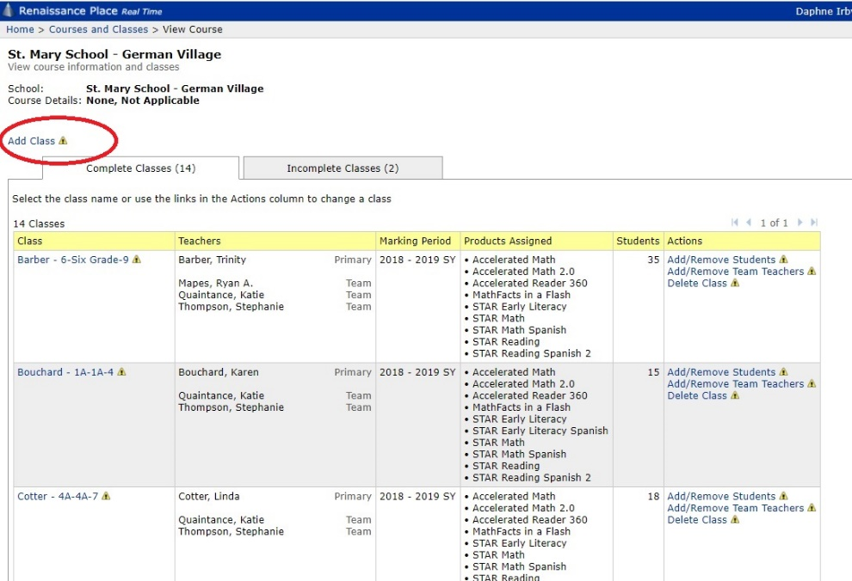

- Then go to main home page and click Users, Add student. When you enter a student into Renaissance Place, you will need to put STU- and a randomly assigned number into the user ID field. This account will not be deleted in the nightly sync.
- OR if you are anticipating enrolling at a later date, you can enter the student as previously done. The sync overnight will make the student inactive; however, we can recover the information by merging accounts when he/she is enrolled.

