Accessing School Performance by Strand data

- Click on Renaissance Analytics after logging into Renaissance.
- Click on Star Reading Proficiency Rate (State benchmark) or Star Math Proficiency Rate (State Benchmark).
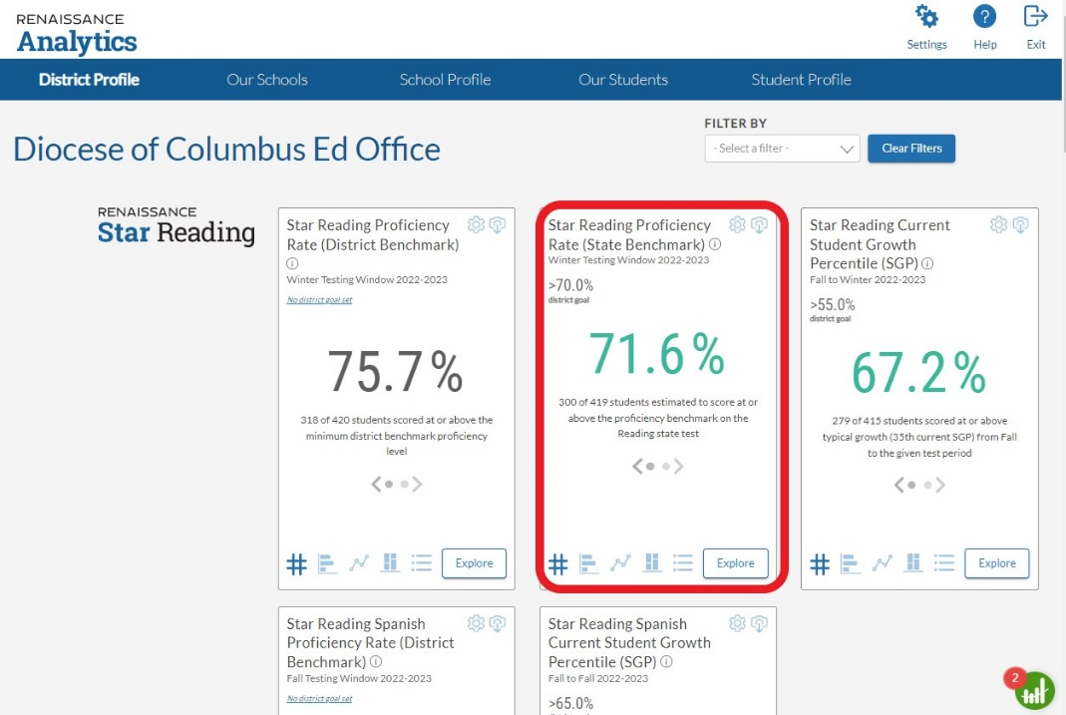

- Click on Explore at the bottom right of the tile.
- Select the time period (testing window).
- Choose Content. You can select Strand or Standard. You can remove any of the items by clicking the x.
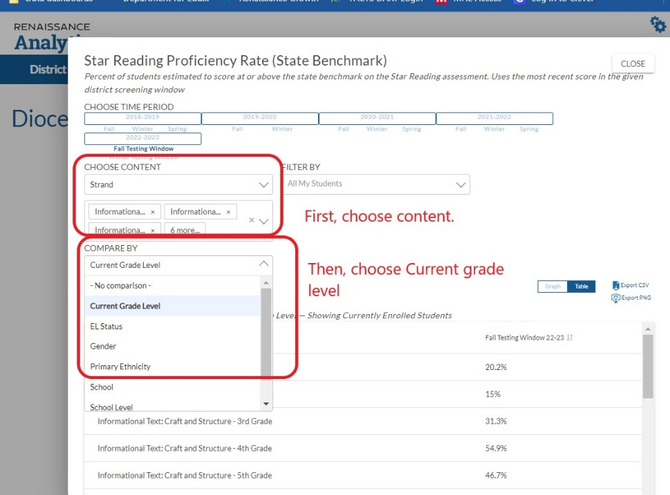
- To see the data by grade level, select Current Grade Level under Compare By.
- Click Table to view data. You can also export it to a csv file.

