Audio can only be turned on for individual students. There is not an option to turn on for an entire grade level.
- Click on STAR Math and scroll down to Preferences. Click.

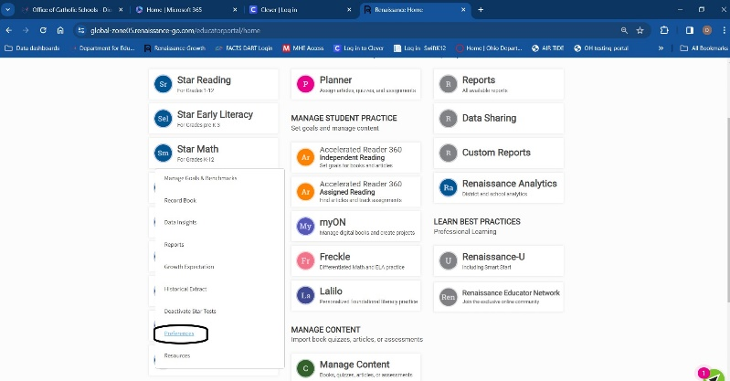
- Scroll down to Individual Student Preferences.

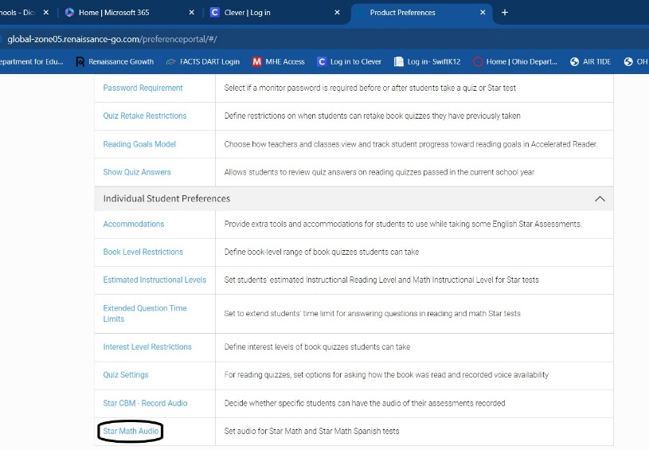
- Click on Math Audio.

- Select Class and Student(s). Click.

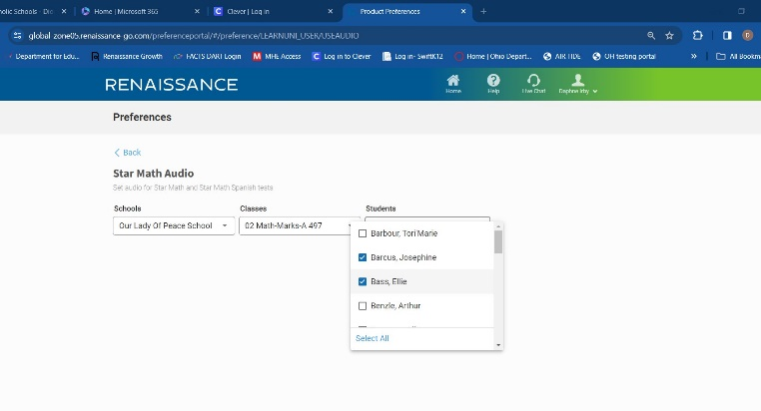

- Click in the box labeled Audio enabled. You will see a blue check. You can also click Set All and click Audio enabled.

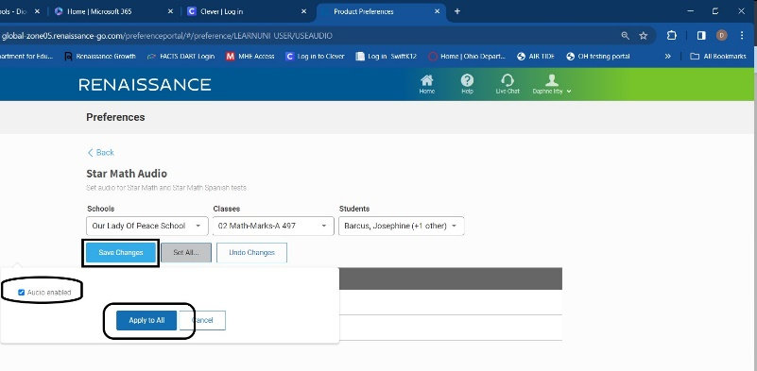
- Click Save Changes.

