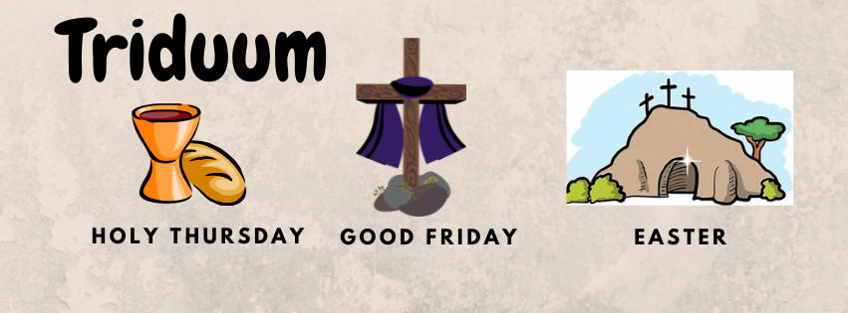

What's it all about?

HOLY THURSDAY - commemorates Christ's Last Supper and the initiation of the Eucharist.
Holy Thursday Tradition…
- At the evening Mass, after the bells ring during the Gloria, they are rung no more until the Easter Vigil.
- The Washing of the Feet, a rite performed by Christ upon His disciples to prepare them for the priesthood.
- Sacred Hosts in the ciborium, are carried to the "Altar of Repose."
- The altar is stripped, no bells are rung. Holy Water is removed until Easter the Easter Vigil.

GOOD FRIDAY – commemorates the day on which Jesus Christ was crucified.
Good Friday Tradition…
- A day of fasting, with only one meal taken in the whole day.
- Some families observe silence between noon and 3:00 pm, the hours that Jesus was on the cross.
- At the evening service, the Cross is venerated. (kiss, touch, bow, etc. to it in symbolic acknowledgement and respect).
- At Sacred Heart, our tradition is to spend the day together beginning with:
  - Walk the Walk at 10AM
  - Simple Meal at Noon
  - Stations of the Cross at 3PM
  - Veneration of the Cross at 7:30PM

EASTER VIGIL - Celebrated after dark on Holy Saturday.
Since the conclusion of the Holy Thursday service, the interior of the church has been bare - similar to a tomb. Candles and holy water have been removed. The Holy Eucharist has been removed and transported to a repository where it remains until the Easter Vigil. There are no flowers or other signs of celebration. This commemorates when Christ went through the "agony in the garden”, betrayed by Judas and turned over to the Romans.
Easter Vigil Traditions…
- The service begins outside, as the priest lights and blesses the Easter fire and the new paschal candle.
- The salvation story is read in the dark.
- As the Gloria is sung signifying the end of Lent, the lights in the church are turned on, the candles on the altar are lighted, and the church bells are rung loudly.
- “Alleluia” is heard again since before the first day of Lent.
- New Holy water is blessed.
- Individuals becoming Catholic are now baptized and Confirmed

