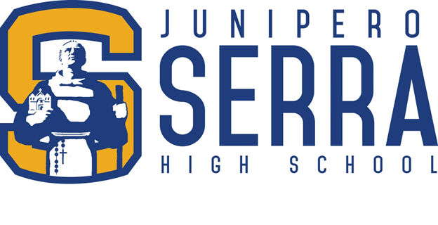
JOB OPENING

MATH TEACHER
Part-Time Interim
3 Sections
(2025-2026 School Year)

Positions begin: October 15-December 5, 2025
Application due date: Until this position is filled
Junipero Serra High School is a Catholic college preparatory for boys. Located in San Mateo, in the heart of the San Francisco Peninsula, Serra’s legacy spans over 80 years of excellence in Catholic education. A rich and rigorous academic curriculum, a wide range of extracurricular activities, and an environment of support, compassion, and mutual respect are hallmarks of Serra. Serra’s faculty and staff are deeply committed to mentoring their students, providing a framework for young men to grow in faith, intellect and character.
Desired background:
- Bachelor’s degree (Master’s degree preferred)
- Single Subject Teaching Credential Preferred
- 3 years of previous secondary level teaching experience
- Such alternative qualifications may be deemed appropriate
- 3 sections of Honors Algebra 2/Trigonometry
- Salary Range - $71,715.00 -$112,65.00

To apply please send the documents listed below to hr@serrahs.com:
- Cover Letter & Resume
- List of references or at least 2 letters of recommendation
- Copies of transcripts (unofficial are acceptable)
- Evidence of California Single Subject Teaching Credential and/or master’s degree in subject area
ALL EMPLOYEES OF THE ARCHDIOCESE OF SAN FRANCISCO SHALL BE EMPLOYED WITHOUT REGARD TO RACE, COLOR, SEX, ETHNIC OR NATIONAL ORIGIN AND PURSUANT TO THE SAN FRANCISCO FAIR CHANCE ORDINANCE, WILL CONSIDER FOR EMPLOYMENT QUALIFIED APPLICANTS WITH CRIMINAL HISTORY.

