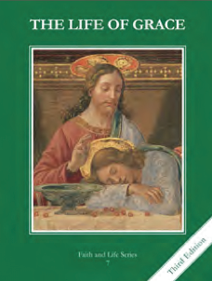
CCD GRADE 7: THE LIFE OF GRACE
Chapter 24: Sin and Mankind
• PREPARATION – How to Get Ready

Teacher’s Manual: pp. 294, 296, and 298 (not

• PROCLAMATION – Main Theme

We suffer from an inclination to sin (concupiscence) as a result of original sin. Temptation and sin can be fought against and overcome through Christ’s grace.
• EXPLANATION – Content of Lesson

- As a result of Original Sin, man suffers from an inclination to sin (concupiscence). L1
  - Concupiscence weakens us and inclines us to choose ourselves and our desires over God and his will.
- Temptation is the enticement to sin. Man is tempted by the world, the flesh, and the devil. L2
- The seven capital sins are pride, avarice, envy, wrath, lust, gluttony, and sloth. L2
  - Know and strive to practice the opposing virtues!
- Man must avoid the occasions of sin. L2
  - Persons, places, and things that may easily cause us to sin
- Man can sin by thought, word, deed, and omission
  - Mortal sin
  - Venial sin
- Conscience – the act of our intellect by which we judge right from wrong in human actions
• APPLICATION – Connecting it to Students

- Relationship with Jesus Christ makes all the difference
- Virtues vs Vices booklet
- Ocean of Mercy – Chris Stefanick (https://www.youtube.com/watch?t=21&v=CvZ4l9ZI67A)
  - “Next to the ocean of God's mercy, your sin is a pebble. He died to free you from it. Let him.”
• CELEBRATION - Conclusion

- Pray the Stations of the Cross together as a class…in a particular way, ask Our Lord for the grace to overcome temptations in our lives through his grace, always reaching up for his hand when we fall into sin.

