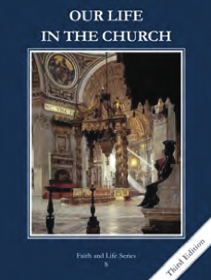
CCD GRADE 8: OUR LIFE IN THE CHURCH
Chapter 23: Prayer
• PREPARATION – How to Get Ready

Teacher’s Manuel: pp. 285-295
Materials: Jar and materials to decorate the prayer jar.
• PROCLAMATION – Main Theme

We are all called to unite ourselves to Christ through the Sacraments and prayer. Jesus showed us how to prayer perfectly to the Father.
• EXPLANATION – Content of Lesson

1. Prayer is the lifting of our minds and hearts to God. L1
- We are called to sanctify our lives and unite ourselves to Christ.
2. The five steps to prayer are preparation, humility, resignation, and perseverance. L1
  - Prayer is essential to our spiritual lives.
3. Mental and vocal prayer. L2
  - Mental prayer is what is said interiorly. Vocal prayer is spoken out loud.
  - Formal prayers follow a set pattern. Informal prayer is praying with one’s own words.
• APPLICATION – Connecting it to Students

- Activity: Prayer Jar Activity
- Video: https://youtu.be/-_mmPI-SYBE
• CELEBRATION - Conclusion

- Read over the prayers in the prayer jar. Make sure they are anonymous. Pray for each petition.

