Senior Health Partners is a community organization dedicated to the health and well-being of senior citizens in Calhoun County.
We are located in the back of the Battle Creek Family YMCA on 28 Penn St.
Our Guiding Principles are:
- Older adults should be treated with dignity and respect.
- Older adults should have access to education and information that enhances their ability to make informed health decisions.
- Older adults should have access to an integrated continuum of care and community resources.
- Caregivers should be supported as they care for their loved ones.
- Organizations working in partnership deliver better health care.

We provide:
- FREE Nurse-Supported Exercise and Fitness Programs
- FREE Monthly Support Groups
- Caregiver Supports and Services
- Community Care Options – Care planning, homemaking and problem solving for older adults in Calhoun County
- Various Educational Programs and Classes, including nutrition classes such as Food Smarts ; A Matter of Balance – Fall Prevention Classes; Mind Sharpener™ Classes; Walk With Ease Classes; Tai Chi for Arthritis and Fall Prevention; SilverSneakers™ Yoga; and HealthRHYTHMS© Drumming Classes.
- Home
- Caregivers
- Caregiver Education

Caregiver Education Services are available for Caregivers who are:
- Family members caring for someone 60 years of age or older.
- Caregivers who are 60 years of age or older and care for a disabled adult over 18 or for another older adult, age 60 or older.
- Caring for a loved one who needs assistance with 2 or more Activities of Daily Living (ADL’s).
- Residents of Calhoun County.

Services Include:
- Information and referrals
- Support groups
- Caregiver training
- Counseling
- Caregiver Resource Library
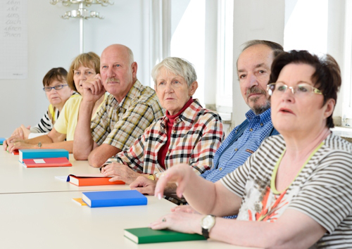
Senior Health Partners offers free classes for caregivers, friends and family to be educated and supported in various issues of caregiving, including improving caregiving skills, using community services and taking better care of yourself.
Senior Health Partners also offers several Caregiver Support Groups, including a general caregivers support and a Parkinson’s Disease Caregiver specific group.

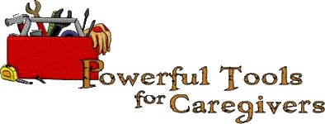

A FREE six-week series designed to provide caregivers with the tools to:
- Reduce personal stress and change negative self-talk
- Communicate feelings and needs to others
- Set limits and learn to ask for help
- Use community services
- Deal with difficult emotions – like anger, guilt and depression
- Make tough caregiving decisions
- Deal effectively with difficult family decisions
For more information or to register, please call Anne Clark, Eldercare Coordinator, at 269.986.3135 or email us.

- FREE Nurse-Supported Exercise and Fitness Programs
- FREE Monthly Support Groups
- Caregiver Supports and Services
- Community Care Options – Care planning, homemaking and problem solving for older adults in Calhoun County
- Various Educational Programs and Classes, including nutrition classes such as Food Smarts ; A Matter of Balance – Fall Prevention Classes; Mind Sharpener™ Classes; Walk With Ease Classes; Tai Chi for Arthritis and Fall Prevention; SilverSneakers™ Yoga; and HealthRHYTHMS© Drumming Classes.

