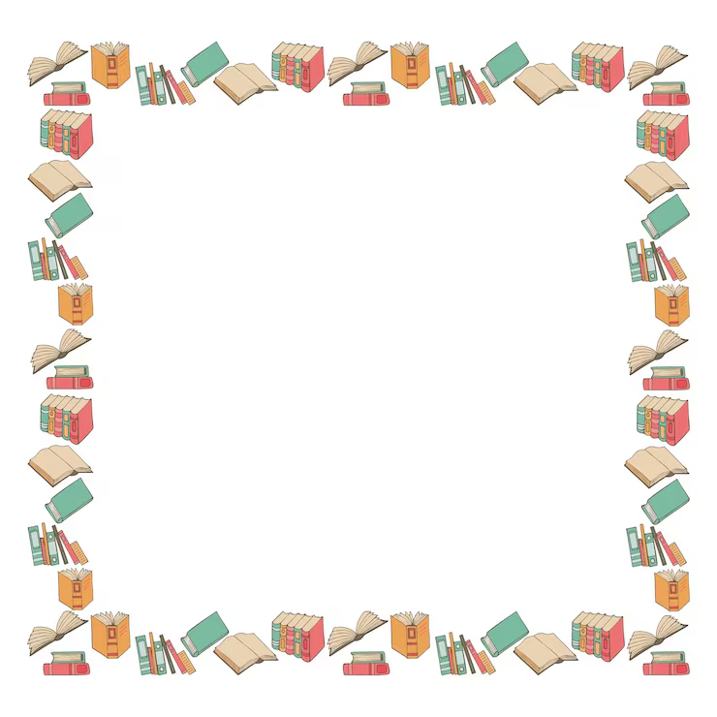
3K Summer Reading List
Take some time this summer to visit your local library with your child. Try to make it part of your summer routine. Most libraries offer summer reading programs that are age appropriate and often have great incentives!
Here are some ideas for some summer reading fun.
- My Letter, My Name—Find a book that focuses on the first letter of your child’s name. Help them to learn and recognize the beginning letter for their name.
- Reading Picnic—Find a favorite story, set up a blanket and snack outside and enjoy some outdoor reading time.
- Let’s Go Camping—Build an indoor blanket fort or tent for some cozy reading time and imaginative adventures set in the great outdoors.
- Hey, That Rhymes!—Find a book with lots of rhyming words. Emphasize the rhyming sounds and see if your child can identify the rhyming words or make up their own.
- You Can Count on Me!—Read a book that provides opportunities to count up to 10.
- We’re Having a Wild Time—Go on a literary adventure and read some animal stories.
- Cozy Corner—Create a comfy, cozy corner with blankets and pillows and have your child “read” to their favorite stuffy.
- Come On, Let’s Go!—Take a little trip with some transportation stories.
- Down on the Farm—Sing “Old MacDonald” and read some books set on a farm.
- That’s My Favorite—What is your child’s favorite book that you’ve read hundreds of times? Have them “read” the story to you!
Here’s a fun idea to help with letter recognition. Write the letters of the alphabet on a beach ball and play catch. Help them identify the letter that is closest to their thumb.

