Sacramental Marriage Preparation class

Two Day Marriage Retreat
We have implemented a two part marriage retreat in the Archdiocese!
Friday evening is meant to let the couple have time to focus on their individual relationship with God as the foundation for their marriage. This night will include a talk on the Gospel with Adoration and Confession. There will also be time to socialize and meet other couples at the end of the night.
Saturday is intended to let the couple focus on connecting with each other. There will be talks, time for reflection, and time for couple discussion. There will be presentations on the Sacrament of Marriage, Family of Origin, Communication, Finances, and Natural Family Planning from married couples across the Archdiocese.
Friday Night: 6:30pm-9:30pm
Saturday: 9am to 3:30pm
Overnight accommodations are available for couples who need them who are driving a considerable distance that would make it difficult to drive back Saturday morning.
We are excited to have you join us!

WHO SHOULD ATTEND?

The Archdiocesan Marriage Preparation Guide-lines state that a couple should attend at least one of these programs: Archdiocesan marriage preparation class and/or the Parish Sponsor Couple program at a parish. Couples desiring an opportunity for more in-depth preparation often attend two of these programs.

WHEN SHOULD A COUPLE

ATTEND?

When a couple decides to marry or are seriously considering marriage, it would benefit their relationship to participate in any of the programs. Once the decision to marry has been made, it is best to participate in a marriage preparation program at least six months in advance.
A couple should contact a Priest to begin preparation for the Sacrament of Marriage and the marriage ceremony at least six months prior to the desired wedding date.

WHAT IS THE COST?

The fee is $50.00 per couple. This amount should accompany your application form. This fee defrays the cost for use of the facilities, lunch, and materials used.

Checks or Money Orders should be made out to the “Office of Marriage & Family Life.”

To register and pay online go to:

https://archokc.stellarwebsystems.com/join?euuid=16b5f3ec-3fd4-11eb-b866-16bd7eac75f3

PRE-REGISTRATION IS

REQUIRED!

There is a limit to the number of couples that can be accommodated and there is usually a waiting list. It is best to send in your registration as early as possible to guarantee your preferred date.

The total fee be applied to another date for any of our marriage preparation programs.

More detailed information can be provided by contacting: (405) 709-2709
Rae Biesiada, (rbiesiada@archokc.org) English Lisa Carrasco (lcarrasco@archokc.org) for Spanish

As with all programs sponsored by the Office of Marriage & Family Life, fees should not prohibit a couple from attending. Special arrangements for payment can be made if needed.

2024 DATES

January 12-13
March 8-9
May 10-11
July 19-20
September 13-14
Nov. 9

REGISTRATION (Please print clearly)

His Name ___________________________________

Address _____________________________________

____________________________________________
City State Zip

Phone ______________________________________

His Email____________________________________

Her Name ___________________________________

Address _____________________________________

____________________________________________
City State Zip

Phone ______________________________________

Her Email___________________________________

Wedding Date ________________________________

Parish ______________________________________

Priest’s Name ________________________________

Program Date ________________________________

Amount Enclosed _____________________________

Mail to:
Office of Marriage & Family Life
P O Box 32180
7501 N.W. Expressway
Oklahoma City, OK 73123

The Program will be held at:

The Catholic Pastoral Center
7501 N.W. Expressway
Oklahoma City, OK 73123

This Program is sponsored: by the Office of Marriage & Family Life Ministry of the Archdiocese of Oklahoma City through the generosity of contributions to the Annual Catholic Appeal.

Sacramental Marriage Preparation Class

Archdiocese of Oklahoma City
Office of Marriage &
Family Life Ministry
7501 N.W. Expressway
Oklahoma City, OK 73132
Archokc.org

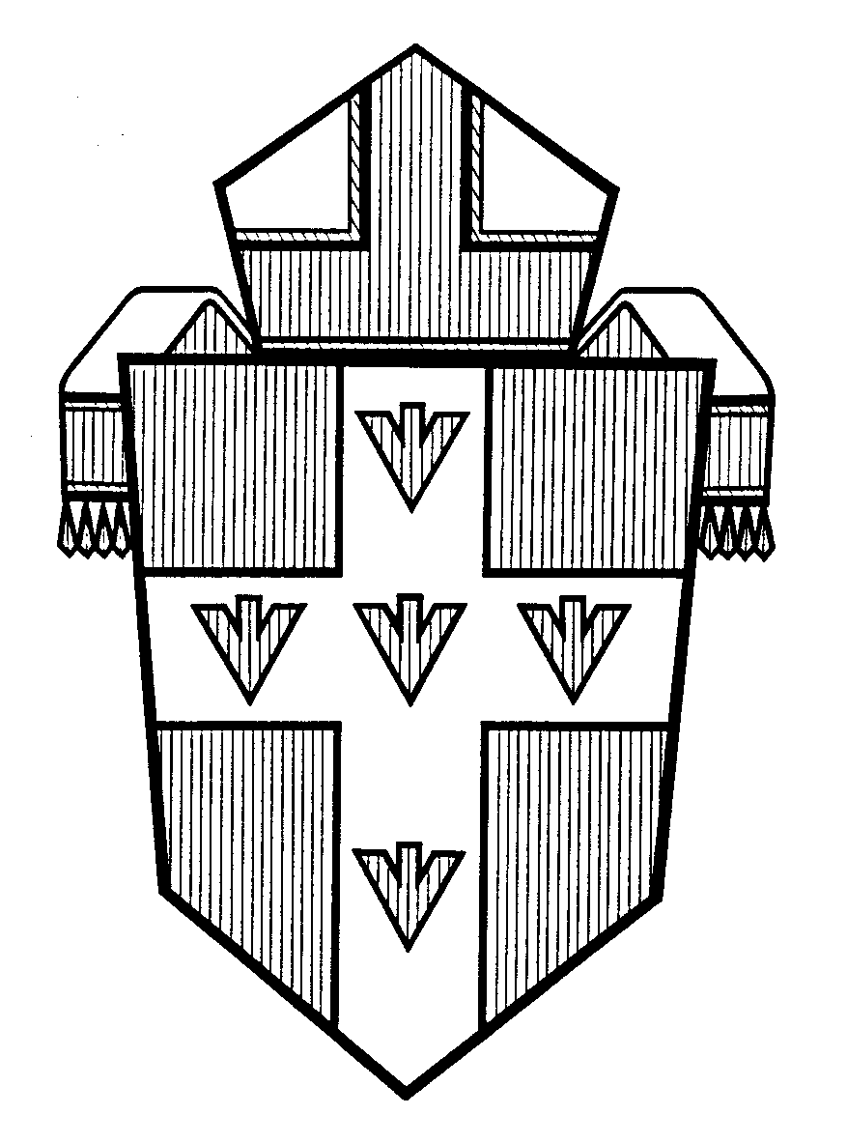

Go Make Disciples

