2022 – 2023

EARLY REGISTRATION

St. Aloysius Catholic Church

3rd Avenue and NW Zobrist Street

Estacada, Oregon 97023

503-630-2416

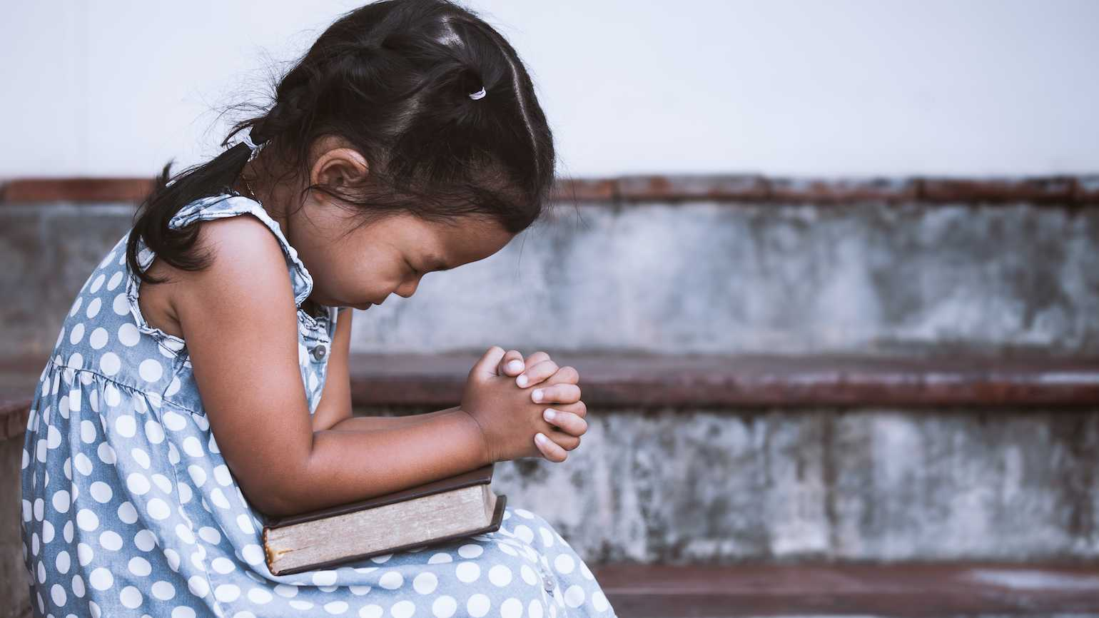

FAMILY LAST NAME: __________________________________________________________________________

Mailing Address _______________________________________________City _____________ Zip ___________

Family Email Address: ________________________________________________________________________________

Father’s Name _________________________________________ Phone: ___________________________

Mother’s Name ________________________________________ Phone: __________________________

**Name of children enrolling D/birth Grade**

***(1)______________________________________________________ _________________ __________***

*CIRCLE SACRAMENTS CHILD HAS ALREADY RECEIVED: BAPTISM FIRST COMMUNION CONFIRMATION*

***(2)______________________________________________________ _________________ __________***

*CIRCLE SACRAMENTS CHILD HAS ALREADY RECEIVED: BAPTISM FIRST COMMUNION CONFIRMATION*

***(3)______________________________________________________ _________________ __________***

*CIRCLE SACRAMENTS CHILD HAS ALREADY RECEIVED: BAPTISM FIRST COMMUNION CONFIRMATION*

***(4)______________________________________________________ _________________ __________***

*CIRCLE SACRAMENTS CHILD HAS ALREADY RECEIVED: BAPTISM FIRST COMMUNION CONFIRMATION*

***(5)______________________________________________________ _________________ __________***

*CIRCLE SACRAMENTS CHILD HAS ALREADY RECEIVED: BAPTISM FIRST COMMUNION CONFIRMATION*

***(6)______________________________________________________ _________________ __________***

*CIRCLE SACRAMENTS CHILD HAS ALREADY RECEIVED:**BAPTISM FIRST COMMUNION CONFIRMATION*

Registration/Book fee $25 per child - Return form to the parish office by August 31, 2022

to receive a $10 family discount

