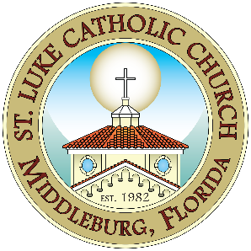
Confirmation Service Hour Log Sheet
St. Luke Catholic Church, Middleburg, FL

Student Name: ______________________________________
Guidelines for the log sheet: You may use any service hours from June 2025 to current.
Log sheet is to be filled in with the service activity; description of the service, time served and must be signed by the Family Faith Formation Department. A total of 20 hours is required in order to receive the Sacrament of Confirmation. (10 hours at St. Luke Catholic Church)
 | Date | Type of Service | Location of Service | Hours Served | Supervisor’s Signature & Phone #
1.
2.
3.
4.
5.
6.
7.
8.
9.
10.
Total Hours Served:

___________________
*Confirmation Service Hours are hours spent sharing your love of Jesus Christ with others who may or may not be as fortunate as you are. It is your opportunity to show that you believe in Jesus and what He taught us by your actions and deeds.

