St. Luke Catholic Church
Confirmation Handbook
2025-2026

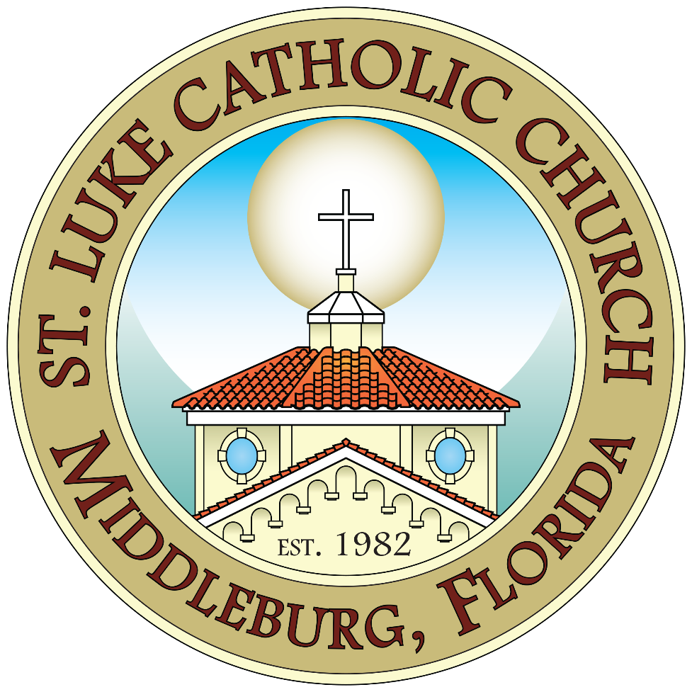

1606 Blanding Blvd
Middleburg, FL 32068
www.stlukesparish.org

Contents
Introduction: 2
About the Sacrament of Confirmation 2
Preparation and Formation for the Sacrament: 3
ROLE OF THE CANDIDATE 4
Immediate Preparation for Confirmation 4
SELECTING A CONFIRMATION SAINT 5
Practical Guidelines in Selecting a Saint 5
Saint Report 5
Bishop Letter 6
Information for Confirmation Sponsors 7
Service Hours 8
CONFIRMATION DRESS ATTIRE 8

Dear Parents,
Congratulations! Your child has chosen to prepare for the sacrament of confirmation. This is an
important part of the road you all are traveling—a chance to stop and view where you have been,
where you are, and where you are going in your faith lives. As a parish community, we strive to
support you and your family as you share your life and your faith with us.

This guide is a resource, a “trail guide” for your continuing journey. Many of the questions you
may have will be answered by its contents. We offer religious-education sessions for the
sacrament of confirmation that are based on the Catechism of the Catholic Church.

Confirmation celebrates neither the beginning nor the end of Christian initiation for your child, but rather a gradual and continuing growth into the Eucharistic community. We are not celebrating a graduation, but growth in the baptismal way of life, which is meant to lead us all into the Eucharistic way of life throughout your life. Your child’s growth into the living body of Christ is not finished by Confirmation—it is only getting started.

In this handbook, we provide a list of general guidelines and other important information for you
and your family. We hope that this information is helpful and enlightening. Please feel free to contact me at the Family Faith Formation Office with any questions or thoughts that you may have. Please pray for all our Confirmation candidates.

Sincerely,

Laura Austin
Coordinator
Family Faith Formation
St. Luke Catholic Church

Introduction:
Confirmation is a Sacrament of Initiation that is closely connected to the Sacrament of Baptism and Eucharist. It completes the Sacrament of Baptism, brings an increase and deepening of baptismal grace and strengthens the gifts of the Spirit received at Baptism. The Sacrament of Confirmation also leads us to the Eucharist as the way to live out our lives as fully initiated Catholics.

About the Sacrament of Confirmation
From the Catechism of the Catholic Church #1316-1321
Confirmation perfects Baptismal grace; it is the sacrament which gives the Holy Spirit in order to root us more deeply in the divine filiation, incorporate us more firmly into Christ, strengthen our bond with the Church, associate us more closely with her mission, and help us bear witness to the Christian faith in words accompanied by deeds.
Confirmation, like Baptism, imprints a spiritual mark or indelible character on the Christian's soul; for this reason, one can receive this sacrament only once in one's life.
In the Latin Church this sacrament is administered when the age of reason has been reached, and its celebration is ordinarily reserved to the bishop, thus signifying that this sacrament strengthens the ecclesial bond.
A candidate for Confirmation who has attained the age of reason must
- profess the faith
- be in the state of grace
- have the intention of receiving the sacrament
- and be prepared to assume the role of disciple and witness to Christ, both within the ecclesial community and in temporal affairs.
The essential rite of Confirmation is anointing the forehead of the baptized with sacred chrism, together with the laying on of the minister's hand and the words: "Accipe signaculum doni Spiritus Sancti" (Be sealed with the Gift of the Holy Spirit.) in the Roman rite.
When Confirmation is celebrated separately from Baptism, its connection with Baptism is expressed, among other ways, by the renewal of baptismal promises. The celebration of Confirmation during the Eucharist helps underline the unity of the sacraments of Christian initiation.

Preparation and Formation for the Sacrament:
Sacramental Preparation for Confirmation is open to all 9th through 12th-grade students who are baptized and have received their First Eucharist.
At St. Luke Catholic Church, we have a two-year preparation program for the Sacrament of Confirmation. During these two years, we have classes which catechize the student and help them to understand their faith and the guidelines of the Catholic Church. Year 1 typically begins when the student is entering 7th grade.
Eighth graders who have completed our Year 1 Confirmation prep classes, attend a Catholic School, or are enrolled in a Homeschooling religious education program are eligible to enroll as candidates for our 2nd year Confirmation classes.
Formation for the celebration of Confirmation involves the cooperative efforts of parents (the primary educators), pastors, catechists and young adults. It is a time for a young adult to become a mature, practicing Catholic, characterized by the willingness to personally follow Christ and actively participate in the vital mission of His Church.
Readiness to receive Confirmation means the student actively attends and participates in Sunday Mass, Faith Formation classes, retreats, and perform service activities.
Attendance Policy: The sacramental preparation is an ungraded structure and readiness is determined a significant part by participation and attendance. A student may only miss three classes during the Confirmation Preparations—make-up work required and signed by a parent for any class which is missed.
*If a candidate misses more than 3 Faith Formation sessions each year, then we will suggest that the candidate wait until he or she can maintain consistent attendance to be confirmed.
Formation for the celebration of Confirmation involves the cooperative efforts of parents (the primary educators), pastors, catechists, and young adults. It is a time for a young adult to become a mature, practicing Catholic, characterized by the willingness to personally follow Christ and actively participate in the vital mission of His Church. Immediate catechesis for the sacrament of Confirmation is a robust formation on what it means to be an authentic disciple of Christ. The confirmation student should be able to rationally express and zealously defend the truths of Catholic doctrine.

ROLE OF THE CANDIDATE
- Participate in all sessions; arrange work and school schedules so that they can attend ALL the sessions.
- Complete all the homework as assigned and turn it in as scheduled.
- Participate in service projects
- Be able to explain their faith: Talk about faith in their own words and why they wish to live as Catholic Christians
- Attend the Confirmation Retreat
- Be open to participation in the events and instruction.
- Participate in parish life: Attending Mass on a regular basis and be involved in parish
activities.

Immediate Preparation for Confirmation
The stage of immediate preparation for Confirmation includes the following, which the candidate is expected to perform:
- Attend all sessions being held for Confirmation preparation. This includes the Spirit Day activities and the overnight retreat. All absences should be reported to the Family Faith Formation office by calling 904-282-0439 or via email: laura@stlukesparish.org. Excessive absenteeism may result in the candidate not being properly prepared to receive the Sacrament of Confirmation and may delay the preparation process.
- Attend weekly Mass. Weekly Mass Attendance record form must be turned in at least monthly.
- Participate regularly in the life of the Church by attending Sunday and Holy Day Mass, receiving the Sacraments, including Reconciliation, and actively giving service to others
- Complete and return all forms by the required date to be properly prepared and presented for reception of the Sacrament of Confirmation at this time. The required forms are:
- Copy of child’s baptism certificate
- Saint Report
- Bishop Letter
- Sponsor form
- Service Hour Log

SELECTING A CONFIRMATION SAINT
Each Confirmation candidate chooses a saint as a patron and is confirmed under that patron saint’s name. The name is a symbol of your full initiation into the Church and her mission. When you are presented to the bishop at the Confirmation, he will call you by the name that you have chosen and mark you with the sign of the cross.
A patron saint is someone already in heaven with whom we feel a connection, want to imitate, and from whom we request intercession throughout life.
The tradition of taking on a new name reflects a new role in life. This is evident throughout the Scriptures, e.g. “Abram” was changed to “Abraham” which means “Father of Many Nations,” and Simon was changed to “Peter” which means “Rock” because Jesus founded His Church upon him as the first pope.
When you choose a new name for your Confirmation, it should be the name of a saint you have read and learned about, admire, and want to imitate. You should not choose a Saint because you like his/her name. You should choose a saint that you want to be like. In choosing a saint name, spend some time and research a saint that you would like to model your own life after. Tell us about why you chose this saint and hand this form along with essay report to the parish office or at confirmation class by the November class meeting.

Practical Guidelines in Selecting a Saint
- You should be familiar with this saint’s life. It is to be hoped that you see similarities between you and this saint and/or want to aspire to be like this saint.
- The saint you select should be someone you look up to as a hero.
- You should develop a personal devotion to this saint and build a relationship with him/her through constant prayer.
- You should try to learn about a lot of saints. That way you will make a better decision choosing your patron saint. Moreover, the more saints you are familiar with the easier it becomes for you to request their intercession (even from the ones that are not your special Confirmation patron); the saints are always eager and happy to help us.

Saint Report
The saint report should be a typed essay with at least three paragraphs: (1) a brief biography of the saint written in your own words, (2) an explanation of the reasons why you have selected this saint, (3) and ideas of how you will develop your devotion and relationship with this saint. Try to include in your report cool facts about the saint, what he/she is a patron of, when they lived, and when they were canonized. The report will be read by the Confirmation coordinators.

Bishop Letter
It is essential that each candidate express his or her desire to be confirmed in writing to the Bishop. In the letter you share who you are and a little about yourself, why you wish to be confirmed, as well as whom your confirmation saint is and why you chose that saint. Before the celebration of Confirmation, the Bishop is required by Canon Law to know that candidates have been properly prepared. He should also know that each candidate has a desire for, and knowledge of, the sacrament.
To help the Bishop meet his responsibilities, each Confirmation candidate must write a personal letter to the Bishop requesting the Sacrament of Confirmation. The purpose of this letter is to introduce yourself to the Bishop and to explain your Confirmation preparation experience as well as to assure him that you are asking for the sacrament freely. All of the letters are mailed together from the Parish to the confirming Bishop prior to the Confirmation ceremony; for this reason, late letters will not be accepted. The Bishop personally reads each letter he is sent and often refers to them during the Confirmation ceremony.
The questions below should help you reflect on some of the things you may want to include in your letter to the Bishop. Answer the questions below, and then write a first draft of your letter requesting the Sacrament of Confirmation. Then, after leaving it sit and praying on it for some time, write your final draft.
- Your letter should be about one page in length using 1-inch margins and a business-style 12- point font. Single space the paragraphs of the letter.
- The letter may be typed and must be at least 4 paragraphs long. If it is handwritten it must be on loose leaf paper – no fringes! It must be your own work and signed by you. There is no ‘right’ way to do it since everyone’s experience is different. Please try to avoid just going down the list below.
Dear Bishop Pohlmeier,
- In what ways has the preparation of the Sacrament of Confirmation helped you?
- How does the Catholic Church understand the Eucharist? What does the Eucharist mean to you personally?
- What will you do for the Church – for the society as a confirmed Catholic?
- What is your basic prayer life? Tell me about your prayer life as an individual and as part of a family.
- Explain the definition of stewardships and how Confirmation calls you to be a steward for others.
- Is there a particular Saint you have come to know about and learn about? If so, who is it? What qualities of the Saint do you hope to imitate in your life after Confirmation?

Information for Confirmation Sponsors
The Role of a Confirmation Sponsor
A sponsor must be a person who knows the candidate and can help him/her on his/her spiritual journey and can share his/her own faith. This selection should be indicated at the beginning of the candidate’s immediate preparation (8th grade) so that the sponsor can play an active part in the preparation process. Ideally, it should be someone who has been involved already in the candidate’s spiritual formation, such as a godparent, a family member, or a member of the local parish.
Eligibility of a Confirmation Sponsor
- A sponsor must:
- Be a practicing Catholic in good standing with the Church (Canon 874.3)
- Good standing includes being in a marital state that is blessed by the Church
- Be at least 16 years old (Canon 874.2)
- Belong to the Catholic Church and have been fully initiated (have received the Sacraments of Baptism, Confirmation, and Eucharist) (Canon 874.3)
- Not be the biological parent of the candidate (Canon 874.5)
- Not prohibited by law from exercising the role of sponsor

Verification of Eligibility: Each name submitted to be a sponsor must be verified in advance of the Confirmation Liturgy by the parish.
Suggestions for Sponsors
- Be a good Catholic role model. The primary job of a sponsor is to show a candidate how to live the faith as an adult. This includes going to Mass every Sunday and Holy Day, going to Confession regularly, and praying daily. But it also means bringing your faith into the ordinary situations in daily living: being a model of forgiveness, compassion, and personal sacrifice. If you are not growing in holiness yourself, you will not be able to help your candidate grow in holiness.
- Offer prayer support. Remember to pray for your candidate every day for the rest of your life. It can be as simple as offering a Hail Mary every morning or as complex as creating your own prayer routine. Remember your candidate in your Mass intention each Sunday and Holy Day. And let him/her know that you are praying for him/her.
- Show visible spiritual support. Make it a point to ask your candidate about his/her prayer life on a regular basis. Is he/she going to Mass every Sunday and Holy Day? If not, how can you help (take him/her yourself, talk to his/her parents about going as a family, etc.)? Is he/she getting to Confession regularly? If not, how can you help?
- Mark the Confirmation Anniversary. Remember the date that your candidate is confirmed and celebrate it each year. Send a card, make a phone call, or go out to dinner. Do something to remind your candidate (and yourself) that this is a major event in both of your lives.

Service Hours
Candidates are required to fulfill twenty hours of service. Ideally, service hours should be divided between service to the family, parish, and to the community at large. We kindly ask that at least 10 hours of service be performed here at St. Luke Catholic Church.
We will have forms for service hours available online on the parish website and will also have on hand at classes. For more information or clarification, contact the Family Faith Formation Office.
Students are required to keep a record (copies) of the service hour forms and should document all future community service during their high school careers and develop a Service Portfolio which could be used later to apply for service-based college scholarships. The service record forms are also an excellent resource for writing their Bishop Letter.
The Religious Education Office is not responsible for scheduling or providing service hours. We recognize the scheduling demands that many parents and children face, and we aim to provide as many service opportunities as possible. We will also notify the candidates when service opportunities present themselves. Please check the Sunday bulletin for available service opportunities.

CONFIRMATION DRESS ATTIRE
Direct from the Diocese of St. Augustine Website:
**This dress code applies to candidates and sponsors. **
Candidates for Confirmation must be dressed in “Sunday-best” attire. The following norms apply:
1. For Young Men:
■Dress trousers (no jeans), with a shirt and tie. A coat is recommended. Dress shoes are required.
2. For Young Women:
■A dress, or a skirt and blouse, or a pantsuit, none of which may be tight fitting.
■The dress or skirt must reach the knees (no miniskirts) and it must cover the back
■The dress or blouse must have sleeves that cover the shoulders (spaghetti straps, etc. are not sleeves)
■No low-cut tops on blouses or dresses.
Please ascertain prior to the ceremony that dress is appropriate.
Hair should be styled in such a way that the forehead is easily anointed.

