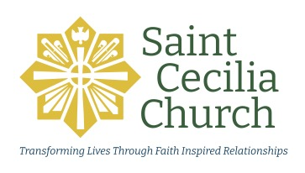

SCC Meeting Summary Template

Name of the Ministry/Organization:

Date of the Meeting: Start & End Time of the Meeting:

Location of the Meeting:

Roles at the Meeting:
Facilitator: Timekeeper:
Person Preparing Meeting Summary:

Who was in attendance?

Actions/Decisions | Who is  Responsible? | When will it be done?

Actions/Decisions | Who is  Responsible? | When will it be done?

Please make note of any other significant conversations that took place:

The next meeting date will be:

Agenda items will include:

Best Practices:
- The Meeting Summary is shared with the leaders/members within 7 days of the meeting.
- The leaders of the ministry/organization are responsible for following up on action items and decisions regarding follow-through.
- A copy of this summary is shared with the Staff Member responsible for the group. This is to keep the parish staff informed on the group's vitality and to provide for the history of the parish and its ministries.
- The leaders share any concerns, problems or immediate needs to that same Staff Member as soon as possible.

