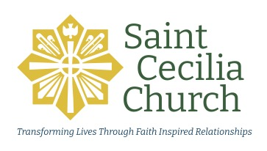

SCC Ministry Profile Sheet

Name of Ministry/Group:

Purpose of the Ministry/Group:

History of the Ministry/Group

Current Leadership of the Ministry/Group
Name Role When will their term end?

Goals for the next 12 Months (based on the parish’s current Pastoral Priorities: spiritual growth, engaging young families, and opportunities for service)

Meetings/Events for the next 12 months (if possible)

Do you have any need for financial support from the parish?

By this time next year, what impact do you want your ministry/group to have had within the parish and/or outside the parish?

How will your group help your members grow as disciples of Jesus Christ (prayer, retreats, discussions at meetings, etc.)?

Is there anything else the Parish Staff should know about your group, its needs and hopes for the coming year?

