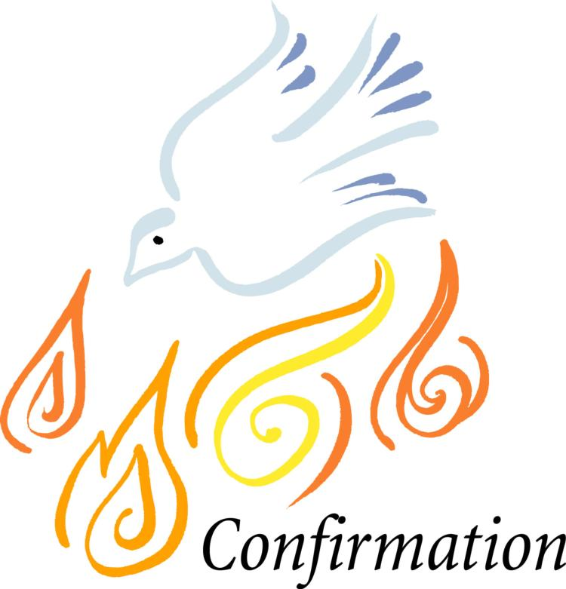
Confirmation Sponsor
Verification Form
Saint Kilian/Holy Sepulcher Parish

Confirmation Candidate’s Name: _________________________________________________________________

This is to certify that I, (name of sponsor) ________________________________________________________ ,
have received the Catholic Sacraments of Baptism, Eucharist and Confirmation; am actively participating in my Catholic faith by being a registered and supportive parishioner of my parish; regularly attend weekly Mass and am living my life as a disciple of Jesus Christ. (Please note that sponsors who are members of Saint Kilian or Holy Sepulcher do not need to complete this form.)

Signature of Sponsor

(This section is to be filled out by the Catholic Parish in which the Sponsor is a registered member.)

I verify that this member, to my knowledge, is qualified to act as a Catholic sponsor for
the Sacrament of Confirmation.

Parish Name:

Parish Address:

Parish Phone Number:

Pastor’s Signature:

Date:

Please return this form by March 1, 2023 to:

Andrea Wheeler
Saint Kilian Parish
7076 Franklin Rd
Cranberry Twp PA 16066

(724) 625-1665 x 2134
awheeler@saintkilian.org
Parish Seal

