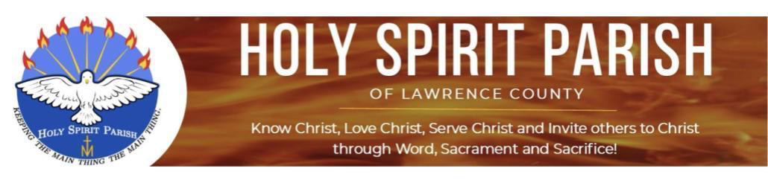

Gospel Reflections

The Holy Family of Jesus, Mary, and Joseph
Gospel for Sunday, December 27, 2020 - Luke 2:22-40

When the days were completed for their purification
according to the law of Moses,
They took him up to Jerusalem
to present him to the Lord,
[ just as it is written in the law of the Lord,
Every male that opens the womb shall be consecrated to the Lord,
and to offer the sacrifice of
a pair of turtledoves or two young pigeons,
in accordance with the dictate in the law of the Lord.
Now there was a man in Jerusalem whose name was Simeon.
This man was righteous and devout,
awaiting the consolation of Israel,
and the Holy Spirit was upon him.
It had been revealed to him by the Holy Spirit
that he should not see death
before he had seen the Christ of the Lord.
He came in the Spirit into the temple;
and when the parents brought in the child Jesus
to perform the custom of the law in regard to him,
He took him into his arms and blessed God, saying:
“Now, Master, you may let your servant go
in peace, according to your word,
for my eyes have seen your salvation,
which you prepared in sight of all the peoples,
a light for revelation to the Gentiles,
and glory for your people Israel.”
The child’s father and mother were amazed at what was said about him;
and Simeon blessed them and said to Mary his mother,
“Behold, this child is destined
for the fall and rise of many in Israel,
and to be a sign that will be contradicted
—and you yourself a sword will pierce—
so that the thoughts of many hearts may be revealed.”
There was also a prophetess, Anna,
the daughter of Phanuel, of the tribe of Asher.
She was advanced in years,
having lived seven years with her husband after her marriage,
and then as a widow until she was eighty-four.
She never left the temple,
but worshiped night and day with fasting and prayer.
And coming forward at that very time,
she gave thanks to God and spoke about the child
to all who were awaiting the redemption of Jerusalem.]
When they had fulfilled all the prescriptions
of the law of the Lord,
they returned to Galilee,
to their own town of Nazareth.
The child grew and became strong, filled with wisdom;
and the favor of God was upon him.

Reflection: The presentation of Jesus in the Temple is more than the simple fulfillment of a prescription of the Law. Rather it shows how Jesus, from the time of his childhood, lived like all his people, in a humble family that was submissive to the religion of its ancestors. Mary and Joseph, demonstrate how to achieve holiness by placing God first with docile and obedient hearts, fulfilling the gift of His holy law in all their thoughts, words and deeds.

Questions for Reflection:
- Do I desire to model the humble obedience of the Holy Family by submitting to the holy laws of God in my own life—in my thoughts, my words and my deeds?
- Can I understand the doctrines of Christ proclaimed by the Church as a holy path to peace and fulfillment and not a restriction of my personal freedoms? “How I love your law, Lord! I study it all day long (Ps 119: 97).”
- Do I see how the example of Mary and Joseph’s full participation in the rituals of the Covenant invite me and my family to engage more fully in the the sacramental life of the Church?

Questions were adapted from the reflection on the Presentation of the Child Jesus in the Temple in Sacred Story, An Ignatian Way to Pray the Mysteries, William Watson, SJ

