NEW BRITAIN COUNCIL OF CATHOLIC WOMEN
ARCHDIOCESE OF HARTFORD
nbcouncilcatholicwomen@gmail.com
COLLEGE SCHOLARSHIP

APPLICATION NO. __________

Senior members of high school graduating classes are eligible to apply for a college scholarship in the amount of $1000.00.

CRITERIA
- Community Service and other Activities – 25%
- Need – 25%
- Performance – 50%

To qualify for this scholarship you must:
- Be a resident of the New Britain Deanery (New Britain, Kensington, and East Berlin)
- Be a practicing Catholic
- Include letter of recommendation from your Parish Pastor affirming good standing in the Parish
- Submit autobiographical letter with application (typed – single spaced)
- Complete the application form

Applications may be picked up from your parish office or you may request the materials via email – nbcouncilcatholicwomen@gmail.com

Your completed application with all attachments can be mailed to the Scholarship Committee of the New Britain Council of Catholic Women -

New Britain Council of Catholic Women Scholarship Committee
Attn: Diane Deutsch
61 Galpin Lane
Kensington, CT 06037

or can be emailed to nbcouncilcatholicwomen@gmail.com before April 12, 2018.

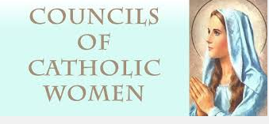
Scholarships will be presented to the recipients at the Council’s Annual Scholarship Banquet on May 8, 2018.

