Bl. Chiara Badano  
**Birth Name**: Chiara Luce Badano  
**Country of Origin**: Italy  
**Feast Day**: October 29  
**State of Life**: Lay woman, athlete, student  
**Patron Saint Of**: Athletes, young people, those suffering from illness  
**Lifespan**: October 29, 1971 – October 7, 1990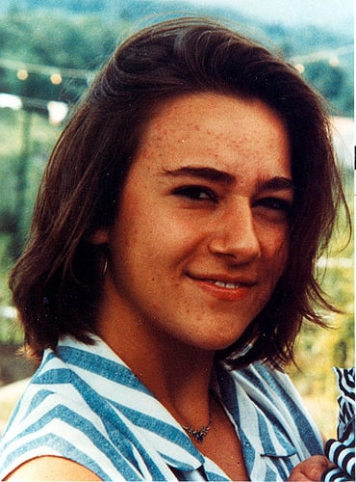

Chiara was born on October 29, 1971 in a small town in northern Italy, to Ruggero and Maria Teresa Badano, who had longed to have a child for many, many years. Chiara was a loving and exuberant child, and, despite her headstrong and sometimes defiant temperament, had a close relationship with them. Chiara was a supremely ordinary teenager: she loved sports, such as tennis and swimming. She loved hiking, and she loved listening to pop music and dancing with friends.

When she was sixteen, Chiara felt a sting in her shoulder when she was playing tennis. At first, she thought it was simply fatigue or tendinitis. But, as the pain persisted, Chiara underwent a series of tests and discovered she had a rare form of bone cancer. When she entered treatment for the cancer, Chiara refused all morphine. She wanted to have a lucid mind to understand what was happening to her. Chiara embraced her sufferings as an opportunity to offer up her life more radically for Christ. For the next two years, Chiara underwent difficult chemotherapy and slowly prepared herself for death as operations failed to slow down her cancer and as she eventually lost both hope of remission and the ability to walk.

Chiara offered up everything—her disappearing hair, her pain, and her sadness at leaving her parents—to Christ. In the hospital, as she prepared for an operation, Chiara described her heart as "filled with an immense joy and all fear left me. In that moment, I understood that if we're always ready for everything, God sends us many signs of his love." Chiara continued to be a bright light of faith and joy for the doctors, for fellow patients, for her friends, and for her devastated parents. Chiara died after receiving the sacraments, surrounded by the prayers of her families and friends, on October 7, 1990. Chiara's great love for others spilled over into their great love for her—thousands of people attended Chiara's funeral, effectively shutting down her small hometown of Sassello. Chiara was declared a blessed on September 25, 2010, in Rome, and her feast day has been celebrated on October 29 since then.

Bl. Laura Vicuña  
**Country of Origin**: Chile  
**Feast Day**: January 22  
**State of Life**: Lay woman, student  
**Patron Saint Of**: Young people, those with difficult family situations  
**Lifespan**: May 5, 1891 – January 22, 1904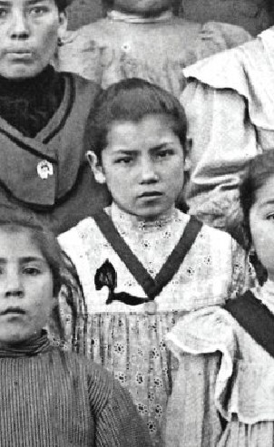

Laura was born in Santiago, Chile, in 1891. Laura's father died suddenly when she was still just a small child. Mrs. Vicuna, with her two daughters, sought refuge in Argentina. In 1900, the Salesian Sisters welcomed Laura Vicuña into their school. The following year, Laura made her First Communion, and like St. Dominic Savio, she took the resolution to love God with her whole heart, to mortify herself and to die rather than sin. Laura wanted to make Jesus known and make reparation for the offenses Jesus receives. When Laura realized that her mother was living in a sinful situation, she offered her life to God for her mother's conversion.

Fr. Crestanello, the first to write a biography of Laura Vicuña, tells us, "Laura suffered secretly in her heart... One day she decided to offer her life and to accept death willingly, in exchange for the salvation of her mother. She begged me to bless this ardent desire of hers. I hesitated for a long time." Laura grew in virtue and, with the consent of her confessor, privately vowed to live the three vows professed by religious Sisters, poverty, chastity, and obedience. She died of illness in Junin de los Andes, Argentina, on January 22, 1904.

During Laura's last night, she confided to her mother: "Mommy, I am dying! I asked this of Jesus, some time ago, and offered my life to Him for you, that you might return to God... Mommy, will you give me that joy before I die?" On the day of Laura's funeral, her mother returned to the Sacraments and began a new life. St. Pope John Paul II beatified Laura Vicuña and proposed her as a model of evangelical courage, to the point of giving one's life, for the mission of salvation.

Bl. Marie-Clementine Anuarite Nengapeta  
**Birth Name**: Anuarite Nengapeta  
**Country of Origin**: Congo  
**Feast Day**: November 1  
**State of Life**: Religious sister  
**Patron Saint Of**: The Congo, those who suffer from violence  
**Lifespan**: March 29, 1939 – November 1, 1964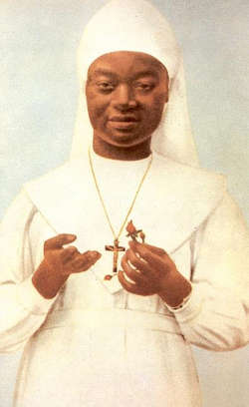

Blessed Marie-Clémentine Anuarite Nengapeta was a religious sister from Congo who was killed by invading rebels fighting the 1964 civil war. Anuarite Nengapeta was born in Congo in 1939, and was educated in the first mission in her region of Africa. When she entered the religious community of the Holy Family Sisters in 1959, she took the name Sister Marie-Clementine. Five years later, civil war broke out across Congo. Rebels opposed foreign influence in the nation, and even suspected religious men and women who were native to Congo because they thought they cooperated with western powers.

In 1964, the Holy Family Sisters convent was attacked by rebels. The rebel commander, Colonel Pierre Olombe, assaulted Sister Marie-Clémentine and attempted to rape her. Before being bayoneted and shot, she managed to proclaim, “I forgive you for you do not know what you do.” When Pope St. John Paul II visited Zaire in 1985, he beatified Marie-Clémentine Anuarite Nengapeta. Among the crowd was Olombe, the colonel who had killed her.

After the civil war, Olombe was condemned to death and spent five years in prison before being pardoned by the new president. He was also educated by missionaries, and returned to his Catholic faith when he was released from prison. When the pope made his visit, a newspaper editor found Olombe, who had become a wandering beggar, and shared with the pope the man’s desire for forgiveness. Sister Nengapeta’s parents had already declared their forgiveness for the man, and they sat next to the pope during her beatification Mass when the pope said, “And I myself, in the name of the whole church, I forgive with all my heart."

Our Lady of Fatima  
**Country of Apparition**: Portugal  
**Feast Day**: May 13  
**State of Life**: Marian Apparition  
**Patron Saint Of**: Portugal, those seeking peace and conversion  
**Dates**: Apparitions occurred in 1917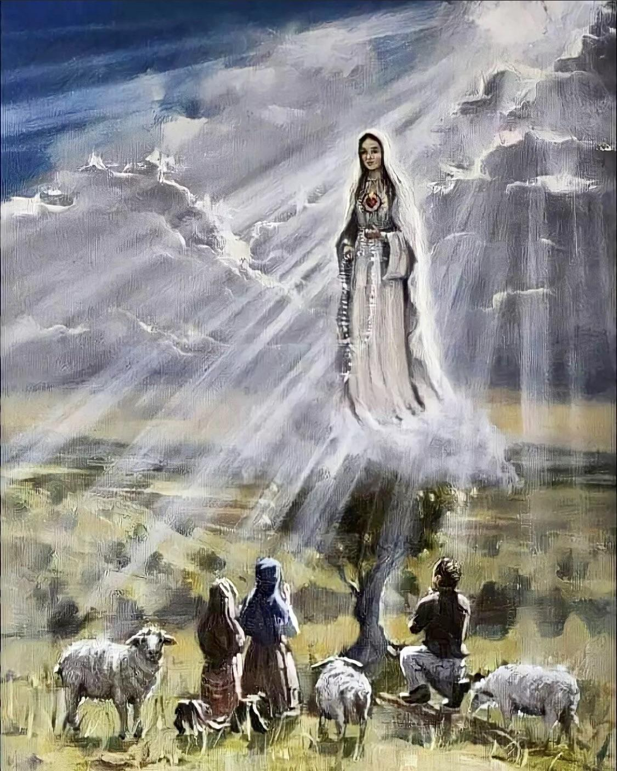

In the middle 1917 in Portugal, three children were tending sheep in a pasture near the poor village where they lived. The oldest, Lucia, 10, was in charge, and Francisco and Jacinta—brother and sister—helped. Several times during that summer, they were visited by an angel while they were in the fields, and the angel taught them a prayer to the Trinity. On May 13, 1917, a bolt of lightning caught their attention as they tended the sheep. When they looked in that direction, they saw a brilliant figure, a woman described by Lucia as “brighter than the sun, shedding rays of light clearer and stronger than a crystal ball filled with the most sparkling water and pierced by the burning rays of the sun.”

The lady, Mary, asked the children to pray for the conversion of sinners and for an end to the war (World War I) which was devastating Europe at the time. On the day of Mary’s last appearance, a crowd nearing 70,000 gathered with the children to witness the appearance, though only the children could see Mary. In her first appearance, Mary told the children that they would witness a sign in the heavens during that last visit, and the whole crowd saw the phenomenon: the sun seemed to dance in the sky and fall towards the earth.

Mary also shared three “secrets” with the children that have been revealed over time. In the first secret, the children witnessed a vision of hell. In the second, Mary asked for the conversion of sinners, and especially communist Russia, and told of another phenomenon in the heavens that would precede a second great war. (In the month before Hitler seized Austria, an occurrence of the aurora borealis covered most of Europe—it was the widest display in 200 years.) The third secret told of a vision in which the children saw a figure like the pope killed by soldiers. Pope John Paul II interpreted the secret to refer to his survival of an assassination attempt (on May 13, the same day as the first apparition), and to the many persecutions and wars of the 20th century.

Our Lady of Guadalupe  
**Country of Apparition**: Mexico  
**Feast Day**: December 12  
**State of Life**: Marian Apparition  
**Patron Saint Of**: Mexico, the Americas, and the unborn  
**Dates**: Apparitions occurred in 1531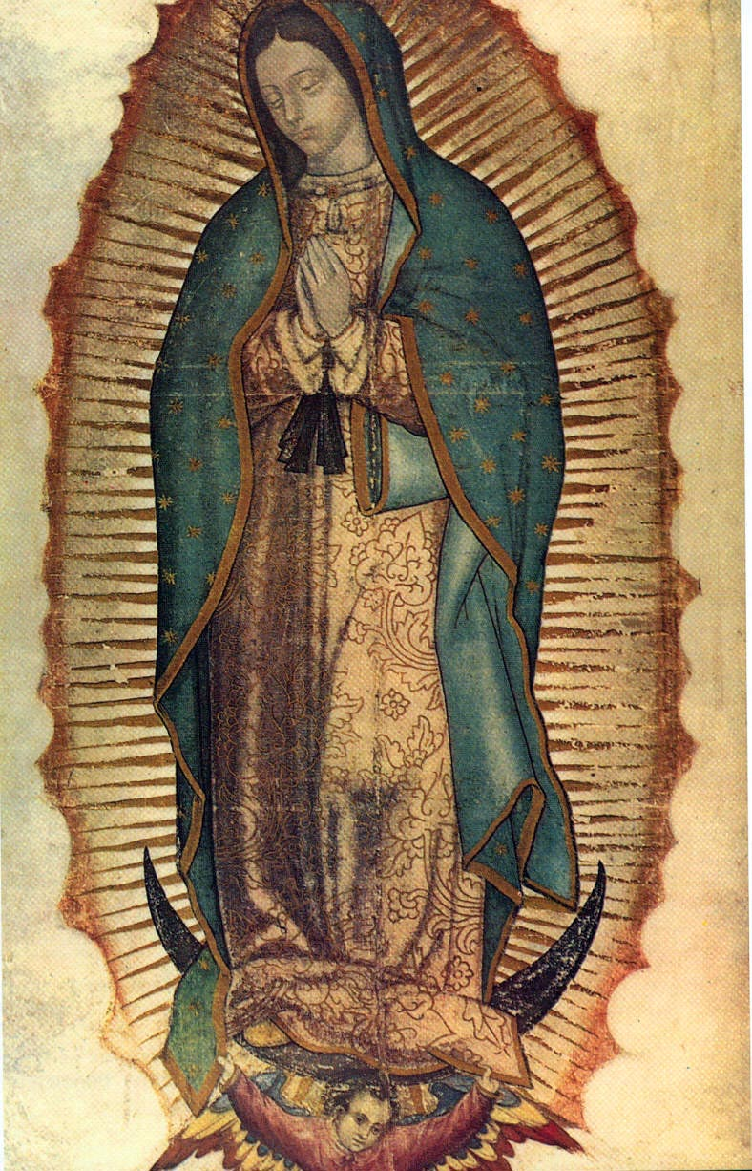

In December of 1531, a poor native Aztec Indian named Juan Diego was walking through the hills outside of Mexico City on his way to Mass. He heard sweet music and a woman’s voice calling his name from a hill called Tepeyac. Juan Diego climbed the hill and found a woman who looked like she was also Aztec and dressed in traditional Aztec clothing. She identified herself as the Virgin Mary and instructed Juan Diego to tell his bishop to build a shrine on Tepeyac hill to encourage faithfulness in the people of Mexico City.

When he heard Juan Diego's request, the bishop was skeptical and asked for a sign. When Juan Diego went back and gave this message to Mary, she told him to go to the top of Tepeyac hill and pick the roses he would find there. Juan Diego gathered the roses in his tilma, a cloak-like a poncho, and Mary arranged the flowers and told him to take them to the bishop. When Juan showed the bishop the roses, they saw that an image of Mary was left upon Juan’s cloak. The bishop was immediately convinced and built a shrine on Tepeyac. Soon, some 8 million people had come to the faith because of Mary’s apparition.

Juan Diego’s tilma was framed and kept in the shrine. It was made of a rough material from cactus and should have decayed within a few decades, but 500 years later is still an object of wonder for millions of pilgrims today. (Recent analyses have revealed that recorded in the image of Mary's iris there are small images of Juan Diego himself, which further indicates its supernatural origin.) Our Lady of Guadalupe was declared patroness of the Americas. And, as, in the image of Guadalupe, she is portrayed as an expectant mother (her pregnancy is indicated by the high-waisted black sash) she is depicted as pregnant with Jesus, she is also the patron of the Right to Life movement.

Our Lady of Kibeho  
**Country of Apparition**: Rwanda  
**Feast Day**: November 28  
**State of Life**: Marian Apparition  
**Patron Saint Of**: Rwanda, those seeking reconciliation and peace  
**Dates**: Apparitions occurred in 1981-1989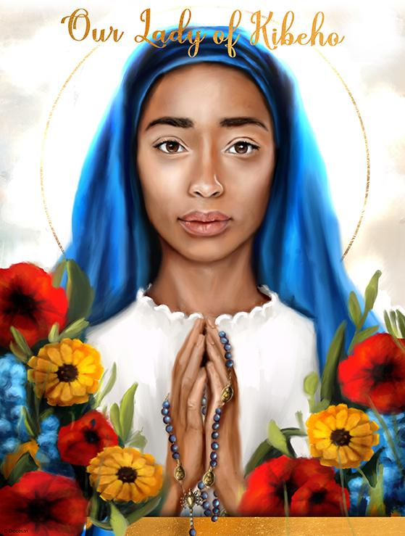

On Nov. 28, 1981, Our Lady appeared in Kibeho, Rwanda, with messages not only for that small African country but for the whole world. The Mother of God appeared first to 17-year-old Alphonsine Mumureke, who was alone in the dining room of Kibeho High School, a Catholic boarding school founded by a parish priest and run by the Benebikira Sisters. The teen had arrived at the school that October. Our Lady identified herself: “I am the Mother of the Word” (*Nyina wa Jambo*). She later explained it was synonymous to *Umubyeyl W'iamna*, “Mother of God.”

As has happened in other approved apparitions, the school community did not believe Mumureke at first. Still, she pressed her schoolmates to ask the Blessed Mother to enlighten them and to appear to some of them, too. Two months later, in January 1982, Our Lady also appeared to another student, 20-year-old Nathalie Mukamazimpaka. Then, in March, Mary began appearing to a third student, 21-year-old Marie Claire Mukangango. This was quite significant because, as Bishop Augustine Misago of the Diocese of Gikongoro, later noted in his declaration of the authenticity of the apparitions, Marie Claire at first “had been well known for her strong opposition to the apparitions. This new development was immediately interpreted by some as a positive sign coming from heaven to all the double-minded who were reluctant to take the apparitions Alphonsine spoke about seriously.”

Bishop Misago also noted that Our Lady repeatedly told Mumureke to repeat to the people: “Faith and unbelief will come unseen.” The bishop also recorded, “‘Pray always for the Church, when many troubles are upon it in the times to come.’ Thus Mary said to Alphonsine on Aug. 15, 1983, and on Nov. 28, 1983.” Bishop Misago added that it “proved to be prophetic” because of the genocide that took place, beginning in 1994. Being our loving Mother, Our Lady constantly gave the Kibeho visionaries the antidote, the perfect cure with simple motherly directives to change dire events. Our Lady said, “Pray the Rosary as my children. Pray together. Make prayer groups to give each other strength. Every day pray the Rosary.

Our Lady of Lourdes  
**Country of Apparition**: France  
**Feast Day**: February 11  
**State of Life**: Marian Apparition  
**Patron Saint Of**: The sick, those seeking healing  
**Dates**: Apparitions occurred in 1858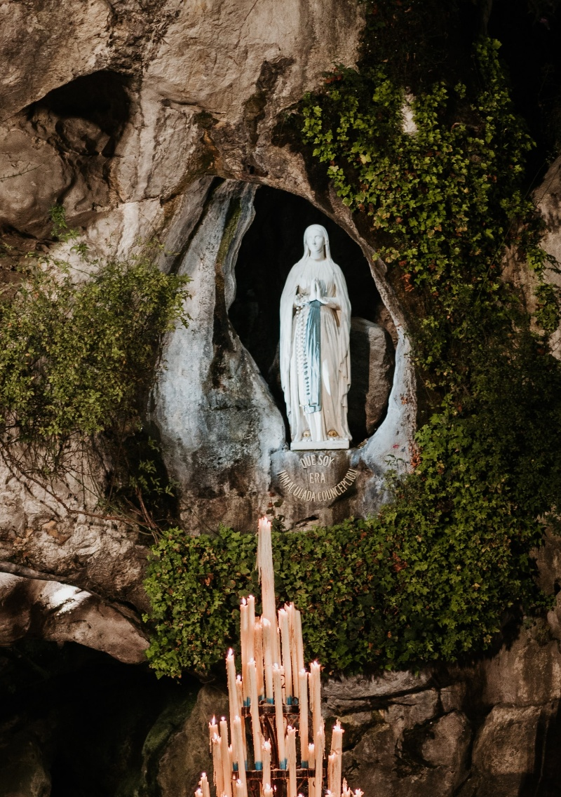

On February 11, 1858, a poor 14-year-old shepherd girl named Bernadette Soubirous was collecting firewood near Lourdes, France. She saw a bright light, and Mary appeared before her in a natural hollow of rock in a cave on the shore of a river.

Mary appeared with a youthful face, and she wore a white garment with a blue belt and carried a rosary. Over the course of 18 appearances, she identified herself as the Immaculate Conception. Mary told Bernadette to drink from a spring within the cave and to tell Church authorities to build a shrine on the site.

Since those appearances, more than 200 million pilgrims have visited Lourdes, many reporting cures from the miraculous spring. The Lourdes Medical Bureau has confirmed 70 official miracles of complete physical healing resulting from the intervention of God with the intercession of Our Lady of Lourdes, as well as countless other physical, mental/emotional, and spiritual healings through her intercession.

Servant of God Julia Greeley  
**Country of Origin**: United States  
**Feast Day**: TBD  
**State of Life**: Lay woman  
**Patron Saint Of**: TBD  
**Lifespan**: December 24, 18335 – June 7, 1918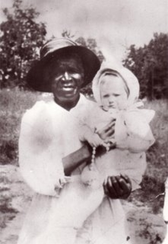

Julia Greeley was born in captivity in Hannibal, Missouri. The dates given for her birth range from 1835 to 1855. She lost eyesight in one of her eyes when a slavedriver's whip cut her face across her eye. She was emancipated at the end of the Civil War in 1865. After being employed in St. Louis as a maid, Julia Greeley arrived in the city of Denver to work for a wealthy widow Mrs. Dickerson. Mrs. Dickerson was a former Washington D.C. socialite who married Colorado's first governor, William Gilpin. Julia began working with Mrs. Dickerson and her family in 1879 and was a kind and caring housekeeper for the family.

In 1880, Julia was received into the Catholic Church at Sacred Heart Church in Denver. Quickly, Julia became a fixture of charity in the community. She worked for many different families in the community with love and maternal care. When not working, Julia begged and obtained mattresses, baby carriages, food, and other items for families who needed them. She delivered them at all hours of the day and night. No one who ever asked Julia Greeley for help was ever turned away.

Julia fasted frequently and received communion daily at Denver's Sacred Heart church. She loved to visit the many convents of religious sisters around Denver, and they had an open door policy for her. In 1901, Julia became a member of the Third Order of St. Francis. Her imitation of Francis was beautifully evident in her love of giving to others. On June 7, 1918, the feast of the Sacred Heart, Julia died in Denver. She had given away her burial plot to a man who was going to be buried in a pauper's grave. In repayment, Julia was buried in her Franciscan habit and laid in state in Sacred Heart Church. In 2017, Julia's body was exhumed and buried in Denver's Cathedral of the Immaculate Conception. She is one of six Black Americans, who is on the path towards officially being recognized as saints in the Roman Catholic Church.

Servant of God Mary Lange  
**Birth Name**: Elizabeth Clarisse Lange  
**Country of Origin**: Haiti, Dominican Republic, or Cuba  
**Feast Day**: TBD  
**State of Life**: Religious sister, foundress of religious order  
**Patron Saint Of**: TBD  
**Lifespan**: circa 1784 – February 3, 1882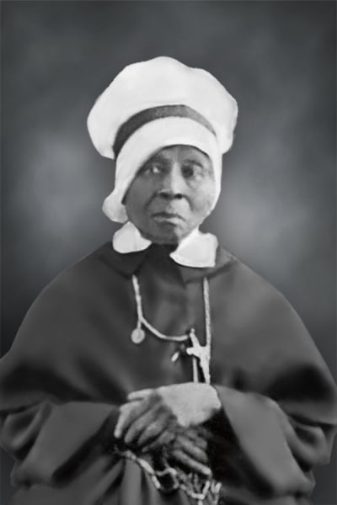

We do not know very much about Elizabeth Lange’s early life. Recent research points to Santiago de Cuba as her birthplace. Most likely she grew up in the French speaking area of the city. Because she was well educated we believe that she came from a family of some means and social standing. In the early 1800’s young Elizabeth left her home country to seek peace and security in the United States. Providence directed her to Baltimore, Maryland, where great influxes of French-speaking Catholic refugees from the Haitian Revolution were settling.

By 1813 Elizabeth Lange was living in Baltimore. She was a courageous, loving and deeply spiritual woman. She came as a strong, independent thinker and doer. It did not take Lange long to recognize that the children of her fellow Caribbean immigrants needed education. She was determined to respond to that need in spite of being a black woman in a slave state long before the Emancipation Proclamation. She used her own money and home to educate children of color. Elizabeth, with a friend, Marie Magdelaine Balas, offered free education to children in their home in the Fells Point area of the city.​

Early in 1828 she started a school for girls of color as well as the first religious order of women of African heritage, though black men and women could not aspire to religious life at that time. God provided a way! Elizabeth, founder and first superior of the Oblate Sisters of Providence, henceforth was known as Sister Mary. She served as superior general, helped to nurse the sick during the Cholera Epidemic, worked at Saint Mary’s Seminary, and was the novice mistress. Mother Mary Lange practiced faith to an extraordinary degree. In fact, it was her deep faith which enabled her to persevere against all odds. To her black brothers and sisters she gave of herself and her material possessions until she was empty of all but Jesus, whom she shared generously with all by being a living witness to his teaching. In close union with her God, she lived through disappointment and opposition until God called her to himself February 3, 1882. .

Servant of God Thea Bowman  
**Birth Name**: Bertha Bowman  
**Country of Origin**: United States  
**Feast Day**: TBD  
**State of Life**: Religious sister, convert, professor  
**Patron Saint Of**: TBD  
**Lifespan**: December 29, 1937 – March 30, 1990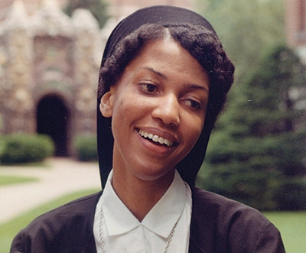

Sister Thea Bowman was born Bertha Bowman in Mississippi in 1937. Bertha's grandfather had been a slave before the Emancipation Proclamation, but her parents were both professionals: her father was a doctor and her mother taught. Bertha was raised in a vibrantly spiritual Methodist home, and she became attracted to the life of love and service that the religious sisters in her town led. With her parents' permission, young Bertha converted to Catholicism when she was just nine.

Bertha was enrolled in a Catholic School, which deepened her appreciation for the Catholic faith and for the sisters who taught her. When she was fifteen, Bertha traveled north to Wisconsin to join the order of the Franciscan Sisters of Perpetual Adoration in La Crosse. She attended college at Viterbo University in Wisconsin and then traveled to Washington D.C. to earn her master's degree and doctorate at the Catholic University of America. She finished her Ph.D. in 1972 and began to teach at CUA, then her alma mater of Viterbo, and Xavier University.

Sister Thea, as she became known as, worked diligently not only at education but on evangelization of Black American Catholics. The Church in the South had been wounded by the history of segregation and slavery. Sister Thea worked to create a hymnal that showcased Black spirituality and culture. She traveled across the American continent and even abroad to the Caribbean Islands and Africa to spread a ministry of joy—a ministry of proclaiming the joy of each culture's unique differences yet their unity in Christ. Sister Thea died on March 30, 1990. She is one of six Black Americans, including Julia Greeley and Venerable Pierre Toussaint, who is on the path towards officially being recognized as saints in the Roman Catholic Church.

St. Agnes Tsao-Kou Ying & Companions  
**Country of Origin**: China  
**Feast Day**: July 9  
**State of Life**: Wife, widow  
**Patron Saint Of**: The Chinese Catholic community  
**Lifespan**: 1911 – July 9, 1948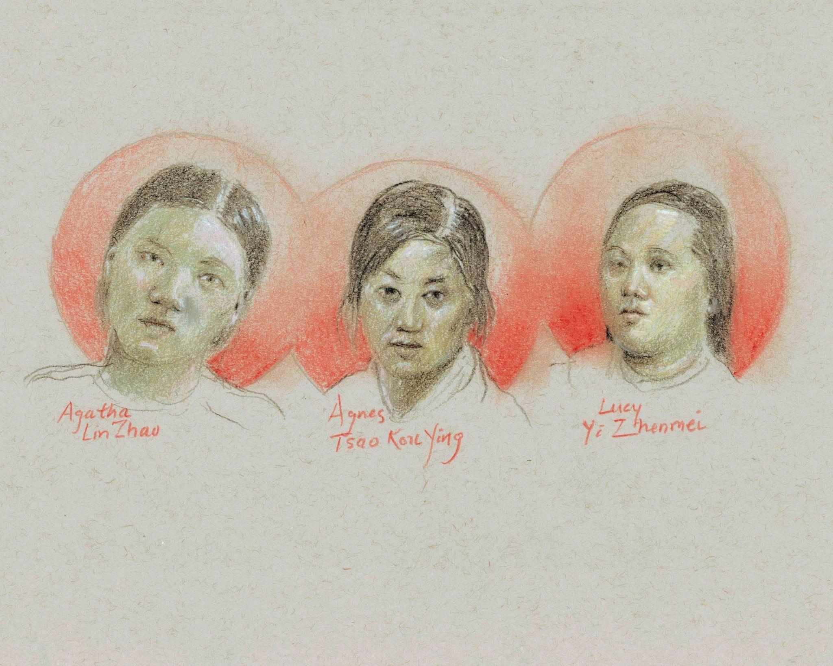

Agnes Tsao Kou Ying, Agatha Lin Zhao, and Lucy Yi Zhenmei were three lay catechists who were martyred in China in the mid-nineteenth century for refusing to renounce the Christian faith. Although Christians were persecuted at this time in large part because of the association between the Christian religion and imperial colonialism, all three of these women were raised within Chinese Christian families, and saw no conflict between their identity as Christians and their identity as Chinese women. All three were canonized by the Roman Catholic Church on October 1st, 2000.

Agnes Tsao Kou Ying was born in the small village of Wujiazhai in Guizhou Province in 1821. She was orphaned at a young age, and had to work to support herself. She married at age 18, but was treated poorly by her in-laws because they disapproved of her Christian faith. After only two years of marriage, her husband died, and she took shelter with an elderly Christian widow who taught her more about the faith. In 1852, the missionary priest Fr. Auguste Chapdelaine heard of her education in the scriptures and in Christian doctrine, and he invited her to accompany him to the province of Guangxi in order to catechize women and children there. After four years of this work, however, they were both arrested and tortured to death. Agnes Tsao Kou Ying died on January 22nd, 1856.

St. Catherine of Siena  
**Birth Name**: Catherine Benincasa  
**Country of Origin**: Italy  
**Feast Day**: April 29  
**State of Life**: Religious sister  
**Patron Saint Of**: Italy, nurses, those who suffer from illnesses  
**Lifespan**: March 25, 1347 – April 29, 1380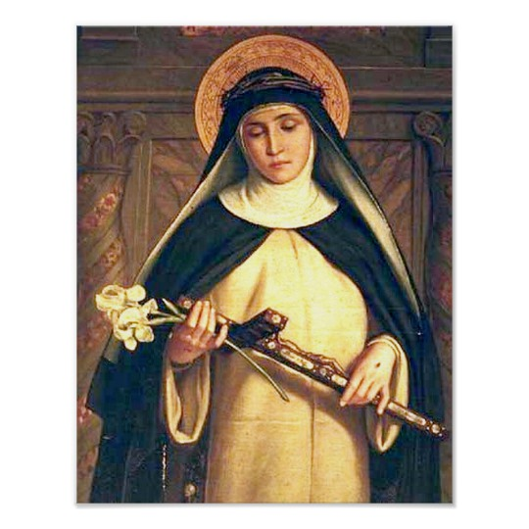

Catherine, from the time she was a child, had an extraordinary and mystical sensitivity to the divine. It was this dynamic relationship with God that propelled her to become one of the greatest female saints we honor. She was born in 1347 in Siena, Italy, the 23rd child of Jacopo and Lapa Benincasa. At the age of 6, she received a vision in which Jesus reached out and blessed her. This encounter encouraged her to give her life to God, and even as a child, she would spend much time alone in prayer.

As she grew into adulthood, her prayer life became even more intense. She would receive tremendous consolations in prayer, but also fierce temptations. At times, God would seem altogether absent, but would always be revealed to be with her in hidden ways. Her life was marked by several visions and manifestations when she was visited by the Lord.

She spent her energy caring for the sick, and took on especially difficult patients. When an outbreak of the plague struck Italy, Catherine cared for the sick and dying, and buried the dead, with great compassion. She became so well-known for her holiness and compassion that many people started to seek her out for wisdom and advice. Three priests were assigned to her so that they might hear the confessions of all of those who were converted to change their lives after speaking with her.

Her counsel was also sought amidst the division in the Church when the papacy was split between Rome and Avignon, France, during that period of history. She spent the last part of her life working to heal this division. Catherine has been declared a doctor of the Church, a title given to 37 saints who are known for elucidating the faith by their words or example.

St. Cecilia  
**Country of Origin**: Italy  
**Feast Day**: November 22  
**State of Life**: Lay woman  
**Patron Saint Of**: Musicians, singers  
**Lifespan**: c. 200 – c. 230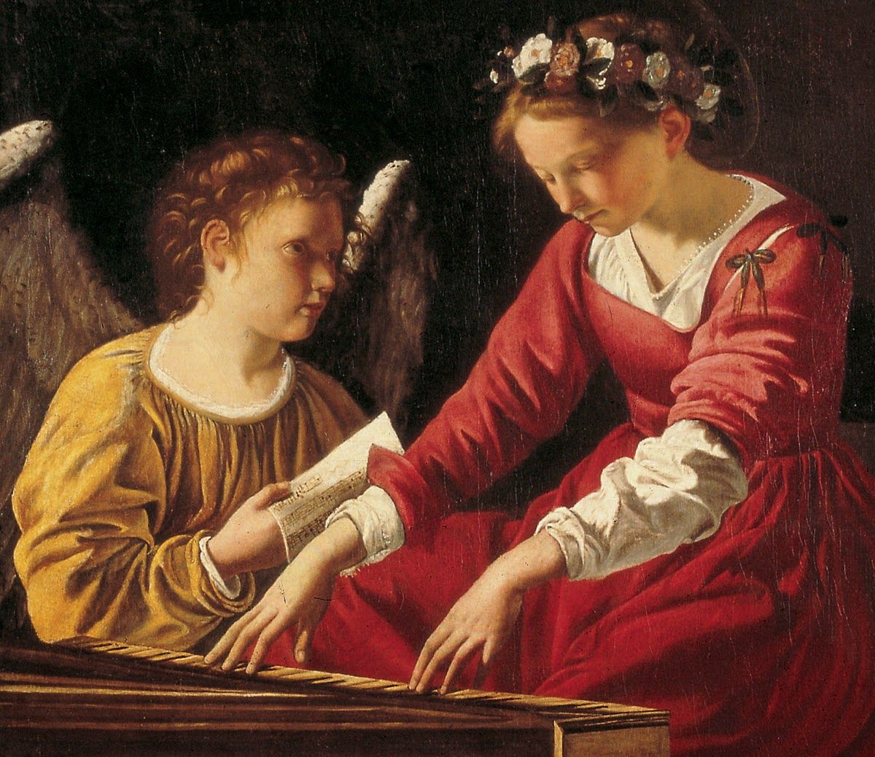

St. Cecilia was one of the most famous virgin martyrs of the early church and historically one of the most discussed. She is a patron saint of music and of musicians.

According to a late 5th-century legend, she was a noble Roman who, as a child, had vowed her virginity to God. When she was married against her will to the future saint Valerian, then a pagan, she told him that an angel of God wished her to remain a virgin. He promised to respect this wish if he were allowed to see the angel. She replied that he would if he were baptized. On his return from baptism he found Cecilia talking to the angel. She then converted his brother Tiburtius, who also saw the angel. The brothers devoted themselves to burying the martyrs slain daily by the prefect of the city, Turcius Almachius, and were arrested for this. Both men were martyred for their faith in about 230, under the emperor Alexander Severus. Cecilia distributed her possessions to the poor, which enraged the prefect Almachius, who ordered her to be burned. When the flames did not harm her, she was beheaded.

Cecilia was buried in the catacomb of St. Callistus, near Rome. At the beginning of the 9th century, Pope Paschal I discovered her incorrupt (undecayed) relics in the catacomb of St. Praetextatus and had them moved to Rome, to a basilica in Trastevere that now bears her name. According to tradition, she “sang in her heart to the Lord” as the musicians played at her wedding, and in art she is often represented playing the organ.

St. Dymphna  
**Country of Origin**: Ireland  
**Feast Day**: May 15  
**State of Life**: Lay woman  
**Patron Saint Of**: Those suffering from mental illness, anxiety, and neurological disorders  
**Lifespan**: c. 7th century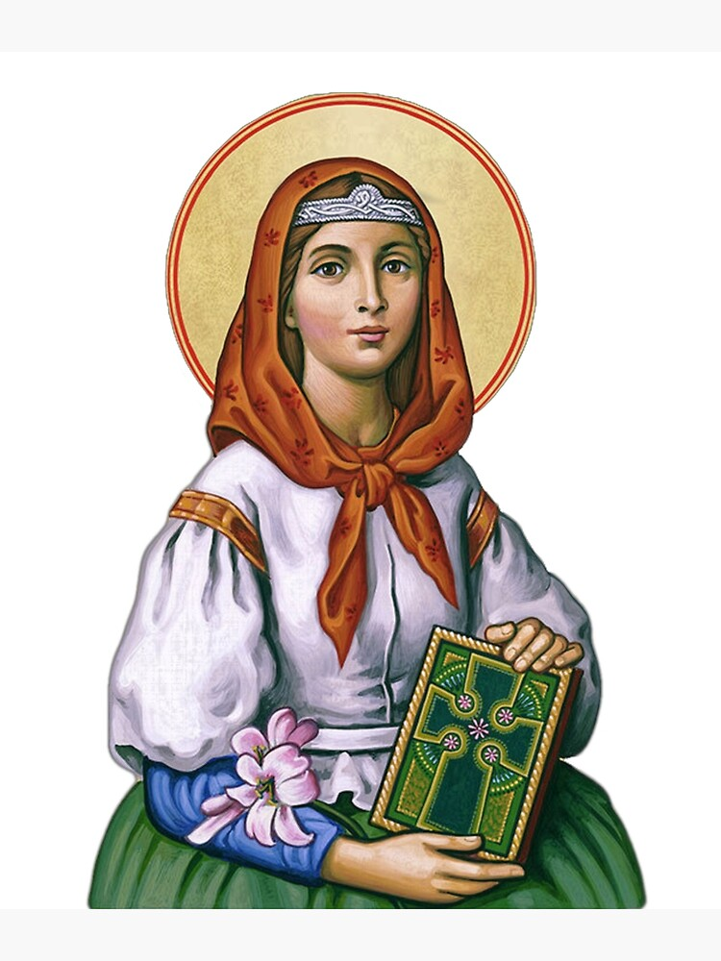

In the 13th century, two ancient marble tombs were discovered in a city near Antwerp, Belgium. Buried inside were the bodies of two saints: St. Dymphna and St. Gerebernus. When the relics of these two saints became known to the city, a number of healings were attributed to their intercession. Those suffering from epilepsy and mental illness suddenly found health through prayer to these saints.

Little is known of these saints, so popular belief filled in their history. It is thought that Dymphna was daughter to an Irish tribal king and a Christian princess, who baptized the girl and raised her as a Christian. When Dymphna was a teenager, her mother died, leaving her father beside himself with grief. He searched the civilized world for a woman who looked like his deceased wife, but found none. Dymphna’s own beauty reminded him of his wife, and he made an advance upon Dymphna, but she escaped.

Her spiritual advisor was an old priest and family friend named Gerebernus. He advised her to leave the country, so together they fled to Belgium and found a small chapel near Antwerp. They decided to live there, both adopting a life of solitude and prayer. They did not know that Dymphna’s father was pursuing them. He searched the countryside for his daughter, and finally caught wind of where she might be hiding. He discovered them and tried to convince them to return to Ireland. When they refused, he killed both Dymphna and Cerebernus.

St. Gemma Galgani  
**Country of Origin**: Italy  
**Feast Day**: April 11  
**State of Life**: Lay woman  
**Patron Saint Of**: Students, those suffering from physical or emotional pain, those with parents who have died  
**Lifespan**: March 12, 1878 – April 11, 1903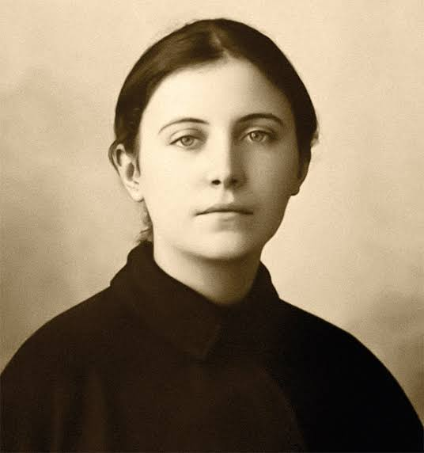

St. Gemma Galgani, also known as the Flower of Lucca, was an Italian mystic often referred to as the "Daughter of Passion," for her intense replication of the Passion of Christ. Gemma (meaning “gem”) was the first, girl child born to the traditional, Catholic Galgani family on March 12, 1878, near Lucca. Inspired by her mother’s teachings, Gemma developed a love for Jesus and a strong devotion to prayer at a very young age. Little Gemma lost her mother when she was only eight years old. It was after this tragic event that Gemma’s father sent her to a Catholic boarding school run by the Sisters of St. Zita, which she described as “paradise.” When she was only 19 years old, her father passed away. Gemma was left orphaned and without any means of support. Soon after this event, Gemma experienced a long and serious illness. As her condition worsened, she developed spinal curvature and even paralysis. It was believed that no medical remedy could cure her.

With hopes of a miracle, one of the sisters gave Gemma a novena card along with the story of the life of the young Passionist, Gabriel Possenti. On her deathbed, Gemma fervently prayed to him. During the prayers of the Novena, Gabriel appeared to Gemma. Gabriel told her that she would be blessed with a cure and that a special grace was being prepared for her.

The miracle of a cure came on March 2, 1899. Then, on the evening of June 8, 1899, while she prayed with Jesus in his sufferings, the Blessed Mother appeared to Gemma and spoke of the grace she was to receive. During the remainder of Gemma’s life, many witnessed this recurring miracle of the holy stigmata. Soon after this extraordinary blessing, Gemma met the Passionist missionary, Father Cajetan. He listened to her miraculous story and allowed her to take private vows. Gemma had a profound, prayerful life, and experienced many mystical visions. Our Lord called Gemma home on Holy Saturday, April 11, 1903. Pope Pius XII canonized Gemma Galgani in 1940.

St. Gianna Beretta Molla  
**Birth Name**: Gianna Beretta  
**Country of Origin**: Italy  
**Feast Day**: April 28  
**State of Life**: Wife, mother, physician  
**Patron Saint Of**: Mothers, physicians, unborn children  
**Lifespan**: October 4, 1922 – April 28, 1962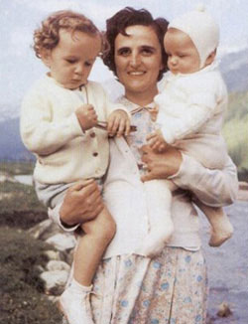

Gianna was born in Magenta (Milan), Italy, the 10th of 13 children. As a young girl she received the gift of faith and Christian education from her parents. She experienced life as a gift from God, had a strong faith in Providence and was convinced of the necessity and effectiveness of prayer. She diligently dedicated herself to her studies, while also applying her faith in generous apostolic service among the elderly and needy. After earning degrees in medicine and surgery, she opened a medical clinic specializing in pediatrics, and gave special attention to mothers, babies, the elderly, and the poor.

While working in the field of medicine—which she considered a "mission" and practiced as such—she increased her generous service to Catholic Action, especially among the "very young" and, at the same time, expressed her love of creation through skiing and mountaineering. Through her prayers and those of others, she reflected on her vocation, which she also considered a gift from God. Having chosen the vocation of marriage, she embraced it with complete enthusiasm and wholly dedicated herself "to forming a truly Christian family."

She became engaged to Pietro Molla and was radiant with joy during the time of their engagement. They were married and then welcomed three children. She balanced the demands of mother, wife, doctor and her passion for life with remarkable peace. In September 1961, towards the end of the 2nd month of her 4th pregnancy, she had developed a fibroma in her uterus. Before the required surgical operation, and conscious of the risk that her continued pregnancy brought, she pleaded with the surgeon to save the life of her unborn child and entrusted herself to prayer. A few days before the child was due, she was ready to give her life in order to save that of her child: "If you must decide between me and the child, do not hesitate: choose the child—I insist on it. Save the baby." On the morning of 21 April 1962 Gianna Emanuela was born. Despite all efforts and treatments to save both of them, on the morning of 28 April, amid unspeakable pain and after repeated exclamations of "Jesus, I love you. Jesus, I love you," the mother died. She was 39 years old.

St. Helena  
**Country of Origin**: Turkey  
**Feast Day**: August 18  
**State of Life**: Wife, mother, empress  
**Patron Saint Of**: Archaeologists, those who find the cross  
**Lifespan**: c. 248 – August 18, 330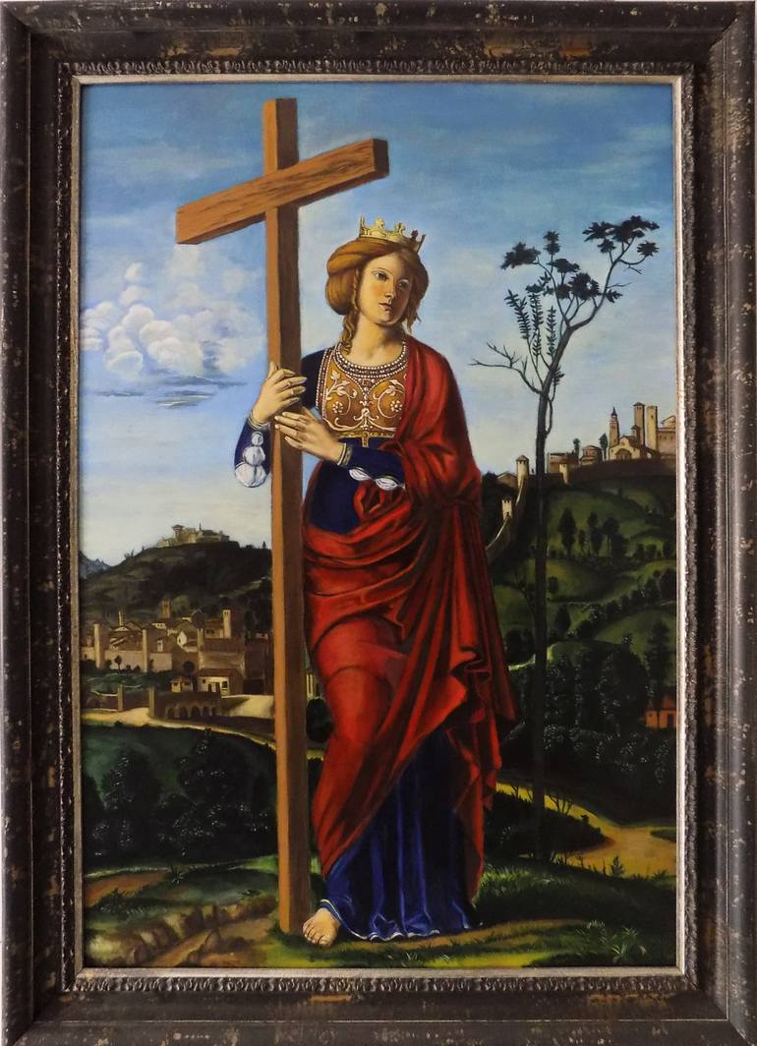

St. Helena was the daughter of an inn-keeper. In about 270, the Roman general Constantius Chlorus met her at her family’s inn and married her. When he was made caesar, he was influenced to divorce her; by that time, Helena had already given birth to a son, Constantine. When Constantius died, Helena’s son, Constantine, was acclaimed caesar by the army. Later, he was declared emperor, and in 313 issued the famous Edict of Milan, which ceased the persecution of Christians. At about this time, Helena converted to the faith. Though she was 63 when she joined the Church, she had great zeal—it seemed as though she were making up for lost time. She wore simple, plain clothes to attend Mass at churches in Rome and supported the poor liberally with the resources at her disposal.

When Constantine’s power spread eastward, Helena visited Palestine to see the places where Jesus lived and died. She wanted to find those places and objects that were sacred to Christians and to preserve them for later generations. She is credited with finding the “true cross” on which Jesus was executed, and she built churches in Bethlehem, on the Mt. of Olives, and over the tomb of Jesus.

She spent the remainder of her life in the Holy Land—praying and supporting the Church there. She continued to live humbly, and when she met pilgrims, she showed them the greatest reverence—even serving them at table and washing their hands. She used her position of power to support the poor and those who were suffering—wounded soldiers, mine workers, the imprisoned. She built churches and adorned many more. She died in 330.

St. Hildegard of Bingen  
**Country of Origin**: Germany  
**Feast Day**: September 17  
**State of Life**: Religious sister, poet, physician, political activist  
**Patron Saint Of**: Musicians, composers, and those involved in natural healing  
**Lifespan**: September 16, 1098 – September 17, 1179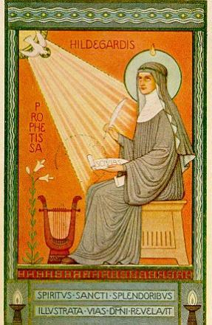

Born in 1098, Hildegard began to live with a hermitess near her parents' home when she was 8 years old. The woman educated the child Hildegard and, over time, gathered several other women into a community of religious sisters. Hildegard began to receive visions while enthralled in prayer, and she was granted the gift of seeing the future while in conversation with others. When the holy hermit woman who had educated her died, Hildegard was appointed the new leader of their monastic community.

She wrote a magnum opus that took ten years to complete, which included twenty-six visions describing God’s relationship to humanity through creation, Jesus’ suffering and death, and the Church, as well as apocalyptic warnings and hymns of praise. She wrote a number of hymns and songs for the community and composed extensive theological treatises on the beauty of sacred music.

Hildegard kept up active correspondences with leaders of nations and the Church, and she was not afraid to give harsh judgments when she deemed them warranted. In all of this, however, she made clear that she spoke from what she had received from God, not on her own authority.

Even though she suffered from chronic illness, she traveled throughout Europe and founded another monastery, while visiting and reforming many others. She continued to write prolifically, including works on natural history and medicine. She was known for a number of miracles during her lifetime. She died on September 17, in 1179, and miracles quickly began to be reported at her tomb. St. Hildegard of Bingen was declared a doctor of the Church quite recently in 2012 by Pope Benedict XVI. She was a poet, prophet, physician, and political advocate who fearlessly gave advice to popes and princes.

St. Jane Frances de Chantal  
**Birth Name**: Jeanne-Françoise Frémiot de Chantal  
**Country of Origin**: France  
**Feast Day**: August 12  
**State of Life**: Wife, mother, religious sister, foundress of religious order  
**Patron Saint Of**: Widows, the Visitation Sisters  
**Lifespan**: January 28, 1572 – December 13, 1641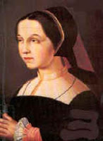

St. Jane Frances de Chantal was born in 1572 in France; her father was president of the parliament of Burgundy. At her Confirmation, Jane took the name Frances, and she married an officer in the French military whom she was deeply in love with when she was 20. The couple had seven children, three of whom died soon after birth. After eight years of marriage, her husband was shot in the thigh during a hunting accident. He survived for nine days, enduring painful surgeries from an incompetent doctor. When he died, Jane was left a widow at the age of 28.

Jane was devastated, and fell into depression for months until she was persuaded to carry on for the good of her children. She prayed that God would show her a holy guide who could help her discover what she was to do with the rest of her life. During one period of prayer, she had a vision of a man whom she did not know. Later, when she witnessed St. Francis de Sales preaching in her town, she recognized him as the man from her vision. She turned to him for direction, and he encouraged her to attend to her responsibilities—to pursue holiness in her role as mother and a woman in the world.

She kept a strict schedule, dedicating much time to prayer and the care and education of her children, and she also visited sick people who lived in her neighborhood, sometimes staying up the whole night to sit with them as they lay dying. When her children were teenagers, St. Francis encouraged Jane to establish a new religious community of sisters and helped her open a convent for the Sisters of the Visitation of Mary in 1610. Convents sprung up throughout France, 65 in all.

Jane experienced much grief and loss in her life. Nearly all of her children died before she did, and she grieved the death of her great friend and mentor, St. Francis de Sales. She was confronted with temptation and periods of dryness in prayer, and met many obstacles in her work. Through it all, she remained humble and faithful. She died at the age of 69 and was buried next to St. Francis de Sales in the original convent they established.

St. Joan of Arc  
**Birth Name**: Jeanne  
**Country of Origin**: France  
**Feast Day**: May 30  
**State of Life**: Lay woman, military leader  
**Patron Saint Of**: France, soldiers  
**Lifespan**: January 6, 1412 – May 30, 1431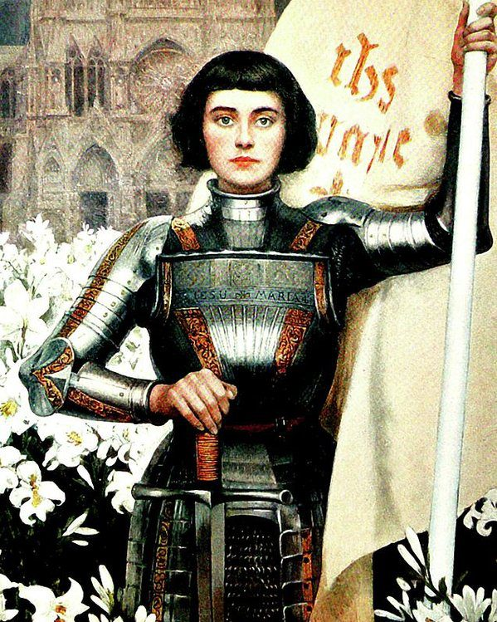

St. Joan of Arc was born to parents who were peasant farmers who lived in a small village in the Champagne region of France. She never learned to read or write, but was full of faith. “She was so good that all the village loved her,” her neighbors said of her. At the age of 14, she began hearing voices telling her she had a mission to save France. She began to recognize these voices as those of saints—Michael the Archangel, St. Catherine of Alexandria, and St. Margaret of Antioch. It was a time of civil war in France. The English had invaded, had displaced the French king, and threatened to conquer the whole nation.

When the voices would not go away, Joan presented herself to the local commander of the French army, but he laughed and sent her away. She returned and the commander softened his skepticism when a defeat that she had foretold actually came about. He sent her to King Charles VII, who received her in a large audience room, but disguised himself. She immediately identified him, and convinced him of her revelations. He had her examined by theologians, who found nothing objectionable, and she was sent to the head of the army in Orleans, a town under siege by the English. She marched into battle with a banner that proclaimed the names of Jesus and Mary. Within 10 days, the siege was broken. Even though she was wounded by an arrow, she pressed on with the army to other regions and routed her opponents. Her victory regained a bulk of the kingdom of France from the intruders, and concluded the mission that was entrusted to her by the voices she heard. She predicted all of these events before any of them happened.

She was captured and sold to England and was tried as a witch. She was questioned and examined tirelessly about the voices she heard, her faith, and the fact that she wore armor in battle to appear as a man. She had no one to counsel her, yet faced her inquisitors and accusers with courage and simple cleverness. They exploited her lack of education by trapping her with theological terms, and she was condemned and denounced. The authorities handed her over for punishment as a heretic if she refused to retract her statements. She stood her ground, even though she was threatened with torture, and was burned at the stake, still a teenager.

St. Josephine Bakhita  
**Country of Origin**: Sudan  
**Feast Day**: February 8  
**State of Life**: Religious sister  
**Patron Saint Of**: Sudan, survivors of human trafficking, those who suffer from abuse  
**Lifespan**: c. 1869 – February 8, 1947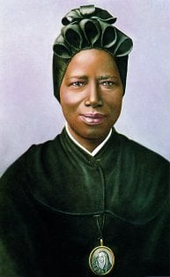

Josephine was born around 1869 in Darfur (now part of western Sudan). Her family was part of the powerful Daju people. Her uncle was the leader of their village, and Josephine was surrounded by a loving, prosperous family during her early years. When Josephine was eight, her life took a tragic turn when she was snatched by slave traders. The trauma of her abduction caused her to forget her own life. The traders gave her the ironic name Bakhita (from the Arabic word barak, meaning blessed), hoping her name suggesting good fortune and luck would attract potential buyers.

Bakhita was bought by an Arab to be a chambermaid for his daughters. She was treated well until one of her owner’s sons broke into a rage and beat her so severely she was unable to walk for over a month. Bakhita was sold to other owners who treated her with unspeakable, inhumane cruelty. In 1883, Bakhita was sold to a new, kinder owner—the Italian Consul to Sudan, Callisto Legnani. When he had to return to Italy, he brought Bakhita with him and gave her to the Michieli family. Bakhita was a faithful nanny to the Michieli family’s young daughter, and they went to stay with the Canossian Sisters in Venice while the rest of the family was away on business. While staying with the Canossians, Bakhita encountered Christianity the first time. The kind sisters instructed Bakhita in the Christian faith. When the Michieli family returned to bring back Bakhita to Sudan, Bakhita refused to go.

Shortly thereafter, Bakhita was baptized and received the new name of Josephine, and then became a Canossian sister. She was assigned to the convent in Schio and lived there forty-two years. When asked later by one of her students what she would do if she met one of her captors or former owners, Josephine responded: “If I were to meet those who kidnapped me, and even those who tortured me, I would kneel and kiss their hands. For, if these things had not happened, I would not have been a Christian and a religious today.” Immediately after her death on February 8, 1947, the people of Schio began to petition for the canonization of their beloved Madre Moretta or "little black mother." On October 1, 2000, Pope John Paul II canonized her.

St. Kateri Tekakwitha  
**Birth Name**: Tekakwitha  
**Country of Origin**: United States  
**Feast Day**: July 14  
**State of Life**: Lay woman  
**Patron Saint Of**: Native Americans, the environment  
**Lifespan**: January 22, 1656 – April 17, 1680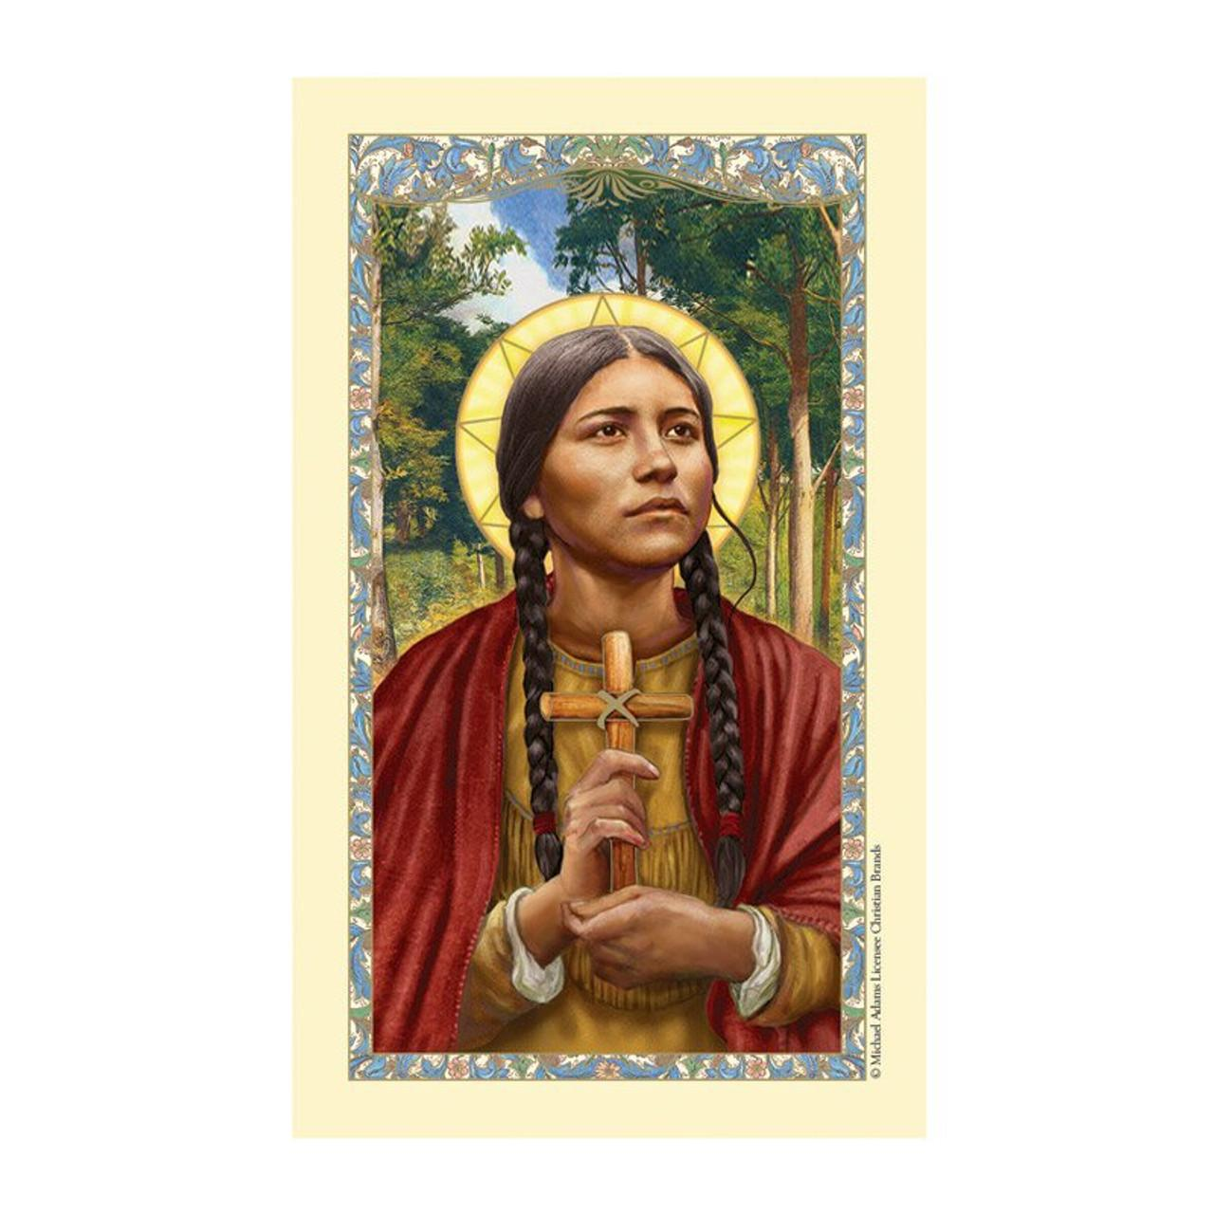

St. Kateri Tekakwitha was a Native American who was known as the “Lily of the Mohawks" for her purity and devotion. She was born in 1656 in what is now New York; her indigenous name is Tekakwitha. Her father was a Mohawk warrior, and her mother was an Algonquin who was captured and brought into the Mohawk tribe. When she was four years old, both of her parents and her brother died of smallpox. Tekakwitha survived the disease, which left scars on her face and damaged her eyesight; she was adopted by her extended family. As she grew up, she would avoid social gatherings because of her scars, and sometimes wore a shawl or veil over her face.

When she was 17, Tekakwitha’s family encouraged her to marry, but she refused. Soon after that, she met a Jesuit missionary and began learning about the Catholic faith. When she was 19, she was baptized, and took the name “Catherine,” or “Kateri,” after Catherine of Siena. Because of her faith, and her unusual reluctance to conform to traditional practices to marry, Kateri was shunned from her family and village. They ridiculed her, gave her difficult workloads, and threatened her. She left her home village to live in a Jesuit mission for Native Americans on the St. Lawrence River south of Montreal.

She continued to grow in the faith there, practicing rigorous mortifications. In 1679, Kateri formally dedicated her virginity to God, and encouraged a number of other women who felt the same calling. When she was 24, her health faltered, in part due to her zealous fasting and harsh bodily disciplines. Kateri died during Holy Week in 1680. She is reported to have appeared to several of her friends and family after her death, telling them that she was “on her way to heaven,” and a number of cures were reported by people who appealed to her help in prayer. St. Kateri was canonized in 2012 following a miracle in Washington State when a boy was cured of a flesh-eating bacterium through her intercession.

St. Katharine Drexel  
**Country of Origin**: United States  
**Feast Day**: March 3  
**State of Life**: Religious sister, foundress of religious order  
**Patron Saint Of**: Racial justice, the Sisters of the Blessed Sacrament  
**Lifespan**: November 26, 1858 – March 3, 1955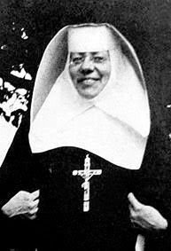

St. Katharine Drexel was born 1858 to a family of wealth in Philadelphia, PA —her father was an investment banker, and her uncle founded Drexel University. Her mother died giving birth to Katharine’s sister, and the girls were sent to live with an aunt and uncle for two years. They returned to her father’s home when he re-married. Despite their wealth, Katharine’s parents did not allow their girls a sheltered life. The family traveled widely, and Katharine saw much of the emerging American nation as well as Europe. Three days a week, their home was opened to feed the hungry and serve the poor with clothing and rental assistance. If they heard of a widow who was too proud to come to them, they quietly sought her out to offer their support.

When Katharine’s stepmother fell ill from a terminal illness, Katharine nursed her, and began to understand that no fortune could save a person from pain or death. She was particularly moved by the plight of Native Americans and African Americans, and on a trip to Europe, she had the chance to greet Pope Leo XIII. She asked him to send missionaries to help Native Americans in Wyoming. He replied, “Why don’t you become a missionary?” This response shocked her and helped her open up new possibilities as to how to spend her life.

She very easily could have married, but after discernment and spiritual direction, she decided to dedicate her life to serving Native American and African American people. Her decision made big news in the elite social circles of Philadelphia; newspapers wondered how she could walk away from married life and an inheritance worth more than $100 million in today's dollars—to serve poor people. Katharine founded a religious order of nuns—the Sisters of the Blessed Sacrament—to serve people marginalized by American society. By 1942, they were running schools and mission centers for black children in thirteen states and ministering to Native Americans in fifteen states. In 1915, Katharine opened Xavier University in New Orleans, the first Roman Catholic university in the nation that accepted black students.

St. Laura Montoya  
**Birth Name**: Laura Montoya Upegui  
**Country of Origin**: Colombia  
**Feast Day**: October 21  
**State of Life**: Religious sister, foundress of religious order  
**Patron Saint Of**: Colombia, indigenous people  
**Lifespan**: May 26, 1874 – October 21, 1949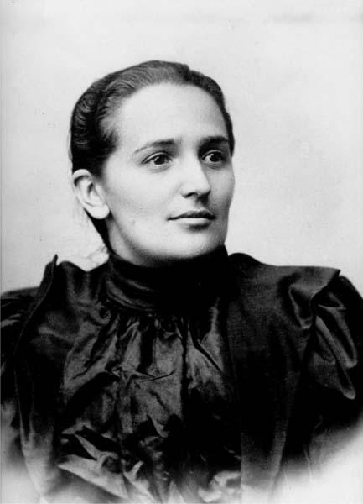

Laura Montoya Upegui was born in Jericó, Antioquia, Colombia, the second of three children to Juan de la Cruz Montoya and Dolores Upegui. When Laura was only 2 years old, her father was killed defending his Country, and the family was left in extreme poverty after all their goods were confiscated. At such a time of deep misery and loss, Laura's mother gave an example of Christian forgiveness and fortitude that would remain impressed in her young daughter's mind and heart forever. Following her father's death, Laura was sent to live with her grandmother. She suffered greatly from misunderstandings and the lack of affection, feeling she had been left "orphaned". However, she accepted with love the sacrifices and loneliness she experienced and sought refuge in God.

As she grew older, she was especially sustained by meditation on Sacred Scripture and the strength she received from the Eucharist. When Laura was 16, her mother decided that her daughter needed to help the family in its financial difficulties and told her to apply to become a teacher. Although Laura was culturally and academically "ignorant", having grown up without a formal education, she asked to receive training to become an elementary school teacher. She was accepted and stood out for her high marks among the students. During her teaching career, Laura felt drawn to helping the Indian population in South America and wished to insert herself into their culture, to share the Gospel of Christ. Recognizing their dignity as human beings in an epoch when they were considered by many as "wild beasts", Laura wanted to destroy this racial discrimination and to personally sacrifice herself in order to bring them Christ's love and teaching.

She left Medellín together with four other young women and headed to Dabeiba to live among the native Indians. This new religious family, known as the "Missionaries of Mary Immaculate and St Catherine of Siena", was thought by some to be nothing more than a family of "religious goats", who were heading off into the wilderness to give the "beasts" a living Gospel catechism. Laura, however, cared little for public opinion. She taught by example the "pedagogy of love" as the only way to teach, the way which allowed access into their heart and culture to bring them Jesus Christ. Mother Laura died on 21 October 1949 in Medellín, after a long and painful illness.

St. Lydia of Thyatira  
**Country of Origin**: Turkey  
**Feast Day**: August 3  
**State of Life**: Lay woman, businesswoman  
**Patron Saint Of**: Merchants, those involved in the textile industry  
**Lifespan**: 1st century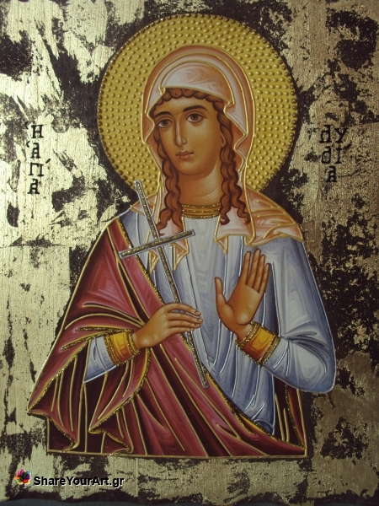

In the midst of Paul’s second missionary journey, he had a vision that prompted him to go at once to preach in Macedonia. During this first mission visit to Europe, Paul soon found himself at a riverbank in the Macedonian city of Philippi. Lydia happened to be at this river with a group of women who were seemingly gathered together for a time of worship. When Paul began to speak to these women about the life of Christ, Lydia’s heart opened, and she believed. Amazingly, Lydia had her entire household baptized and then insistently encouraged Paul and his companions to stay at her home during their time in Philippi. She was the Apostle Paul’s first convert to Christianity in Europe.

The 16th chapter of Acts mentions that Lydia was a dealer of purple cloth (hence she is also known as “Lydia Purpuraria” — Lydia the Purple Seller) from the city of Thyatira. Thyatira was a city in Asia Minor (Turkey) known for its cloth and dye-making businesses. While in Philippi, it appears that Lydia may have let her house be used as a church. The Bible records that when Paul and Silas were evangelizing in the city, they found themselves in prison — quickly followed by a miraculous release. When they left the prison, Paul and Silas went to Lydia’s house, where some Christians were gathered together. The missionaries gave the group of Philippian Christians encouragement and then traveled on to Thessalonica.

Lydia is never mentioned in the Bible again after this story. Whether she remained in Philippi or returned to Thyatira is uncertain. What is known, however, is that her warm acceptance of Paul’s mission opened wide a door of Europe to Christian teachings.

St. Mary Magdalene  
**Country of Origin**: Israel  
**Feast Day**: July 22  
**State of Life**: Lay woman, disciple of Jesus  
**Patron Saint Of**: Penitents, women  
**Lifespan**: 1st century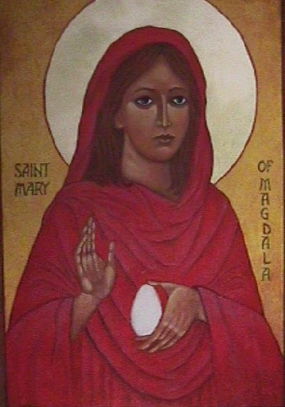

St. Mary Magdalene has been called the second-most important woman in the Gospels, after Jesus’ mother, Mary. The Gospels mention her 12 times, more than most of the apostles. Her name comes from her origin in Magdala, a region in northern Galilee. The Gospels of Mark and Luke tell us that Jesus cast seven demons out of Mary Magdalene. After that, she traveled with Jesus and his followers, and played a prominent role in witnessing Jesus’ crucifixion and resurrection.

She remained at the foot of the cross when most of Jesus’ followers left him, and she is remembered for her courage in faithfully standing with Jesus even as he faced death. Mary Magdalene is the only person noted by all four Gospels as testifying to Jesus’ resurrection. John and Mark portray her as the first witness of the resurrection, and St. Thomas Aquinas honored her with the title “the Apostle to the Apostles” because she was the first to share the news of the resurrection.

Mary Magdalene was a pillar of the early Christian community, a faithful follower of Jesus who was healed by him, and one of the first people to witness and share the good news. Various traditions compete to tell the story of what happened to Mary Magdalene in her later life. One legend has it that she retired to Ephesus with Jesus’ mother, Mary. Another has it that she was transported to France with others and evangelized that area.

St. Monica  
**Country of Origin**: Algeria  
**Feast Day**: August 27  
**State of Life**: Wife, mother  
**Patron Saint Of**: Married women and mothers, mothers of wayward children, victims of domestic abuse  
**Lifespan**: c. 331 – August 387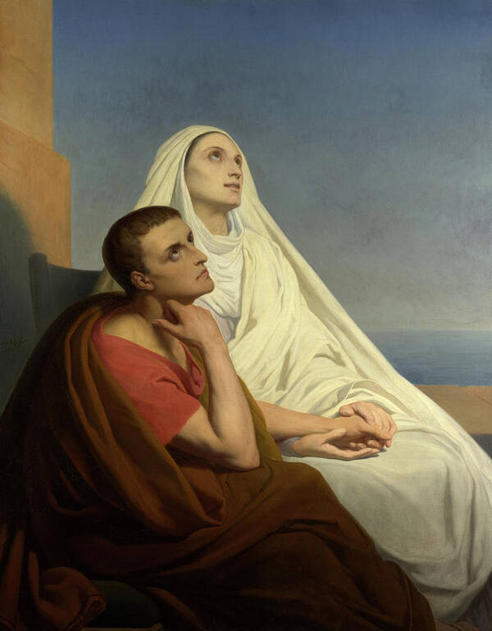

St. Monica was, above all, a stubborn mother. She was married at a young age to an adulterous government official with a violent temper. Years of Monica’s patience and prayer converted him to Christianity just before he died. She prayed unceasingly for her children as well, especially for her brilliant but wayward son, Augustine. Priests learned to avoid her because of her persistence in asking for prayers for him.

She followed Augustine as he pursued studies in Carthage and Rome, praying at shrines and chapels the whole way. They both finally arrived at Milan, where they met St. Ambrose. It was under Ambrose’s guidance that Augustine fulfilled his potential and became one of the most brilliant writers and thinkers the Church has ever known. After 17 years of constant prayer, Monica saw her son baptized when he was 32. He went on to become a priest, bishop, and Doctor of the Church. St. Augustine’s feast day is the day after St. Monica’s. St. Monica is the patron saint of alcoholics, victims of abuse and adultery, widows, and mothers facing family difficulties.

St. Rose of Lima  
**Birth Name**: Isabel Flores de Oliva  
**Country of Origin**: Peru  
**Feast Day**: August 23  
**State of Life**: Religious sister  
**Patron Saint Of**: Peru, indigenous people of Latin America, florists  
**Lifespan**: April 20, 1586 – August 24, 1617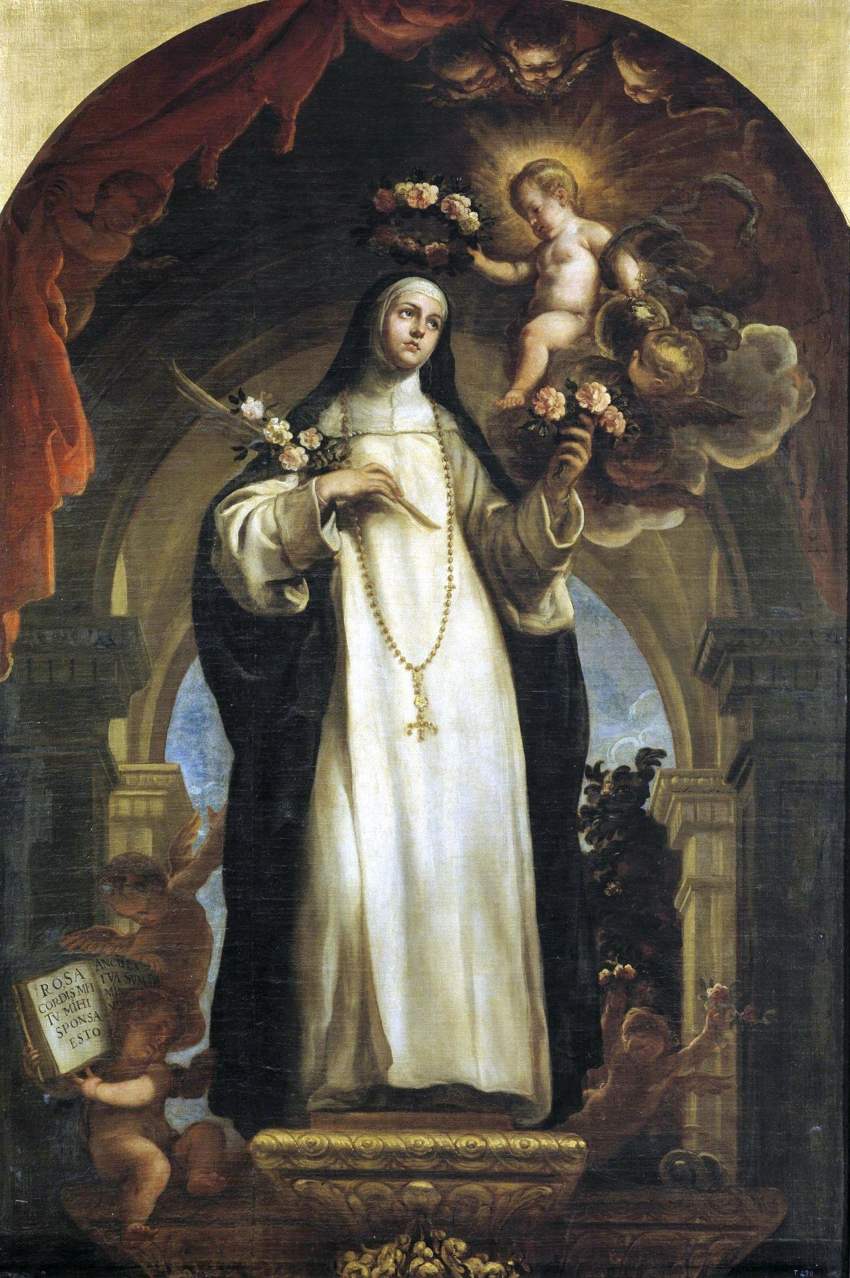

St. Rose of Lima was given the name Isabel when she was born in Peru in 1586. She was such a beautiful baby, however, that people could not help calling her Rose. Her beauty grew as she aged, and she became the subject of much admiration. She decided to devote herself fully to Jesus, however, and the admiration became a distraction to her. She feared her beauty would distract others as well, so she would rub crushed pepper on her face to produce rashes and blisters.

Her devotion led her to take on severe mortifications, but she was devoted to those around her with similar intensity. When her parents fell into poverty, she worked to grow food in their garden and took on sewing jobs at night. She dedicated a room in her family’s home to care for orphans and the poor.

She wanted to enter a convent, but her parents would not give her permission because they wanted her to marry. She was obedient to her parents and did not join a convent. She did convince them of her vow of virginity, however--she clung to her single-hearted devotion to Christ and remained at home for her whole life, giving herself to prayer and good works. She became a third-order Dominican, meaning that she took on the spirituality of the Dominicans as a private lay person. She is the patron of the Americas, the Philippines, and of florists.

St. Teresa of Calcutta  
**Birth Name**: Anjezë Gonxhe Bojaxhiu  
**Country of Origin**: Albania and India  
**Feast Day**: September 5  
**State of Life**: Religious sister, foundress of religious order  
**Patron Saint Of**: the poor and the sick  
**Lifespan**: August 26, 1910 – September 5, 1997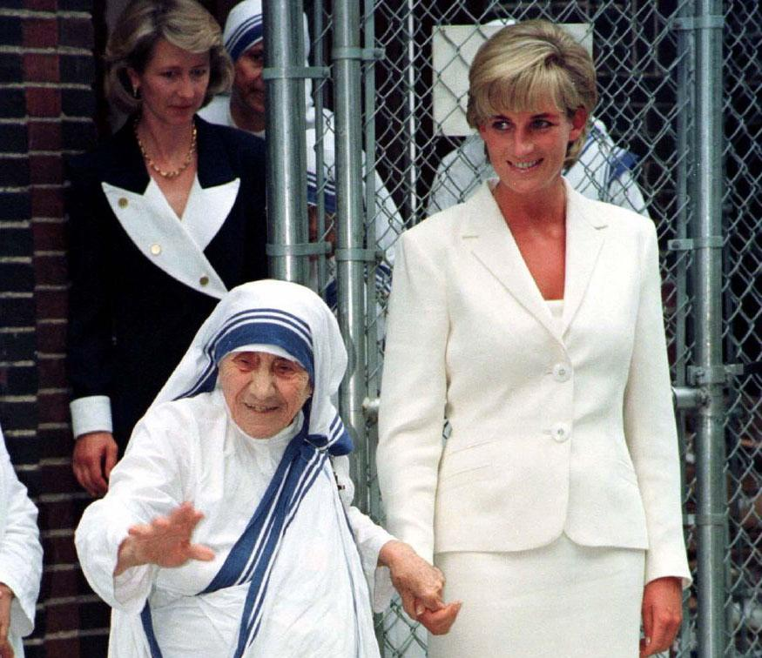

Mother Teresa was born in Skopje, Albania. From the day of her First Holy Communion, a love for souls was within her. Her father’s sudden death when she was about eight years old left the family in financial straits. At the age of eighteen, moved by a desire to become a missionary, she left her home to join the Sisters of Loreto, in Ireland. There she received the name Sister Mary Teresa after St. Thérèse of Lisieux. She arrived in Calcutta, India in 1929. On 24 May 1937, Sister Teresa made her Final Profession of Vows, becoming, as she said, the “spouse of Jesus” for “all eternity.” From that time on she was called Mother Teresa. She was a person of profound prayer and deep love for her religious sisters and her students.

In 1946, Jesus asked Mother Teresa to establish a religious community, Missionaries of Charity, dedicated to the service of the poorest of the poor. She started each day in communion with Jesus in the Eucharist and then went out, rosary in hand, to find and serve Jesus in “the unwanted, the unloved, the uncared for.” During the years of rapid growth she received numerous awards, including the Indian Padmashri Award and the Nobel Peace Prize in 1979, and an increasingly interested media began to follow her activities. She received both prizes and attention “for the glory of God and in the name of the poor.” She started convents in more than 90 countries, including the United States. She’s pictured above with Princess Diana at the convent that she started in the South Bronx, NYC.

The whole of Mother Teresa’s life and labor bore witness to the joy of loving, the greatness and dignity of every human person, the value of little things done faithfully and with love, and the surpassing worth of friendship with God. On 5 September Mother Teresa’s earthly life came to an end. She was given the honor of a state funeral by the Government of India and her body was buried in the Mother House of the Missionaries of Charity. Her tomb quickly became a place of pilgrimage and prayer for people of all faiths, rich and poor alike. Mother Teresa left a testament of unshakable faith, invincible hope and extraordinary charity. In her own words, “By blood, I am Albanian. By citizenship, an Indian. By faith, I am a Catholic nun. As to my calling, I belong to the world. As to my heart, I belong entirely to the Heart of Jesus.”

St. Theresa Benedicta of the Cross  
**Birth Name**: Edith Stein  
**Country of Origin**: Germany  
**Feast Day**: August 9  
**State of Life**: Religious sister  
**Patron Saint Of**: Europe, those who suffer from persecution  
**Lifespan**: October 12, 1891 – August 9, 1942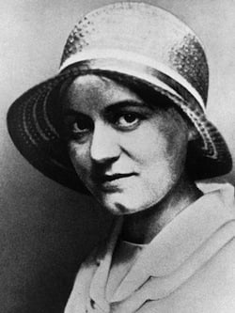

Edith Stein was born to a large Jewish family in Germany 1891, and was an extraordinary student. She earned her doctorate in philosophy at the age of 25 with highest honors. She was an assistant and colleague to the famous philosopher Edmund Husserl.

Though her family was devoutly Jewish, Edith declared herself an atheist in high school. It was the witness of some of her friends that initially invited her to consider the Christian faith. She saw the strength of their faith, and began studying the Catholic tradition. The works of St. Teresa of Avila finally moved her to the faith. She converted and was baptized in 1922, then went on to teach in European institutions of learning as a member of the intellectual elite.

When the Nazi regime required an "Aryan certificate" for anyone to teach or serve the public, Edith had to quit her career as an academic. She followed a long-held desire to become a Carmelite sister in 1934, taking the name Teresa Benedicta of the Cross. Because of her Jewish heritage, her order relocated her to a convent in Holland in 1938 to keep her safe from the Nazis. When the Nazis later invaded the Netherlands, she was sent to the concentration camp at Auschwitz, where she was killed in a gas chamber in 1942. She is one of the patron saints of Europe.

St. Teresa of Avila  
**Birth Name**: Teresa Sánchez de Cepeda y Ahumada  
**Country of Origin**: Spain  
**Feast Day**: October 15  
**State of Life**: Religious sister  
**Patron Saint Of**: Spain, those who seek spiritual renewal  
**Lifespan**: March 28, 1515 – October 4, 1582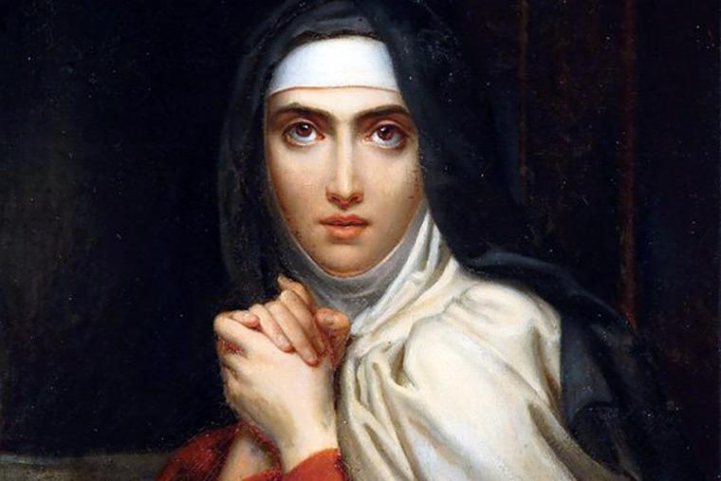

St. Teresa of Ávila was a Spanish nun, one of the great mystics and religious women of the Roman Catholic Church, and an author of spiritual classics. She was the originator of the Carmelite Reform, which restored and emphasized the austerity and contemplative character of Carmelite life. St. Teresa was elevated to doctor of the church in 1970 by Pope Paul VI, the first woman to be so honored. Her mother died in 1529, and, despite her father’s opposition, Teresa entered the Carmelite Convent of the Incarnation at Ávila, Spain. Within two years her health collapsed, and she was disabled for three years, during which time she developed a love for prayer. After her recovery, however, she stopped praying. She continued for 15 years in a state divided between a worldly and a divine spirit, until, in 1555, she experienced a religious awakening.

In 1558 Teresa began to consider the restoration of Carmelite life. Her reform required utter withdrawal so that the nuns could meditate on divine law and, through a prayerful life of penance, exercise what she termed “our vocation of reparation” for the sins of humankind. In 1562, with the pope’s, she opened the first convent (St. Joseph’s) of the Carmelite Reform. A storm of hostility came from municipal and religious personages, especially because the convent existed without endowment, but she staunchly insisted on poverty and subsistence only through public alms.

She met a young Carmelite priest, Juan de Yepes (later St. John of the Cross, the poet and mystic), who she realized could initiate the Carmelite Reform for men. Despite frail health and great difficulties, Teresa spent the rest of her life establishing and nurturing 16 more convents throughout Spain. In 1575, a jurisdictional dispute erupted between two groups of Carmelite friars. Although she had foreseen the trouble and endeavored to prevent it, her attempts failed. The Carmelite general, to whom she had been misrepresented, ordered her to retire to a convent in Castile and to cease founding additional convents; Juan was subsequently imprisoned at Toledo in 1577. In 1579, largely through the efforts of King Philip II of Spain, who knew and admired Teresa, a solution was found. Teresa, broken in health, was then directed to resume the reform. In journeys that covered hundreds of miles, she made exhausting missions and was fatally stricken en route to Ávila from Burgos, Spain.

St. Therese of Lisieux  
**Birth Name**: Marie-Françoise-Thérèse Martin  
**Country of Origin**: France  
**Feast Day**: October 1  
**State of Life**: Religious sister  
**Patron Saint Of**: Missionaries, florists, pilots, priests, and the Little Flower Devotion  
**Lifespan**: January 2, 1873 – September 30, 1897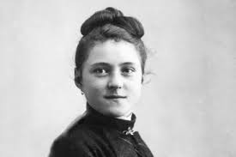

St. Thérèse of Lisieux was a Carmelite nun whose life, although outwardly unremarkable, was later recognized for its exemplary spiritual accomplishments. Marie-Françoise-Thérèse Martin was the youngest of nine children, five of whom survived childhood. After her mother died of breast cancer in 1877, Thérèse moved with her family to Lisieux, France. In the deeply religious atmosphere of her home, her piety developed early and intensively. All four of her elder sisters became nuns, and at the age of 15 she entered the Carmelite convent at Lisieux, having been refused admission a year earlier. Although she suffered from depression, scruples—a causeless feeling of guilt—and, at the end, religious doubts, she kept the order’s rule to perfection and maintained a smiling, pleasant, and unselfish manner. Before her death from tuberculosis, she acknowledged that, because of her difficult nature, not one day had passed without a struggle.

Her burial site at Lisieux became a place of pilgrimage, and a basilica bearing her name was built there (1929–54). The story of Thérèse’s spiritual development was related in a collection of her autobiographical epistolary essays, written by order of the prioresses. Her popularity is largely a result of this work, which conveys her loving pursuit of holiness in ordinary life. Thérèse defined her doctrine of the Little Way as “the way of spiritual childhood, the way of trust and absolute surrender to God.” In her writings she often compared herself to a simple wildflower, “the Little Flower of Jesus.” Therefore, she is often referred to by the nickname “the Little Flower.” She also wrote that after her death she would continue to do good in heaven and would show this by letting fall “a shower of roses” on earth. In devotion to St. Thérèse, many Roman Catholics pray a special novena to her, believing that she will send them a mystical rose from heaven.

She was canonized by Pope Pius XI in 1925 and was named a doctor of the church by Pope John Paul II in 1997. She is the youngest person to be designated a doctor of the church and is only one of four women to be so named. In 2015 St. Thérèse’s parents, Louis Martin and Marie-Azélie Guérin, were canonized by Pope Francis; they were the first spouses to be canonized as a couple.

St. Veronica  
**Country of Origin**: Israel  
**Feast Day**: July 12  
**State of Life**: Lay woman  
**Patron Saint Of**: Photographers, those who seek comfort in times of suffering  
**Lifespan**: 1st century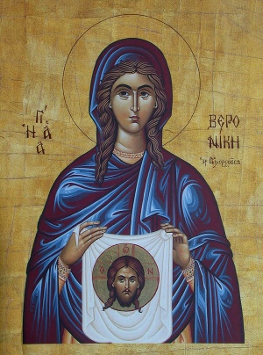

When Jesus was carrying his cross on the way to his death on Golgotha, a woman named Veronica wiped his face with her veil. An image of Jesus’ face is said to have remained on the cloth.

The story of Veronica and her veil is one of the most famous Christian legends. In the early Church, many people were motivated to find and honor relics of Jesus’ death and resurrection. The veil with Jesus’ face was called a vera icon—a true icon, or true image—to distinguish it from other relics, and this is perhaps where Veronica’s name comes from.

Stories about this woman arose to fill in the gaps—some have her as the wife of a Roman officer who was moved with compassion to comfort Jesus; others have her as Jesus’ friend, Martha; or the wife of Zaccheus; or the woman who was healed from her bleeding when she touched Jesus’ cloak. The veil venerated as the original is in St. Peter’s Basilica in the Vatican.

Sts. Perpetua and Felicity  
**Country of Origin**: Tunisia  
**Feast Day**: March 7  
**State of Life**: Lay women, martyrs, mothers  
**Patron Saint Of**: Christian friendship, mothers, expectant mothers, those who are persecuted for their faith  
**Lifespan**: Perpetua: c. 181 – March 7, 203; Felicity: c. 204

Saints Felicity and Perpetua were famous martyrs from the early Church—they are the saints who appear the most on ancient lists of saints and calendars for veneration. In fact, their story was read publicly in the churches of North Africa, and the great St. Augustine himself had to clarify for his people that these accounts were not of the same stature as Scripture, which indicates just how important people found their story.

Carthage in 203 was a Roman city and enforced the persecution of Christians who failed to worship the image of the emperor, which was a hallmark of the imperial religion. Five catechumens were arrested, and among them were a slave, Felicity, who was pregnant, and Perpetua, who was 22 years old, wife of a well-to-do citizen, and mother of a young child herself. They were all condemned to execution, except for Felicity—Roman law prevented the execution of any woman who was pregnant. Felicity, however, wanted to join her fellow Christians with the witness of her life and gave birth in prison during her eighth month. The child survived and was adopted by the Christian community of the city.

Perpetua’s child was still nursing at the time of her arrest, and she received permission to have him join her in prison. He weaned before her execution and was raised by her family. The group was taken to a stadium and killed by wild beasts in front of soldiers on a Roman holiday. Felicity and Perpetua faced a bull, who wounded them but did not kill them. The crowd called for their death by sword, and they exchanged a sign of peace before being killed.

Venerable Henriette Delille  
**Birth Name**: Henriette Diaz DeLille  
**Country of Origin**: United States  
**Feast Day**: TBD  
**State of Life**: Mother, religious sister, foundress of a religious order  
**Patron Saint Of**: TBD  
**Lifespan**: March 11, 1813 – November 17, 1862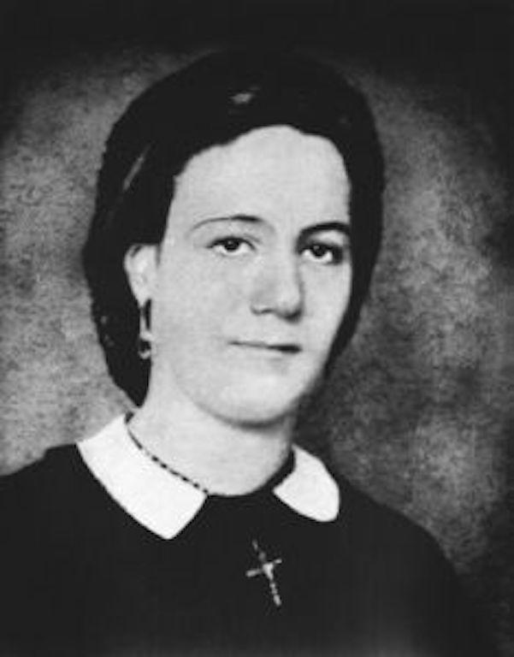

Henriette was born in 1813, to a mother who was a free woman of color, Marie-Josèphe. Her mother lived with a man named Jean-Baptiste, in what was known as the plaçage system. Through the plaçage system, white men lived in common-law--as opposed to civil or sacramental--marriages with women of color. Henriette grew up with her siblings in New Orleans' French Quarter. Her mother raised them Roman Catholic, and educated Henriette to be an accomplished young woman, in preparation for her own marriage to a wealthy patron. But Henriette had different plans for herself. She wanted to bring education to the poor girls of New Orleans and began teaching children around the city when she was still a teenager.

In 1835, Henriette's mother had a nervous breakdown, and Henriette inherited all her mother's assets. Henriette set aside enough money to continue caring for her mentally ill mother and then sold all of her mother's remaining property. With the proceeds of this sale, Henriette began her own religious congregation, which she named the Sisters of the Presentation, later renamed the Sisters of the Holy Family. The Sisters of the Holy Family, to this day, operate schools, nursing homes, and retirement communities for those in need throughout the Southern USA.

Henriette DeLille died in 1862, in the midst of the civil war. Her cause for canonization was opened in 1988, and Pope Benedict XVI declared her "venerable" on March 27, 2010. Venerable Henriette Díaz DeLille is one of six Black Americans, including Julia Greeley and Venerable Pierre Toussaint, who is on the path towards officially being recognized as saints in the Roman Catholic Church.