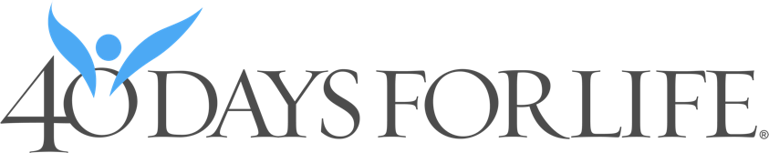

SAMPLE BULLETIN ANNOUNCEMENT:

From September 28 – November 6, you’re invited to join other Christians for 40 Days for Life – 40 days of prayer and fasting for an end to abortion. You’re also invited to stand and peacefully pray during a 40-day vigil in the public right-of-way outside Planned Parenthood, 4555 Precissi Lane, Stockton and also to help spread the word about this important community outreach. If you’d like more information – and especially if you’d like to volunteer to help, please contact: Richard F. Parnacott, OFS; email rp64118@yahoo.com and local campaign web address, https://www.40daysforlife.com/en/stockton.

SAMPLE PULPIT ANNOUNCEMENT:

From September 28 – November 6, you’re invited to join other Christians for 40 Days for Life – 40 days of prayer and fasting for an end to abortion. You’re also invited to stand and peacefully pray during a 40-day vigil in the public right-of-way outside Planned Parenthood, 4555 Precissi Lane, Stockton and also to help spread the word about this important community outreach.

There are cards in the pews or people standing outside of church afterward today asking for your pledge to lift the local 40 Days for Life campaign up in prayer, as well as asking for God’s protection of all human life which – persons made in God’s image and likeness. Please take a moment to fill out one of these cards.

If you’d like more information – and especially if you’d like to volunteer to help, please contact: Richard F. Parnacott, OFS; email rp64118@yahoo.com and local campaign web address, https://www.40daysforlife.com/en/stockton or see today’s bulletin. Thank you!

