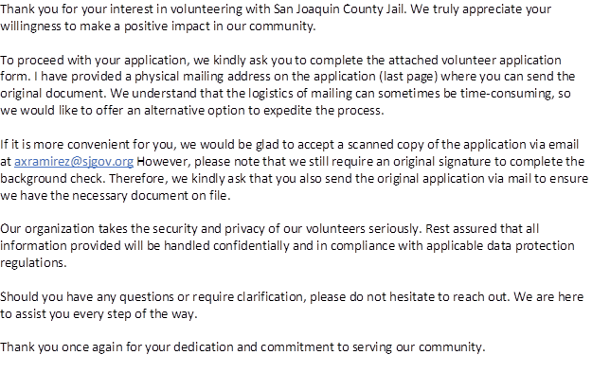

~Alex Ramirez

 | Alex Ramirez  San Joaquin County Sheriff’s Office  Inmate Programs  Phone : 209-468-4615  Fax: 209-468-4517  Email: axramirez@sjgov.org  7000 Michael Canlis Blvd.  French Camp, CA 95231  Please note: I am off every Thursday

