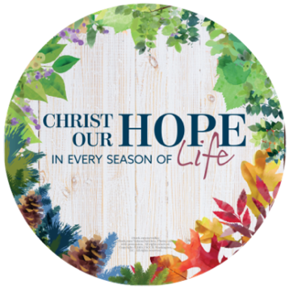

Respect Life Sunday
2nd Collection
October 4th & 5th , 2025

Your donation will support the efforts of the Diocesan Office of Family & Respect Life Ministry
to provide:

* Support parish activities promoting the
dignity of all life
* Networking with Pregnancy Resource Centers
* Post-abortion reconciliation & healing (Project Rachel)
* Christian Marriage (preparation and enrichment)
* Natural Family Planning
* Parenting (in times of crisis and just the everyday)
* Single, Divorced and Separated Catholics
* Care of our Sick & Elderly / End of Life Preparations
Thank you!

