Reconciliation Format: 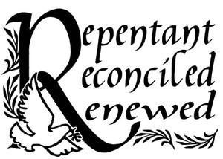
Sit down in the chair and make the Sign of the Cross: “In the name of the Father, and of the Son and of the Holy Spirit. Amen. This is my first confession and these are my sins:”
or:
“It has been _______ since my last confession (give the time lapse since your last confession). These are my sins:”
After you finish confessing your sins, Father may or may not offer guidance or encouragement. Father will then ask you to say an Act of Contrition. After you pray an Act of Contrition (see samples below), he will give you absolution. Make the Sign of the Cross as he says “In the Name of the Father and of the Son and of the Holy Spirit” and say “Amen” when he concludes.

An Act of Contrition
I am sorry for my sins with all my heart. In choosing to do wrong and failing to do good, I have sinned against You whom I should love above all things.
I firmly intend, with Your help, to do penance, to sin no more, and to avoid whatever leads me to sin.
Our Savior, Jesus Christ, suffered and died for us. In His Name, may God have mercy. Amen.

An Act of Contrition
O My God, I am heartily sorry for having offended You, and I detest all my sins because I dread the loss of Heaven and the pains of Hell [or: because of your just punishment]; but most of all because they offend You, my God, who are all-good and deserving of all my love.
I firmly resolve, with the help of your grace, to confess my sins, to do penance, and to amend my life. Amen.
An Act of Contrition
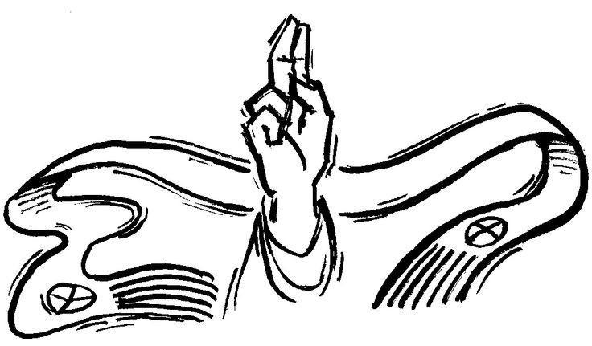
Lord Jesus Christ, Son of God, have mercy on me, a sinner.
Examination of Conscience for Younger Children
Responsibilities to God:
Have I prayed every day?
Have I prayed my morning prayers and night prayers?
Have I prayed with my parents and family?
Have I been moody and rebellious about praying and going to church on Sunday?
Have I asked the Holy Spirit to help me whenever I have been tempted to sin?
Have I asked the Holy Spirit to help me do what is right?

Responsibilities to others:
Have I been obedient and respectful to my parents?
Have I lied or been deceitful to them or to others?
Have I been arrogant, stubborn or rebellious?
Have I talked back to parents, teachers or other adults?
Have I pouted and been moody?
Have I been selfish toward my parents, brothers, and sisters, teachers, or my friends and schoolmates?
Have I gotten angry at anyone? Have I hit anyone?
Have I held grudges or not forgiven others?
Have I treated other children with respect or have I made fun of them and called them names?
Have I used bad language?
Have I stolen anything? Have I returned it?
Have I performed my responsibilities, such as homework and household chores?
Have I been helpful and affectionate toward my family?
Have I been kind and generous with my friends?
Have I been jealous of others because they have something I don’t have?

