Taking it Home #5: God is Love
Hello everyone!
Last week we talked about Jesus. “The word became flesh, and dwelt among us.” God became a man in Jesus Christ to reunite mankind to God. This week, we took a more in depth look at the reason why.
In the first letter of St. John in the Bible, we read that “God is love”. What does this mean? Love is the very essence of who God is, so much so that even as the soldiers drove the nails into Jesus’ hands and feet he cried out, “Father, forgive them for they know not what they do.” Love is what moved God to become one of us, to experience pain, fear, heartbreak, and even death. Jesus conquered all of these things in the name of love.
Sometimes, it’s easy to doubt that God loves us. When natural disasters hit, loved ones become sick, and terrible things happen to beautiful people, we wonder: how can an all-powerful God allow such things to happen? There is no “quick” answer to such a question, but with a little reflection I really believe it can be worked out. You see, this world we live in is only a temporary home for us. It is a journey and a preparation for our permanent home. We are put on this earth to discover God and his love for us. God doesn’t want to overpower us and force us to love him by showing the fullness of his splendor and glory, but he wants to show us that true love is patient. It doesn’t overpower people, but gives them the freedom to choose to love in return. Though we experience pain and suffering in this life, it’s important to remember two things: 1) Pain isn’t permanent. In the kingdom of Heaven, every tear will be wiped away and you will experience joy greater than you could ever imagine. 2) God loves us so much that he wanted to experience pain for himself, and that’s exactly what he did on the cross. When Jesus’ friend Lazarus died, Jesus allowed himself to feel the pain of loss and we read that he wept for him, even though he knew he would bring him back to life. When we are going through suffering, either physical or emotional, we should invite Jesus into that suffering with us. He wants to be there with you and walk with you as you go through it.
God loves you more than you can imagine. Every day, he wants to pour his love into your heart.
Will you let him?
Things to Remember:
- “The Word became flesh and dwelt among us”
- God loves you more than you could possibly imagine. He loved you even before you existed
- Even though bad times come, God is still good and faithful and has abundant blessings for us in heaven.
- Jesus conquered death in the resurrection. We too, who have been baptized into Christ and receive him each week, will conquer death.
- Jesus died on the cross for our sins because he loves us. Love often means sacrificing for others.

Challenge of the Week:
- For this weeks challenge, I want you to find either a Scripture passage, praise and worship song, or quote from a saint that really speaks to you. Write down the quote or song title with the lyric that spoke most to you and write down why you like it or why it helps you see or understand God’s love more clearly.

God bless,
Jonah
Saints of the Week!
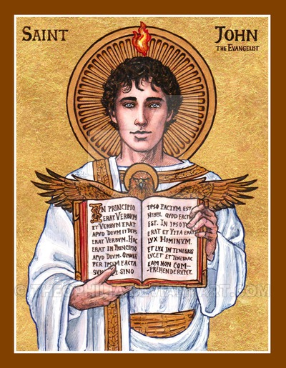
St. John the Apostle
St. John the Apostle is also called St. John the Evangelist, or “”the beloved disciple”. He was the youngest of the twelve Apostles, somewhere in his teens when he was called. He also wrote a good chunk of the Bible. He wrote the Gospel of John, several letters, and the book of Revelation, which is the last book in the Bible. He is known as being one of the closest disciples of Jesus, alongside his older brother James and Peter.
Of all of the twelve apostles, John was the only one who didn’t run away or de ny Jesus. He was the only one who was there when Jesus was crucified, alongside Mary Magdalene and Jesus’ mother Mary. It was to John that Jesus said “Behold, your Mother”, because at that moment John represented the whole Church, being the only apostle present. John is also the only Apostle who didn’t die a martyr’s death, but lived into old age. He was however, persecuted. During Emperor Domitian’s persecution of Christian’s, John was thrown in a boiling cauldron of oil but remained unscathed. Many people who witnessed this miracle take place in the Coliseum converted to Christianity afterwards. In his old age, he was exiled to a small island called Patmos where he spent the last year’s of his life.
St. John is the model disciple for all of us. He had such a deep love for Jesus, which is seen most clearly in his Gospel. He is often referred to as the “Apostle of love” because he writes more about God’s love than any other Scripture writer. St. John teaches us that we are all loved by God, and that he was a plan for each one of us. We just have to say yes.
“God is love. Whoever lives in love lives in God, and God in him.”
-St. John the Apostle
St. Therese of Lisieux
St. Therese of Lisieux is one of my all time favorite saints! St. Therese only lived to be twenty four years old before she died from tuberculosis, and spent the majority of those years in a cloister away from the world. Yet today, she is one of the most known and loved saints. She was born in France in 1873. She was one of nine children, but only five survived into adulthood. When she was four years old, her mother passed away. Shortly after, Therese became really sick and people thought she would die as well. While she was sick, Therese saw her sisters praying near a Mary statue in the room, asking for Mary’s intercession. Therese saw the statue of Mary smile and was suddenly cured!
All of St. Therese’s older sisters joined the Carmelite order (a group of religious sisters who lived away from the world and devoted themselves to praying for the world). Therese wanted to join too, but the superior wouldn’t let her because she was only fourteen years old. After that, she went to the local bishop, who told her the same thing. However, when her family was on a pilgrimage in Rome, her family was given an audience with the Pope, and even though she was forbidden to talk she begged him to allow her to enter the Carmelites. She was soon allowed to join!
Therese lived a hard life. Shortly after joining, her father had a series of strokes, and began experiencing mental illness and had to be put in an insane asylum. She struggled with dryness in prayer, and even experienced doubts at times, but she never gave in to despair. Though she knew she would never get to change the world as an evangelist or missionary, she knew that by doing small acts with great love she could make a difference. She once wrote, “Love proves itself by deeds, so how am I to show my love? Great deeds are forbidden me. The only way I can prove my love is by scattering flowers and these flowers are every little sacrifice, every glance and word, and the doing of the least actions for love.” She would smile at her religious sisters even if they were mean to her, take on loads of chores to serve the people around her, she even took the blame for things that were found broken, even though she didn’t break them.
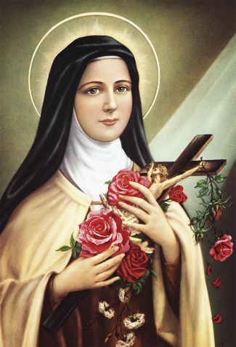
In Scripture, Jesus says “Let the little ones come to me.” Therese wanted to be one of these little ones. She wanted to have complete trust in God as a loving Father. One of her religious sisters who was also her biological sister and her superior told her to write down her memories and journal out her reflections on God’s love. It was published after St. Therese’s death and changed the world. In a sense, it was St. Therese’s own personal prayer journal. The book is called Story of a Soul and I highly recommend it! St. Therese is a great saint to ask for help. Before she died she said that she would spend her time in Heaven doing good things for people on Earth.

"Let us love, since that is what our hearts were made for." ~ St. Therese of Lisieux

