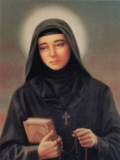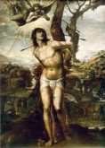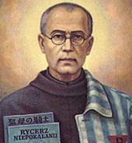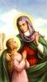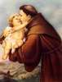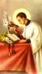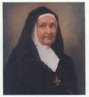
SAINT REPORT – DUE: __________________________ (Date is set by each 8th Grade Catechist)
CHOOSING A CONFIRMATION NAME
As a candidate for the celebration of the Sacrament of Confirmation, you have two options
concerning the choice of a Confirmation name:
1. Stay with your present baptismal name (your regular first name). This shows the sacramental connection with the first and second part of your initiation into the Catholic Church: Baptism and First Eucharist. To stay with your baptismal name would demonstrate that you feel there has been a continual growth in your faith and you now wish to seal your ongoing covenant of faith in the sacrament of Confirmation.
2. Pick a saint’s name that would symbolize a new beginning in your faith life and a relationship with that particular saint. This would be especially true if you felt that you have not been particularly strong in your faith and are now making a renewed commitment to your faith. Your commitment would be symbolized with the taking of a new name to show that you are in some ways now a new person. This new name would be used after your present middle name and before your family name.
The particular saint’s name chosen would represent the direction you feel your faith life is taking, or would represent a strength or virtues you feel you want to acquire. Therefore, it is important and necessary to learn something about the saint you choose before you decide on that name. This option of taking a new name is not to be used because you like the sound of the name, how it fits with your other names, or because it is the name of a nice friend or relative. The choice of a name should be a purposeful, reflective, meaningful decision.
SAINT REPORT ASSIGNMENT
Whether you are choosing to keep your present name or take a new name, you will either write an essay or create a power point or short film.
If you choose to keep your baptismal name, explain why you are choosing to keep your baptismal name. Next, tell about the saint for which you are named and how this saint’s life relates to your life goals.
Explain why you want this saint to continue to be your patron and intercessor.
If you choose to take a new name, tell the story of the particular saint whose name you are choosing. Next explain what motivated you to choose this particular saint. What meaning and example does this saint hold for you? What do you hope to gain by choosing this saint as your particular patron and intercessor?
A written report should be at least 250 words in length, typed and double-spaced. Be sure your name, day and room # are on the upper right hand corner of your report.
A film or powerpoint should be 2-3 minutes in length or no less than 25 frames if it is a
powerpoint. Make sure that the film or powerpoint is formatted on a CD/DVD and can be viewed on a computer.
Information about Catholic Saints can be found on the internet or in the library.
Remember: Give the Saint Report to your catechist/teacher by the due date indicated by
your teacher.

