Meal Train Ministry
Information Guide

The Meal Train Ministry is an outreach of St. Joseph Catholic Church by parishioners for parishioners who need relief from meal preparation after coming home with a new baby, recovering from a medical procedure, or encountering other unforeseen circumstances. Here are several frequently asked questions about the ministry:

Who coordinates this ministry?
The Meal Train Ministry is a part of the Parish Care Committee and is currently coordinated by Katie Buys; if you are interested in signing up to help when there are needs, you may contact her at katiebuys34@gmail.com / (662) 769-9831 or reach out to Demi Dunne in the church office at demidunne@hotmail.com / (662) 323-2257.

How does the coordinator know when someone needs meals?
Usually Demi, in the church office, hears of the need and passes it along to the coordinator; other times, a member of the church will let the coordinator know of a need. If you hear of a need, please share it with Katie so she can work with the individual to set up a meal train.

Who provides the meals?
There are currently about 35 people in the parish on the Meal Train Ministry volunteer meal provider list.

What does the Meal Train Ministry usually provide?
The ministry usually provides 3-6 meals based on the needs of the family or individual.

How do the volunteers find out about the need and sign up?
When there is a need, the Meal Train Ministry coordinator sends a message to all the volunteers on the list. Sign up is usually done via a very user-friendly website- takethemameal.com. The coordinator’s email message will contain a link to the webpage for that meal train where providers can see the dates meals are needed, food preferences, and delivery instructions.

I am willing to sign up, but I don’t know how often I can help; what should I do?
Signing up to receive the emails does not obligate you to take a meal. We have many people willing to assist; it is helpful for us to have a large list because there are times when we have several meal trains operating at one time and need a large pool of providers; but there are sometimes many weeks and even months at a time that we don’t have any meal trains operating. You are never obligated to provide a meal; so if you think you might be interested in this ministry, we encourage you submit your contact information.

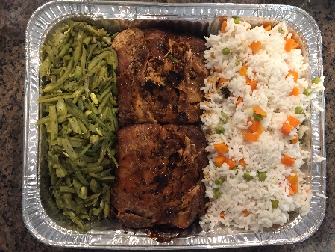
But wait- I don’t have email or I don’t check it regularly; can I still be involved?
Absolutely! We have a few people on the list currently who prefer to be called instead of emailed

How involved has St. Joseph been in this ministry lately?
In the last year, more than 26 volunteers have reached 15 families with 68 meals.

I heard of a need for a friend in the parish and want to take them a meal; do I have to run it through the Meal Train Ministry?
No! If you want to take a friend a meal, please do! If you find that they could benefit from additional meals, please let Demi or the coordinator know of the need, and they will work with the individual or family with the need to set up a meal train convenient for them.

I am happy to sign up, but I’m not sure what to take or how to help; what should I do?
Simple meals are welcomed! This ministry is a small way to provide a practical service to those in need, and in doing so, show be the hands and feet of Jesus. Here are a few suggestions to consider:
1) One-dish meals or casseroles are great options- they are simple and easy to transport.

2) Consider doubling what you plan to prepare for your family and taking the extra rather than cooking something different.

3) Breakfast, snacks, and other non–dinner foods may be helpful. Most of the time, people bring dinner foods, so some variation could be welcomed.

4) Some volunteers prefer to purchase a prepared meal from a restaurant or grocery store. Meals do not have to be homemade.

5) Use disposable dishes to eliminate the need for the recipient to clean and return dishes after they recover. (Hint: You may get these at Dollar Tree.)

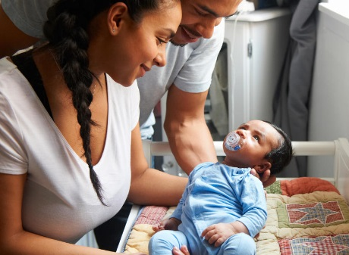
6) Label your containers so that recipients know what they will be eating in case they forget what you told them when you dropped it off.

7) When you deliver the meal, make the visit very brief to allow the family time to rest as much as possible.

8) Consider involving your children in the process of meal preparation and delivery as a way to teach them about service to others.

9) Remember- This is not a cooking contest but a ministry to people who have short-term meal needs. You don’t have to take the finest meal you know how to prepare- just something simple!

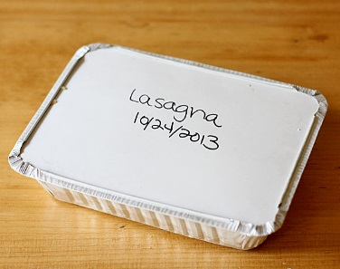
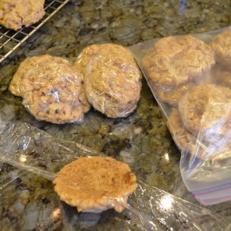
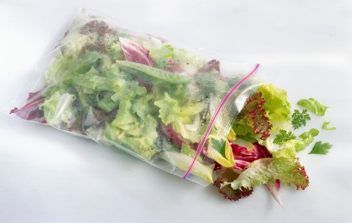

SAMPLE TAKE THEM A MEAL SIGN UP PAGE

