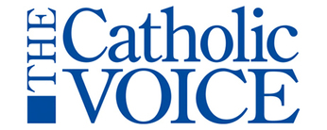 | We know Christmas 2020 won’t look like Christmas 2019.  But we would like to promote parish activities on diocesan social media and The Catholic Voice. Please use this form to let us know of any Advent events and Christmas Masses.

Parish

Full address

Website url

Phone

Event

- Date

- Time

- Reservations

- Cost.

Christmas Eve and Christmas Day Masses.

Date

Time

Date

Time

Special considerations:

Please email this form or forward information to Michele Jurich at MJurich@oakdiocese.org.

