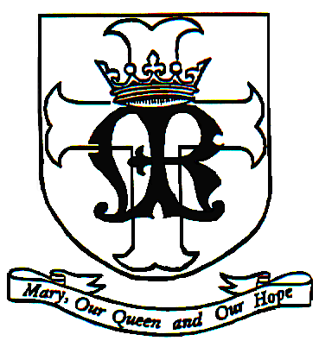
St. Mary Church
School of Religious Education
830 Fifth Avenue
Alpha, NJ 08865
908-454-5264
alphareled@verizon.net

Summer Registration Form
Grades 3,4,5, and 6

Student Information

Full Name________________________________ Grade in Fall 2022________________
Street Address___________________________________________________________
City/State/Zip____________________________________________________________
Email address_________________________________
Father Name________________________________ Phone #______________________
Mother Name_______________________________ Phone #______________________
Does your child have any special needs or allergies?

Tuition 1st Child- $85.00 Payment due by: May 29, 2022
Tuition 2nd Child- $60.00
Tuition 3rd Child- $40.00

Please contact the Religious Education Department if you need financial assistance.

