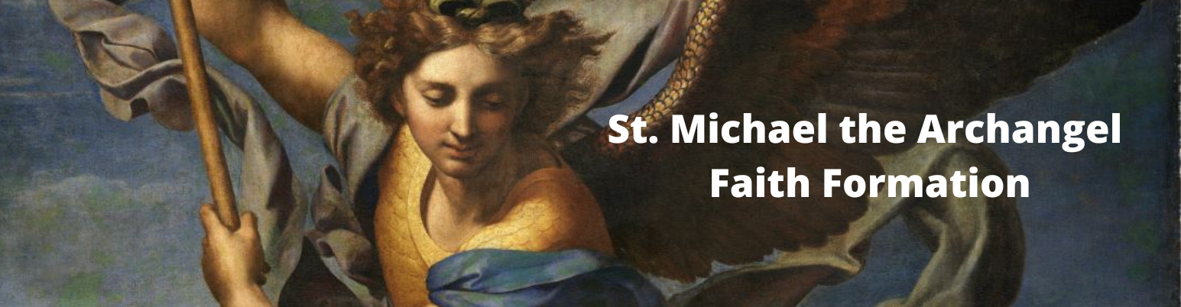
 |  | HOMESCHOOL SCHEDULE 2025-26
HOMESCHOOL ASSIGNMENT | *RELEASE DATE* |  | DUE DATE
1 | September 13, 2025 |  | October 5, 2025
2 | September 13, 2025 |  | October 12, 2025
3 | October 1, 2025 |  | October 19, 2025
4 | October 1, 2025 |  | October 26, 2025
5 | October 1, 2025 |  | November 2, 2025
6 | October 1, 2025 | HOMESCHOOL CHECK-IN (if assignments are behind, we will contact you) | November 9, 2025
7 | November 1, 2025 |  | November 16, 2025
8 | November 1, 2025 |  | November 23, 2025
9 | November 1, 2025 |  | November 30, 2025
10 | November 1, 2025 |  | December 7, 2025
11 | November 1, 2025 |  | December 14, 2025
12 | December 1, 2025 | HOMESCHOOL CHECK-IN | January 11, 2026
13 | January 1, 2026 |  | January 18, 2026
14 | January 1, 2026 |  | January 25, 2026
15 | January 1, 2026 |  | February 1, 2026
16 | January 1, 2026 | HOMESCHOOL CHECK-IN | February 8, 2026
17 | February 1, 2026 |  | February 15, 2026
18 | February 1, 2026 |  | February 22, 2026
19 | February 1, 2026 |  | March 1, 2026
20 | February 1, 2026 |  | March 8, 2026
21 | March 1, 2026 | HOMESCHOOL CHECK-IN | March 15, 2026
22 | March 1, 2026 |  | March 22, 2026
23 | March 1, 2026 |  | March 29, 2026
24 | March 1, 2026 |  | April 12, 2026
25 | April 1, 2026 |  | April 19, 2026
26 | April 1, 2026 |  | April 26, 2026
27 | April 1, 2026 | All assignments must be turned in by May 17, 2026 | May 3, 2026
 |  | Homeschool Saturday dates:
 |  | September 27, 2025
 |  | October 25, 2025
 |  | November 22, 2025
 |  | December 13, 2025
 |  | January 17, 2026
 |  | Note: pick 3 of the 5 dates to attend

9/5/25

