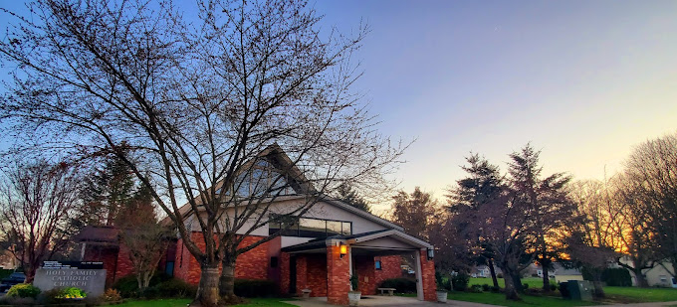

A Proposed Capital Campaign to Address Our
Capital Improvement Needs

Holy Family Catholic Church
Portland, Oregon

Introduction

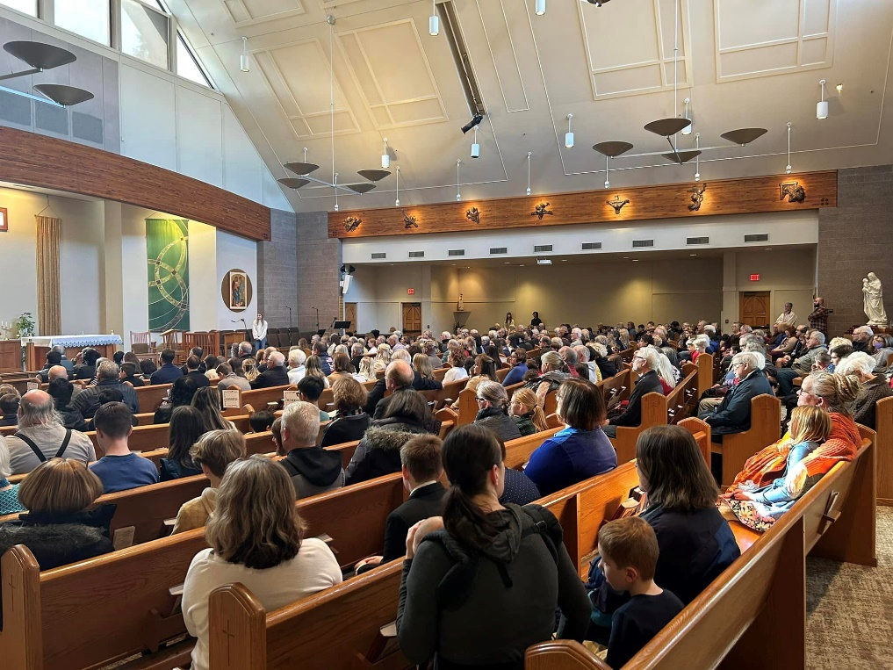

Holy Family Catholic Church is a vibrant community that dates back to 1931. For over 100 years now, our parish has been ministering to the needs of our community. And Holy Family School founded in 1948 has been providing excellence in education for over 75 years now, equipping our children with the strong spiritual, moral, academic, and physical formation foundation they need to succeed from adolescence to adulthood. And while facilities and faces have changed over the years, one thing remains the same…our commitment to Christ, to one another, and to the betterment of our community.
As a result, our parish community today is an active community comprised of over 400 families, and our school, which serves children of preschool age through the 8th grade, has an enrollment of 211 students. Led by a dedicated pastor, principal, parish, and school staff, in addition to a strong corps of lay leaders and volunteers, there are many ways in which people of all ages can participate in the spiritual, educational, social, and service ministries of our church and school.
Yet, despite our accomplishments and strong heritage of activity, some significant challenges remain.
God calls us to care for and cultivate all that He has given us…
not to be complacent, but rather, to constantly strive to be better, to build on and improve what we have… always trying to realize our God-given potential.

Our Needs

Immediate Needs

New Parish Office Center
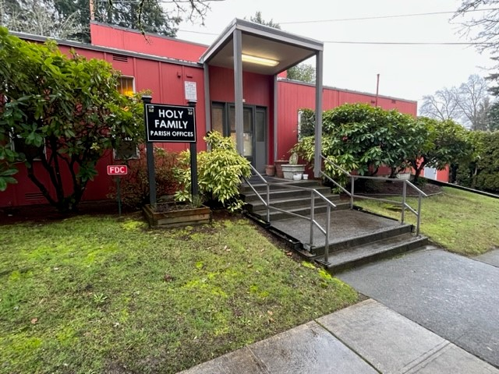
- Our existing parish offices are in our old convent building and are a good distance away from, and not central to, the other main buildings on our parish and school campus.

- This often makes it difficult for parishioners and visitors alike to find our parish offices.

- This also makes it inconvenient for parish staff to get to and manage various parish activities that are happening in our most often used and more centrally located main parish buildings.

- And finally, because our parish and school staff are located a great distance apart, there are some operational inefficiencies that exist, and it makes collaborating and building the more cohesive team we need and seek difficult at best.

- Also, because the parish offices were designed as residential living space for our school’s nuns, they are not ideal for use as professional offices in a variety of ways.

- The office reception area, for example, is too small and not very welcoming or inviting.

- Lighting and electrical systems are aging and not as cost or energy efficient as they otherwise could be.

- And office, work, and storage spaces too, were configured from old living spaces, and as a result, are poorly sized and shaped for professional office use.

- The existing parish office building also has cracks in the ceiling and a leaky roof that will need to be repaired, at a fairly high expense.

- And the problem is, it would be almost as expensive, if not more expensive, to repair this structure and bring it up to code than it would be to build an all-new building. Plus, even if we were to repair and remodel our existing parish offices, they still would not be ideally situated or suited to meet our parish’s needs.
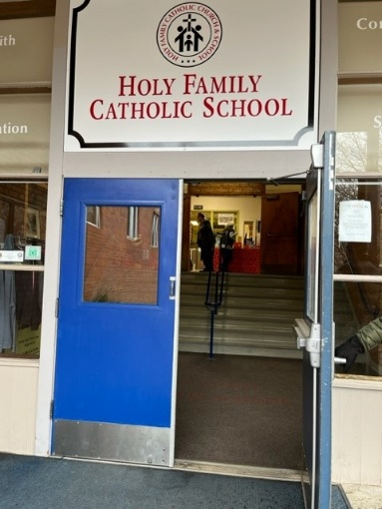
Improved Accessibility at our Parish Offices & Education Center
- Both the parish office building as well as our parish education center and school are also not fully handicapped accessible, which is an affront to our sense of social justice and not up to current building code requirements.

- Both buildings, for example, do not have an elevator and require climbing steps to access them and the various levels within them.

- This makes it difficult if not impossible for those with walkers or wheelchairs or those with mobility issues to partake in various meetings, activities, and events that we hold in these buildings.
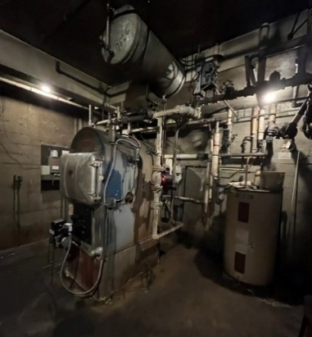
New HVAC System for Our Parish Offices & Education Center
- Our existing parish offices as well as our school building, also have old heating systems that have long outlived their useful lives, are cost and energy inefficient, and are increasingly and unnecessarily expensive to maintain.

- Regulation of heating is also difficult and spotty in both buildings, and neither building is air-conditioned. This makes them uncomfortable for occupants most times of the year, but especially on warm weather days.
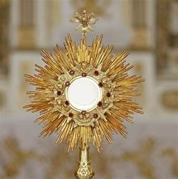
New Multi-Use Adoration Chapel
- We also don’t have a reverent small chapel for smaller group services or Eucharistic adoration on our existing campus that might be used for various other activities too.

- Currently, our main church is used for smaller group services and adoration, which is an overly large space for these purposes, especially since we must light, heat or cool this space whenever it’s in use.
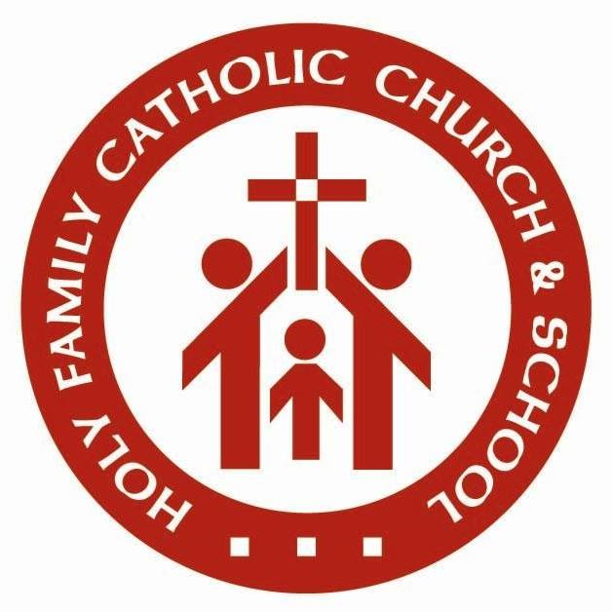

Celebration Hall Improvements
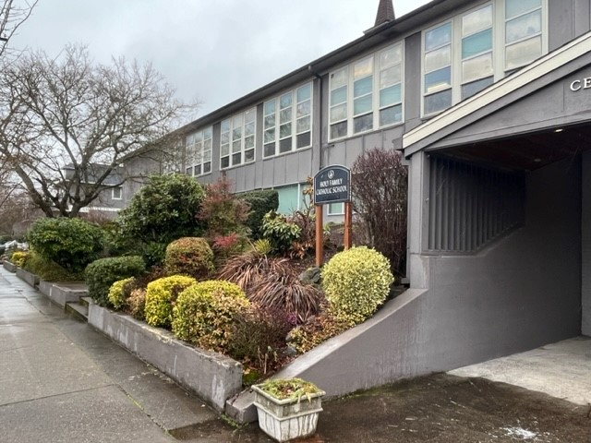
- Celebration Hall, which was designed for use primarily as a school cafeteria is attached to our education building and school. It’s also across the street from our church and used as a fellowship space for a variety of parish activities. This is less than ideal in various ways because it causes people to cross the street to attend parish socials and often causes conflicts when there are parish social activities on school days. But it serves its purpose for now. Yet there are still various problems with our existing hall we must address.

- The high walls with small windows near the ceiling make it look like you’re in an uninviting basement.

- The lighting system and fixtures we have are also not very illuminating and are not as cost and energy efficient as they otherwise could be.

- Plus, the floors, walls, ceilings, and décor are also dated.

- And the acoustics of the room do not lend themselves well to quality and clarity of sound.

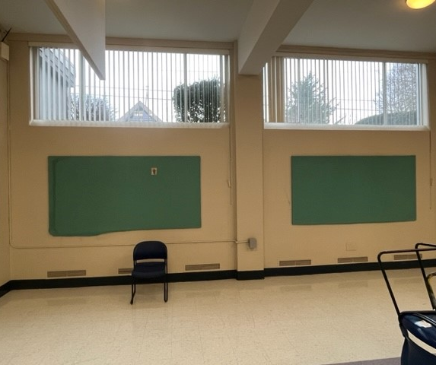

Ultimate Needs

New Multi-Use Gymnasium, Youth & Community Center

Our parish and school gymnasium is also aging and too small for many sporting and other events held or that we would like to host. Plus, it has no built-in bleachers or stage.

Our locker and restroom facilities are also in poor shape and need to be renovated or replaced.

While we have a dedicated youth space at our parish in the current gym it is not soundproofed and cannot be used when there are practices or games in the gym.

And finally, we also don’t have adequate space for our St. Vincent de Paul Food Pantry, which provides a needed and valuable service providing free food goods to the members of our parish and local community.

Education Center & School Expansion

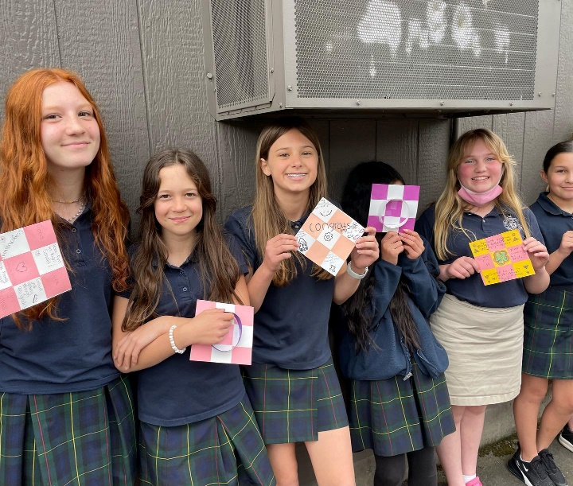
We will also need to someday expand available space at our school, which has seen a resurgence of growth over the years since the addition of our preschool and kindergarten classes as well as the Covid pandemic.

We also lack adequate dedicated space for important programs like science, technology, and music.

Plus, with the success of our preschool and kindergarten programs we’ve also had requests and seen demand for a new daycare program which could serve as an added feeder program and source of income for our parish and school.

New Dedicated Parish Hall Connected to Church

And finally, we’d also like to eventually have a dedicated parish hall that would be connected to our church, would provide more adequate space for various parish social activities, would be more easily accessible from our church, and would eliminate our having to displace school students when we need fellowship space for things like funeral luncheons on school days.

Let us rise-up to meet every need, to overcome every obstacle and to passionately pursue every opportunity available to better our church. This is the very essence of what God asks and commands of us as stewards of His church.
Our Plans

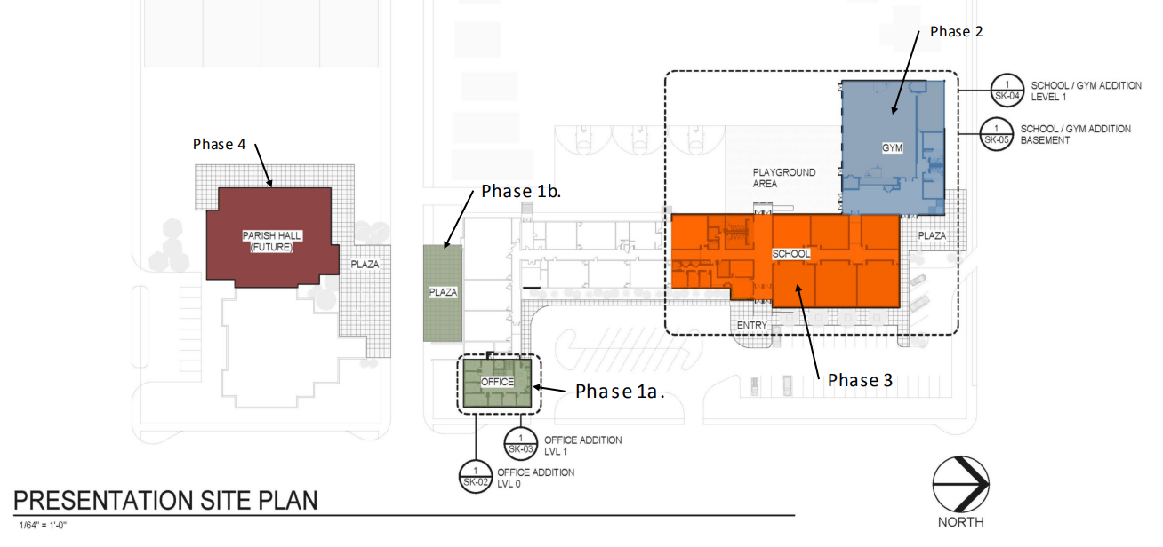
To address these various needs, we have a bold and exciting plan. It calls for the construction of a new more centralized Parish Office Center that will attach to the east side of Celebration Hall, which is connected to our education center and school and will include a new HVAC system and an elevator and ramp that will also be part of and benefit the school. We also plan to make some needed improvements to Celebration Hall. Ultimately, we additionally plan to also build a new multi-use gymnasium, expand our education center and school, and construct a new dedicated parish hall that will be attached to our church.

Immediate Plans

Parish Office Center Improvements
- The first phase of our plan calls for building a new two-story Parish Office Center which will be connected to Celebration Hall and our school.

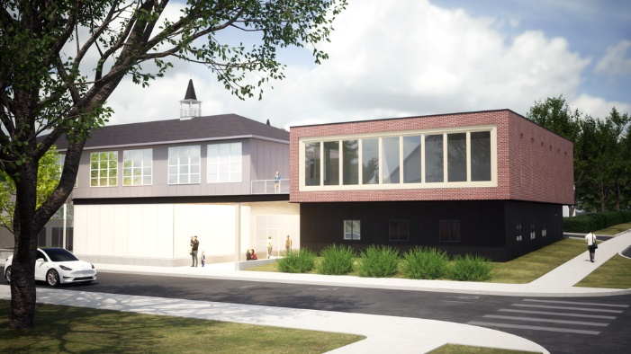
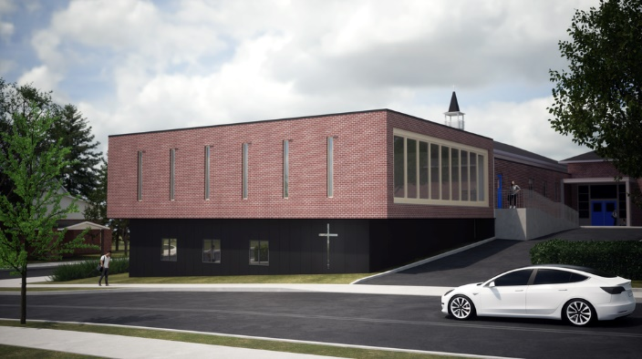

“Where there is no vision, the people perish.”

Proverbs 29:18-27

- This new parish office center will be more visible and central to our campus and will consist of:

- A new, more welcoming, and spacious reception area with an adjacent workroom, a small chapel with a storage closet where the chapel can be used for other various purposes too, a large-sized or community conference room, a handicapped accessible restroom, and ample storage, all on the ground level, and

- A combined parish and school office with a large open office area, a medium-sized conference room, an office for our pastor, three new amply sized parish and school staff offices, a handicapped accessible restroom, and an enlarged staff and teacher’s lounge on the new office center’s upper level.
Improved Accessibility at our Parish Offices & Education Center
- Our new Parish Office Center will also have a new elevator that will provide access to all levels of both the Parish Office Center and our education building and school.
New HVAC System for Our Parish Offices & Education Center
- Plus, this new building will also have a state-of-the-art HVAC system that will provide not only zoned and more cost and energy-efficient heating, but also, air conditioning throughout not only the Parish Office Center building, but also, our entire education center and school.

Just as those before us have done, we are called to build a better church, and to leave a legacy of improvement for those who follow us.
Celebration Hall Improvements
- We also plan to remove the overgrown landscaping on the street side of Celebration Hall facing our church building and replace the small windows and exterior brick on the south side of this building with new floor-to-ceiling glass wall with doors that open and extend the entire length of this side of the Celebration Hall building. This will dramatically open and flood the hall with an abundance of beautiful, warm, and natural light.

- Immediately outside this new glass wall and doors of Celebration Hall, we also plan to add a new, more welcoming and inviting outdoor entry and gathering plaza that will be used for a variety of purposes and will invite and welcome people into our hall.

- And the interior of the hall will be undergoing a dramatic transformation too.

- It’s ceilings and flooring will be replaced with new more aesthetically and acoustically pleasing materials,

- It’s lighting system and fixtures will be updated with brighter more cost and energy- efficient fixtures and lights,

- The walls of Celebration Hall will be acoustically treated and repainted, and

- We will refresh the hall’s décor and furnishings too.

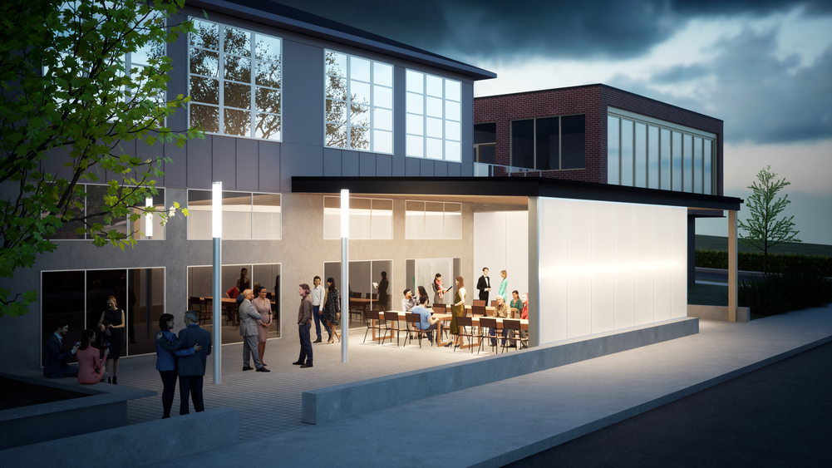

Ultimate Plans

New Multi-Use Gymnasium, Youth & Community Center

Then, in a future phase, we plan on building an all-new, multi-use gymnasium with built-in retractable bleachers and stage, a new dedicated and soundproof youth room, and an enlarged St. Vincent de Paul Food Pantry all that would extend from but be connected with our school.

Education Center & School Expansion

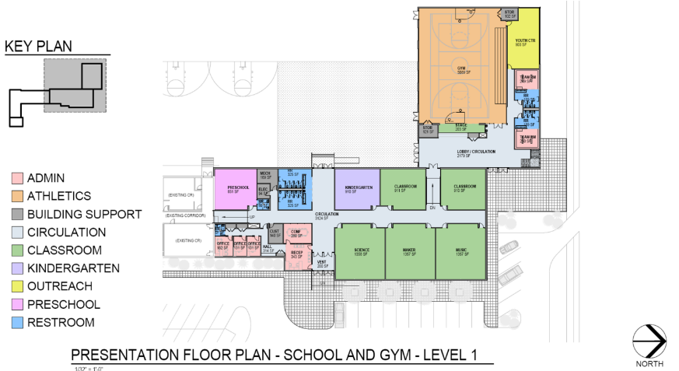
We also plan at some point, to expand our education center and school to include dedicated in-school spaces for our preschool and kindergarten classes as well new classrooms for science, technology, and music too.

Plus, we’d also like to explore the possibility of starting a daycare program and having this be part of our school.

New Dedicated Parish Hall Connected to Church

And finally, we’d also like to someday have a dedicated parish hall that would be directly connected to our church and would provide more adequate space for various parish social activities and would eliminate our having to displace school students when we need fellowship space for things like funeral lunches on school days.
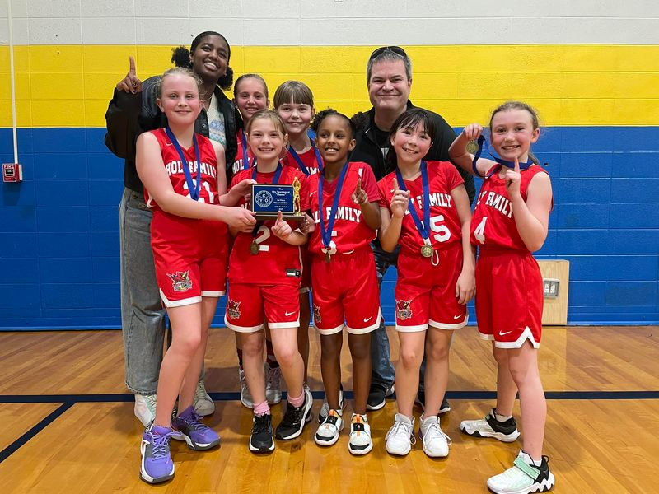

Costs & Campaign

The total cost for addressing our most immediate needs is estimated to be in the $3.5 million range, an amount that we would plan to raise in a specially conducted capital campaign where members would be asked to prayerfully consider special gifts – over and above their current gifts to the church – in support of this special project and need.
Gifts to the campaign could be made in a number or combination of ways.
- Pledges over a three-year period would be encouraged and probably essential to meeting our needs since it would be impractical, if not impossible, to reach a goal of this magnitude with one-time, out-of-pocket gifts.
- Non-cash gifts such as securities, real estate and personal property would also be accepted and encouraged as would
- Deferred gifts, such as life insurance policies, gifts in trust and gifts through one’s estate.

“As each one has received a gift, use it to serve one another as good stewards of God’s varied grace.”
1 Peter 4:10

Summary

Through the generous prayerful, volunteer, and financial support of many – and the extraordinary support of a few – we believe that we can succeed in our task. As a result, we are also quite confident of our continued growth as a faith community and in our ability to do even better God’s will and works. So, thank you for your feedback and support in advance.

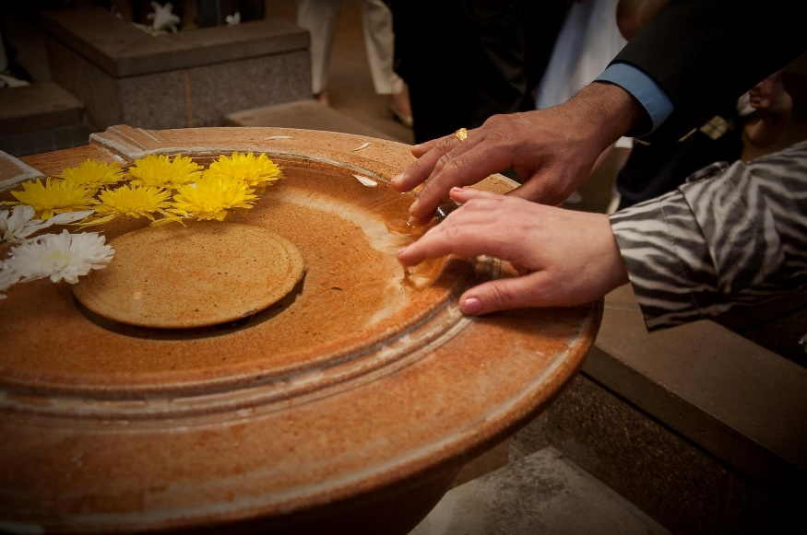

Recognize that all you are and have, are gifts from God. Respond appropriately by sharing what you have in a loving and lasting way with those who seek to do His will and work. This is the essence of what it means to be a sound steward, to emulate the example and become a disciple of the ultimate steward – Jesus Christ.

