Step 1
Create Account
You can create an account with our company by filling out the form below on the www.teacherreacher.com website:
- Click the “SignUp” link in the upper right corner
- Select your school district
- Enter your first and last name
- Enter your email address
- Enter a password
- Enter the Captcha code
- Check your email account for an activation email from donotreply@teacherreacher.com

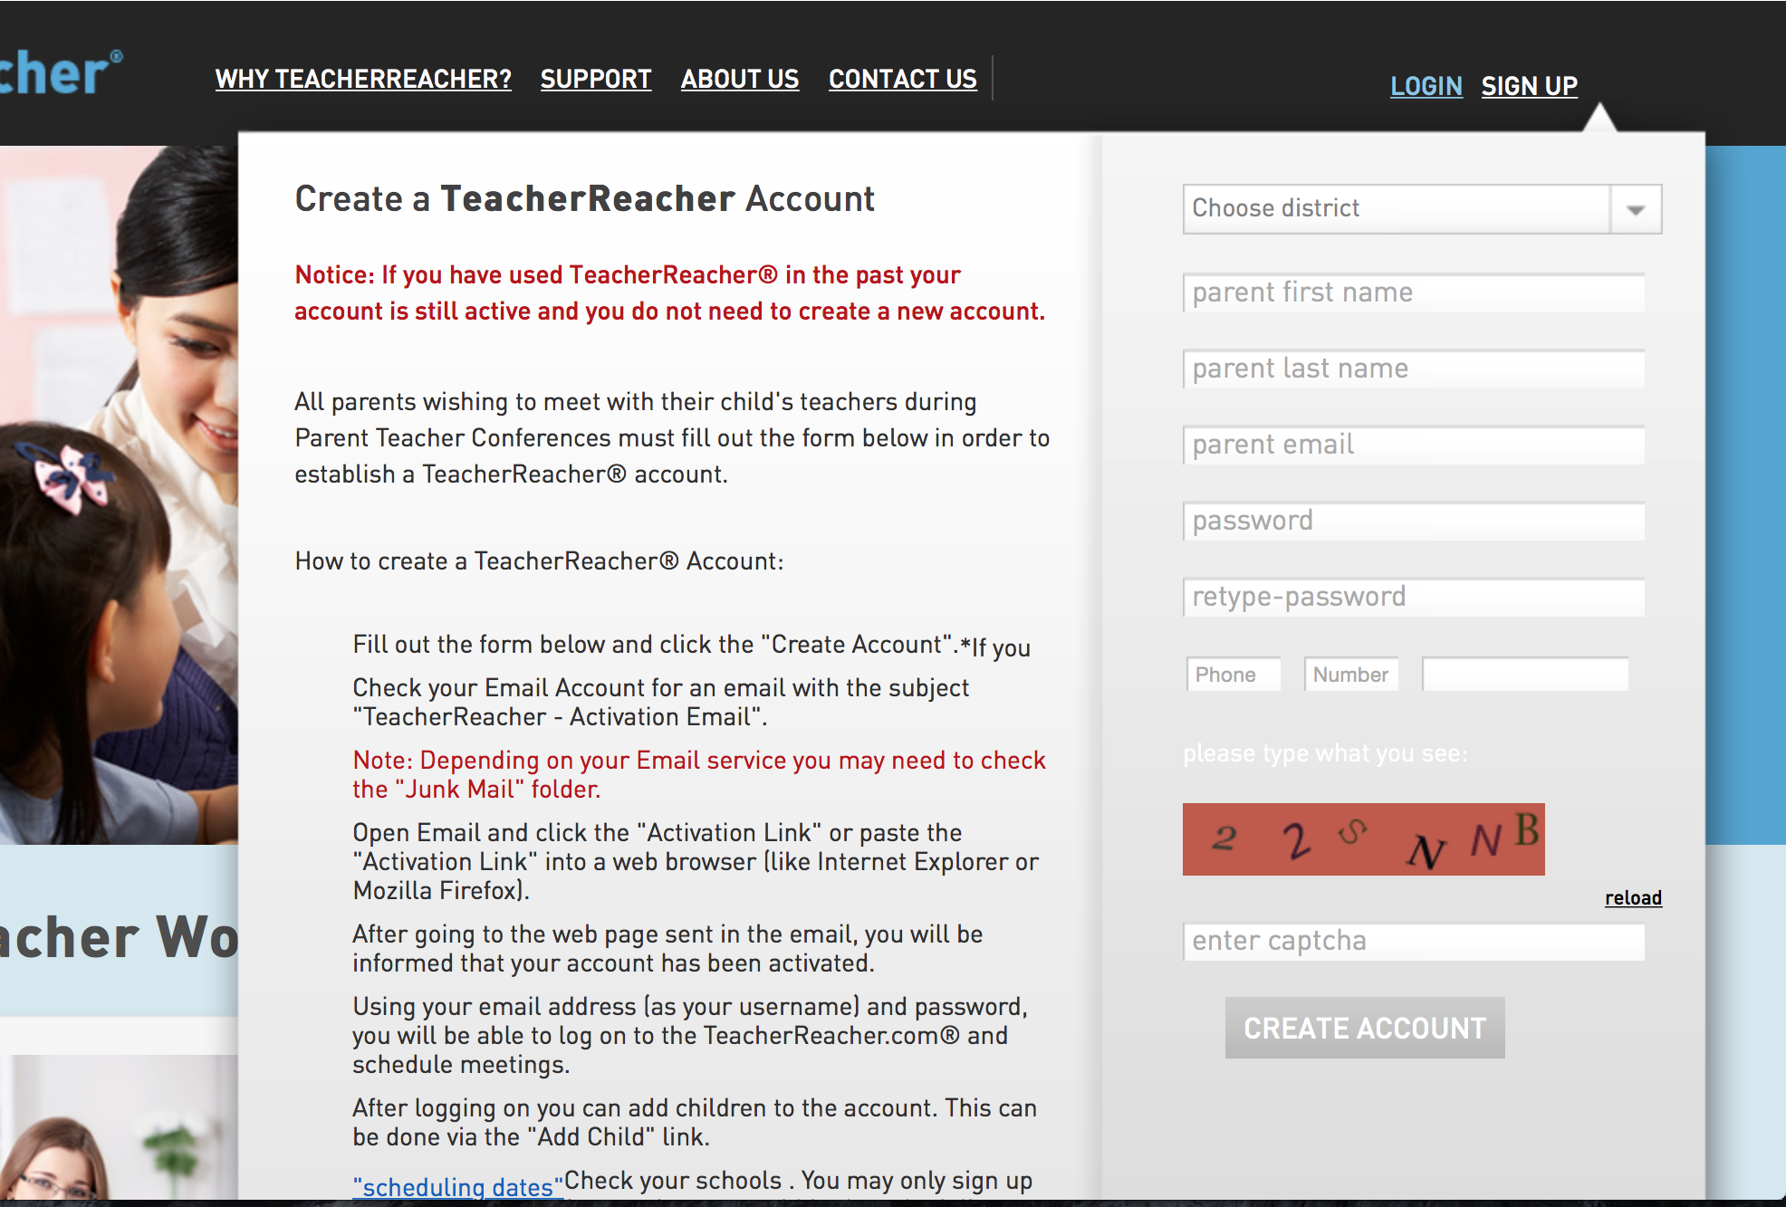

Step 2
Activate your Account
Check your email account for an email from admin@teacherreacher.com.
Open email and click link inside.

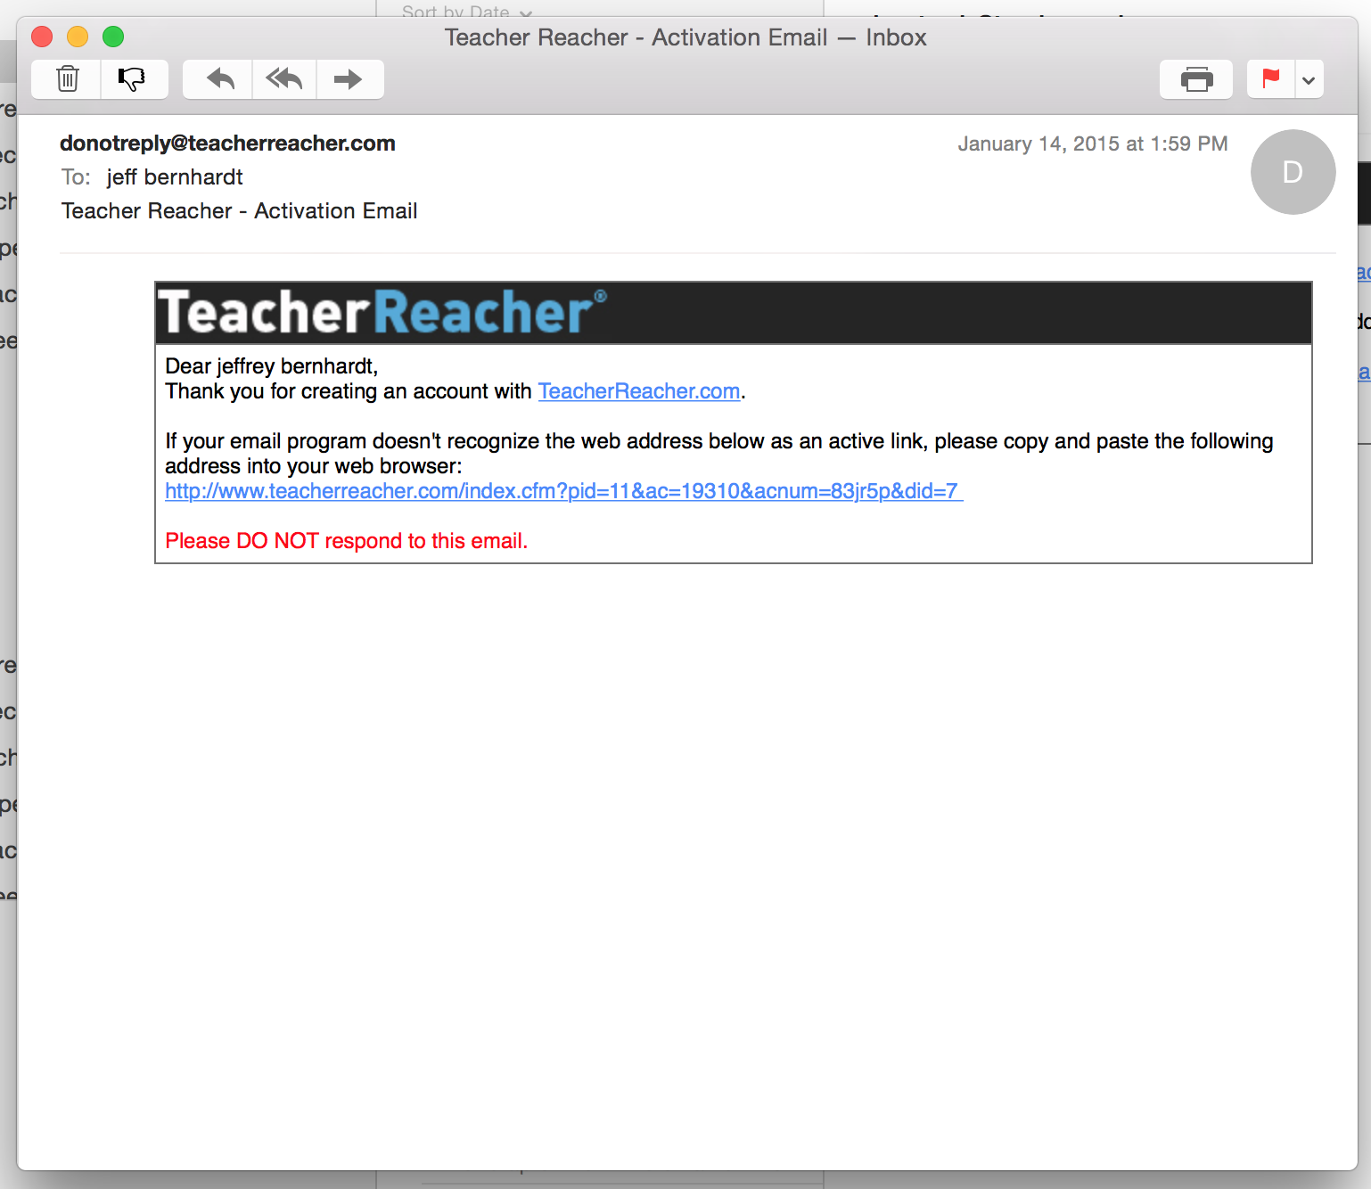

Step 3
Add Children
- Select the school
- Enter Child's Name (as registered in the school district)
- Enter the Child’s birth date
- Click "Find Student"
- Select the correct student from the list below.
- Click "Add Student"
- Repeat.

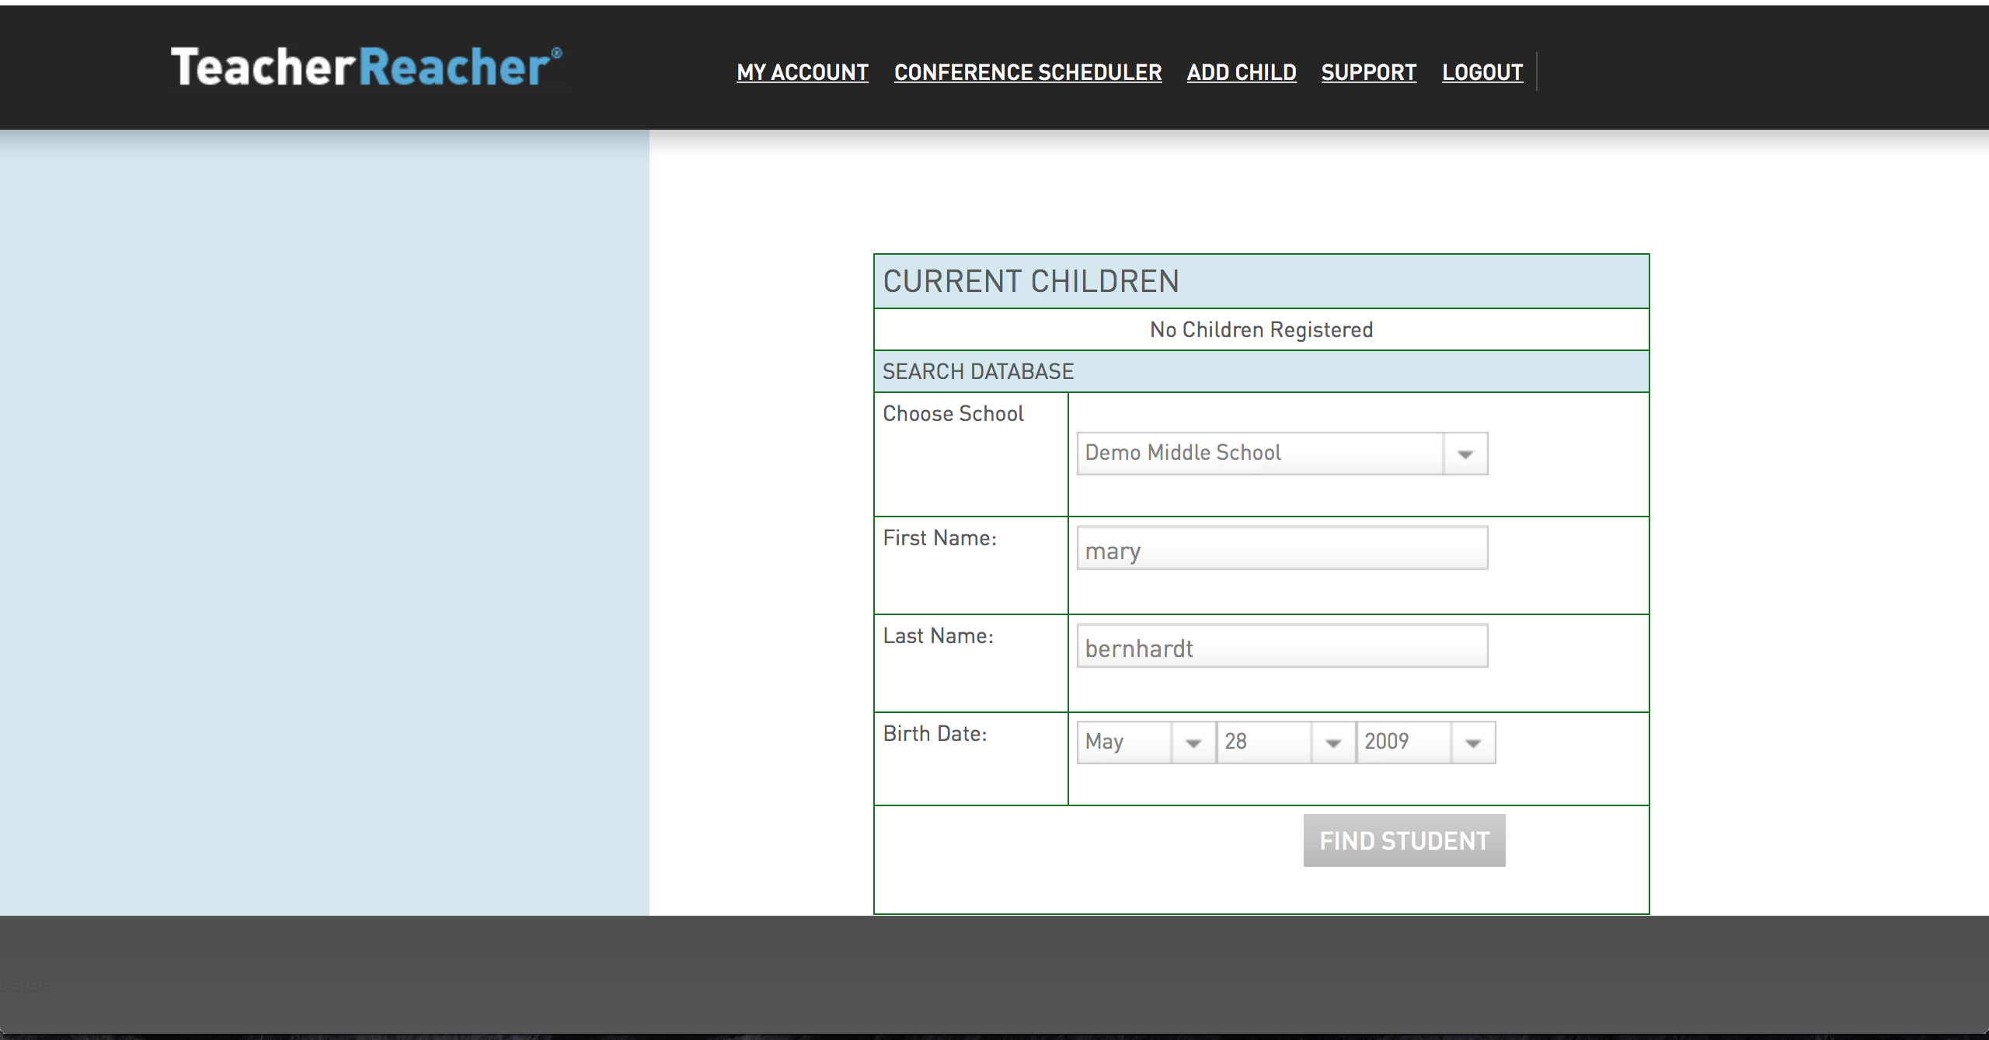

Step 4
Choose Conference Type
Parent Teacher – Are the standard, one-day conference in which parents choose times to meet with teachers.
Events – Are conferences that held over several days. An example of this type of conference would be 11th Grade Guidance Meetings. In this situation the parent has a choice of several days days in which to choose and appointment.
Seminars – Are meetings that have one start time and a limited number of seats. An example of this would be extra help sign up.
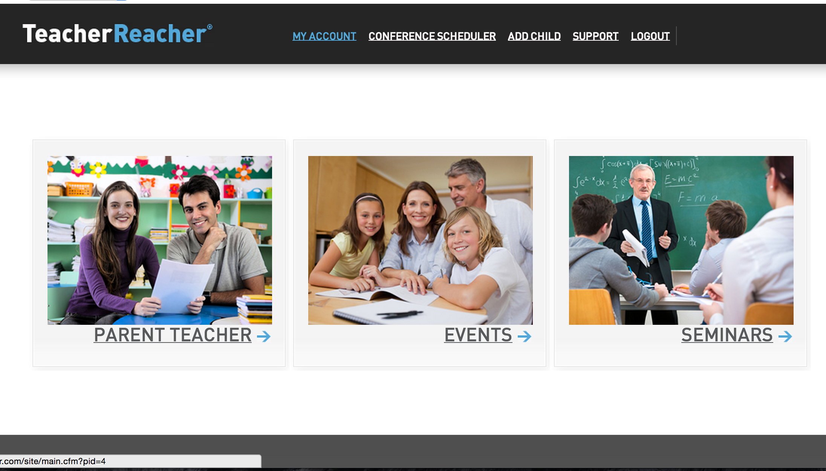

Step 5
Schedule Appointments Part 1
Click on the “MAKE APPT.“ link under the Conference name.
Note: You can only make appointments when scheduling is open.

Click the Scheduling Dates link to see when scheduling will be open.

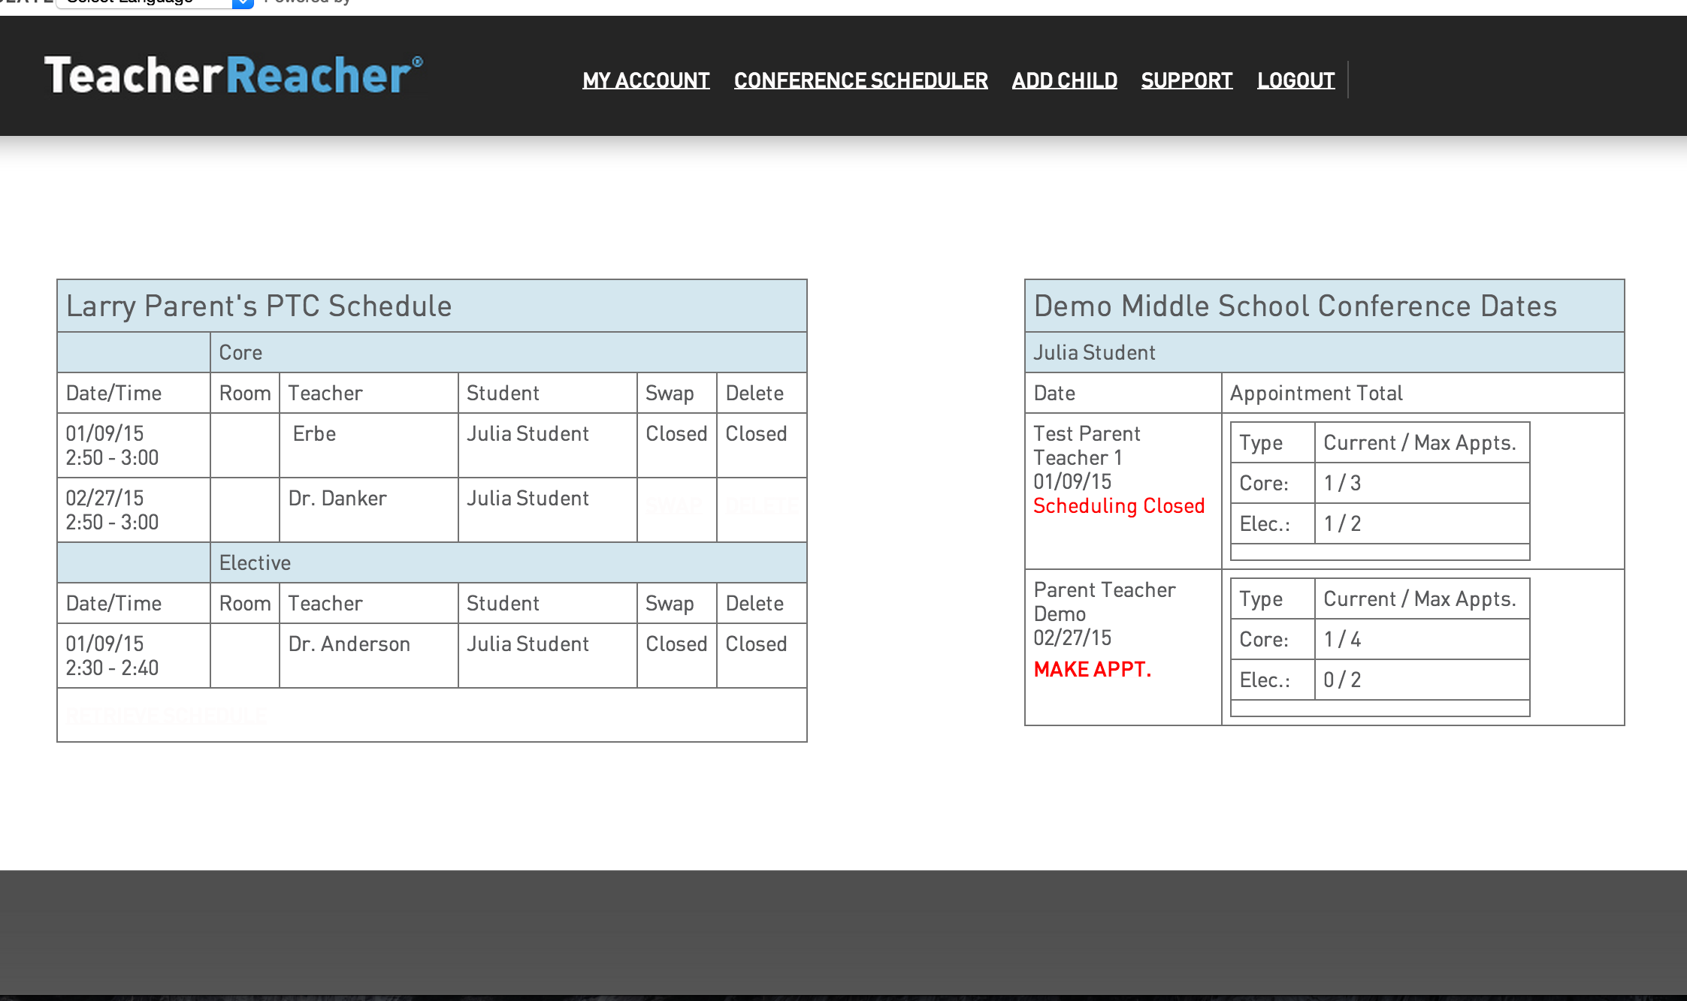

Step 6a – Sorted by Department
Schedule Appointments Part 2
- Click on an Academic Department.
- Click on a teacher.
- Choose an available time.
- Click the “Submit” button.
- Go back to Step 5 and repeat

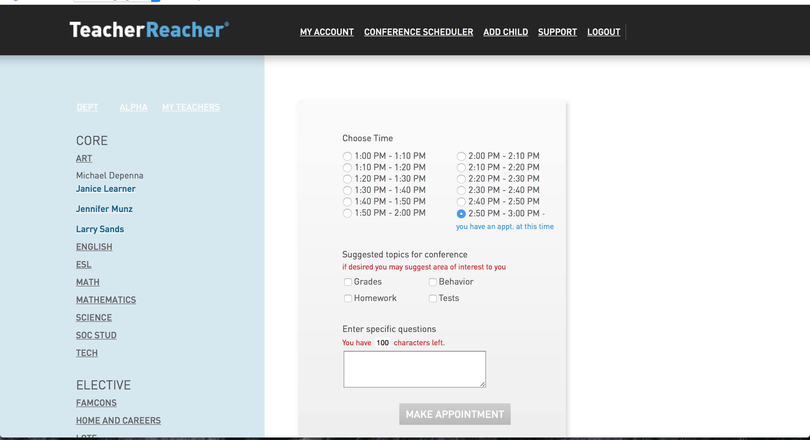

Step 6b-Sorted Alphabetically
Schedule Appointments Part 2
- Click on a teacher.
- Choose an available time.
- Click the “Submit” button.
- Go back to Step 5 and repeat

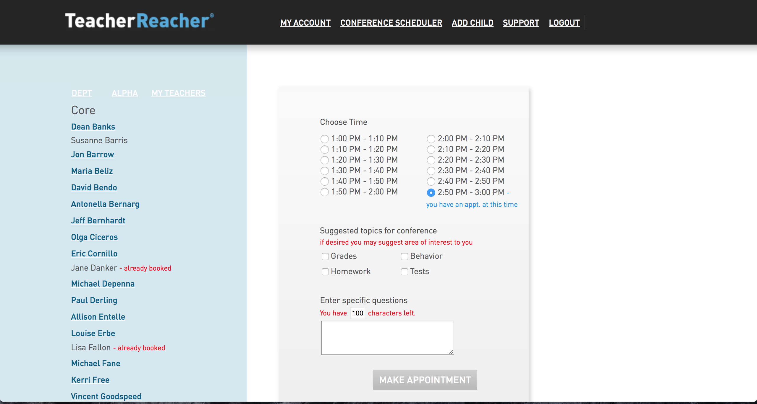

Step 6c-Sorted According By the Students Teachers
Schedule Appointments Part 2
- Click on a teacher.
- Choose an available time.
- Click the “Submit” button.
- Go back to Step 5 and repeat



