SAINT ROSE OF LIMA
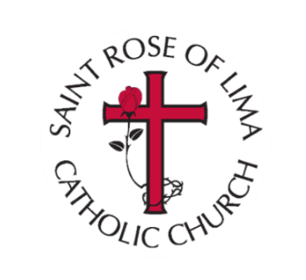
Liturgy Committee
2022-2023
Catherine Wagner, Chair
Bob Buschinski, Greeters
Darlene Buschinski, Greeters
Tom Gahler, Arts and Environment
Maureen Schuh
John Clifford, Lectors
Janine Armstrong, Parish Pastoral Council
Eric Blomquist, Ushers
Alex Schindler, Music
Julie Buerkle, Eucharistic Ministers

