CWL Newsletter #44 – November 15th, 2025
Happy Saturday my fellow CWL Sisters!

🎄 Today’s the Day — Our Christmas Market Has Arrived!

After months of preparation and joyful collaboration, the St. Michael CWL Christmas Market is finally here! What began in September with our Pie Workshops, continued through October with our Tourtière creations and Basket Making, and wrapped up earlier this month with our Frozen Cookie Dough and Quiche Workshops - all of it has led to this exciting day!
We are thrilled to welcome you to our Christmas Market today from 9 AM to 1 PM in the St. Michael Meeting Room. This event is the culmination of our fall fundraising efforts, and we couldn’t have done it without the incredible dedication of our members and supporters. A heartfelt thank you to everyone who contributed their time, talents, and generosity. Your support means the world to us, and we know today will be a resounding success because of you.

If you have never attended our Christmas Market before, what can you expect to find?
- ✨ Handcrafted Quilts by our talented St. Michael’s Sewing Group
- 🎁 160 Gorgeous Gift Baskets — perfect for hostess gifts or holiday thank-yous
- 🥧 300+ Tourtières & 50 Quiches — plus a variety of frozen Cookie Dough flavours
- 🍪 Homemade Baking to sweeten your season
- 🎨 Crafts, Sewing, Knitting treasures made with love
- 📚 Pre-loved Puzzles & Children’s Books — great for cozy winter days
- 🍪 Complementary Hospitality Corner & Café – to keep you nourished and hydrated while you complete your shopping!

So if your morning is free, why not come out and join us for some festive shopping and holiday cheer??? And don’t forget to bring a friend!

Urgent: Pikangikum Christmas Gift Project 2025 – We Need Your Help!

There are still 8 names left for Christmas Gifts for our Family of Parishes Pikangikum Christmas Gift Project. If you would like to provide a gift for one of these 8 people on the list, please contact Theresa vanKeoverden at hmprt@gmail.com or Vera Lawlor at vllawlor@cogeco.ca. Your generous gift donation will bring a smile and message of love to a needy person in Pikangikum First Nation community this Christmas.

💙 CWL Supports St. Vincent de Paul’s Capital Campaign

Following last Sunday’s Mass, our CWL Council proudly presented a $1,000 donation to St. Vincent de Paul in support of their recent Capital Campaign. This initiative aims to upgrade and improve their facilities, ensuring they can continue serving our community with dignity and care.
Our members unanimously endorsed this contribution during our September meeting, recognizing the campaign as a deeply meaningful and impactful cause. We are grateful to be part of this important effort and extend our prayers and support to all involved.

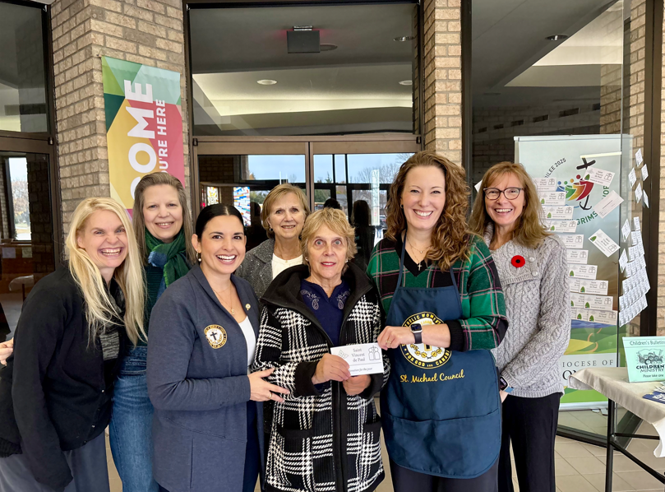

CWL Executive Members assisting with the cheque presentation to Linda Kensley – President – SVPP Sarnia Lambton: LEFT – RIGHT: Lizzie Cyr, Deb Hoek, Mary Grace Craievich, Mary van Delft, Linda Kensley, Stefanie Hammond, Christine Bresette.

2026 CWL Membership Dues – Time to Renew!

As we prepare for Christmas and look ahead to a new year, this is a reminder that it is time to renew your St. Michael CWL Membership for 2026!

Annual dues are $40.00, and there are several convenient ways to submit your payment:
- Cash or cheque in a clearly marked envelope with your name, email, address, and phone number, placed in the weekly collection basket
- Mail or drop off at the parish office
- E-transfer to: cwlsmbgdues@gmail.com (please note in the message: St. Michael CWL Membership)

If you are planning to attend our Christmas Market this Saturday, Maria Do Rego – our Membership Coordinator – will be available in the Narthex to assist those who wish to renew their membership dues this weekend.

Thank you so much to those who have already renewed. Your commitment helps us continue the important work of the CWL.

Tickets on Sale Soon for Our December General Meeting & Christmas Dinner

Just a heads up that starting Sunday, November 23rd, we will begin selling tickets for our December General Meeting, taking place on Wednesday, December 10th.
The evening will begin at 6:00 PM at the Church with a short prayer, reflection, and a Memorial Service honouring the CWL members of our Council who have passed away this year. Following the service, we’ll gather at Huron Oaks for a festive dinner and a brief business meeting.
Dinner tickets are $30 (includes taxes & gratuity), and you’ll have your choice of:
- Traditional Turkey Dinner
- 1-piece Pickerel Dinner served with greens
- Portabella Stuffed Mushroom Caps served with greens
- Plus a Festive Dessert to finish

Tickets will be available after Mass on November 23rd and November 30th. Final numbers must be submitted to Huron Oaks by December 2nd, so don’t delay!

Supporting New Moms in Our Community

At our December meeting, we’ll also be collecting donations for St. Vincent de Paul’s “Newborn Gift Bag” Program, lovingly led by our own council member Valerie Barcroft. This initiative provides essential items to new mothers who visit the Food Bank and Help Centre.
Valerie assembles each gift bag with care, and the following items are especially appreciated:
- Baby blankets
- Socks
- Newborn & Size 1 diapers and wipes
- Sleepers (Size 0–3 months — urgently needed)
- Onesies (Size 0–3 months)
- Bibs
- Bath towels, washcloths, baby soap & body wash
- A small toy or book
- Or a monetary donation, which Valerie will use to purchase needed items
(Please indicate that your donation is for the SSVP “Newborn Gift Bag Program”)

Valerie has shared that many women are expecting babies in the coming months, so your generosity will make a meaningful difference. Thank you in advance for supporting this beautiful and compassionate cause.
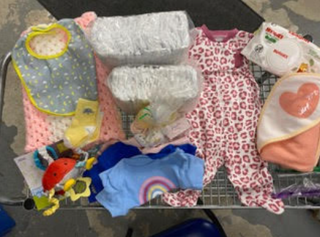
A sample gift bag that Valeries assembles and distributes.

You Are Cordially Invited to a Ladies Only Night Out!

The Watford CWL would like to invite all ladies in our community to come and enjoy a night out at their Annual Christmas Dinner, Penny Sale & Skit Night. This legendary event is taking place on Thursday, December 4th, 2025 at East Lambton Community Complex/Hall, 61 Centennial Ave. Watford, ON.
Admission is $20.00 and doors open at 5:30pm sharp. There will be a Buffet Style Supper at 6:30pm, with entertainment to follow. Advance tickets not required.


Honour Guard Request for the Feast of the Immaculate Conception

We are honoured to once again be invited to participate in the Honour Guard for the upcoming Feast of Immaculate Conception that is taking place on Monday December 8th at 7pm at Our Lady of Mercy Church. If you are planning to attend and would like to participate in the Honour Guard and procession, please let me know as soon as possible so I can advise the organizers and ensure sufficient seating is reserved for our council members. Following the Mass, there will also be a social gathering taking place in the OLM Hall.
Thank you to those that have already messaged me that they are interested in participating – your presence and support is greatly appreciated.

Red Wednesday – Wednesday November 19th

Red Wednesday – being observed this year on November 19 - is a global day of international awareness for the persecution of Christians. This day is marked by prayer, advocacy, and symbolic red lighting.
Red Wednesday was established in 2016 by Aid to the Church in Need (ACN) to raise awareness of the persecution and discrimination faced by Christians around the world. The colour red symbolizes the blood of martyrs and the suffering endured by those who cannot freely practice their faith. This initiative promotes religious freedom and tolerance across all faiths. In Canada, Red Wednesday has grown significantly since its launch in 2018, with over 40 events planned nationwide in 2025.
For members of the Catholic Women’s League and other faith-based women’s groups, Red Wednesday holds deep significance:
- Spiritual Solidarity: Catholic women are often the spiritual backbone of their communities. Red Wednesday invites them to unite in prayer for those suffering for their beliefs.
- Advocacy and Awareness: Women can be powerful advocates for justice. By participating in Red Wednesday, they help amplify the voices of the oppressed and educate others about religious persecution.
- Empathy for Mothers and Families: Women, especially mothers, may feel a unique connection to families torn apart by religious violence. Red Wednesday is a chance to channel that empathy into action.

There are several meaningful ways Catholic women can participate in Red Wednesday:
- Attend or organize a Red Wednesday Mass or Rosary
- Wear red or light your home in red
- Share stories of persecuted Christians on social media
- Support ACN or similar charities with donations or outreach
- Include prayers for religious freedom
Noteworthy Events from Our National, Provincial and Diocesan Councils:
To remain up to date on National, Provincial and Diocesan news and events, I encourage everyone to regularly check out the CWL National, Provincial and Diocesan websites.

November’s ON-Line Newsletter has been published: https://cwl.on.ca/wp-content/uploads/2025/10/NOV-2025-NEWSLETTER.pdf

Highlights from the CWL Ontario Provincial November Newsletter
- Message from Leadership: Encouragement to live out the League’s mission of faith, service, and social justice as we approach Advent. Members are reminded to embrace hope and gratitude during this season.
- The Ontario Provincial Council is now on YouTube! https://www.youtube.com/@OntarioProvincialCouncilCWL/shorts It’s to be used as a hub for sharing updates, insights, and inspiration from across our organization.
- Social Justice Focus: Reflection on the International Day for the Eradication of Poverty (October 17) and the League’s ongoing commitment to justice and dignity for all Canadians.
- Service Updates: Councils are encouraged to continue supporting local and provincial initiatives, including outreach programs and parish-based activities that strengthen community ties.
- Upcoming Events & Reminders:
  - Preparations for the 2026 Provincial Convention are underway.
  - Members are invited to submit ideas for webinars and faith-building activities.
- Faith Formation: Emphasis on prayer and spiritual renewal as we enter Advent, with resources available through the CWL website, including prayers and seasonal reflections.

Upcoming Events
- November 25th – CWL Regional Meeting – St. Ben’s – 7pm **All CWL members are welcome to attend
- December 1st - CWL Executive Meeting – St. Michael Meeting Room – 6:30pm - **All CWL members are invited to attend Executive Leadership Meetings
- December 10th – CWL General Christmas Meeting – St. Michael Church & Dinner at Huron Oaks – 6pm-9pm – tickets will be on sale after the Christmas Market
- March 6th – World Day of Prayer hosted by St. Michael CWL – more details to come
- April 20-21, 2026 - London Diocesan Convention & Annual Meeting of Members – Chatham - more details to come
- June 6th – St. Michael CWL Spring Retreat – more details to come

- Link to St. Michael CWL page on the Family of Parishes website St. Michael.

- To check out all upcoming events taking place within the Family of Parishes, you can check out the weekly Bulletin HERE

Prayers
- For Pope Leo’s special intention for November - inspired by Pope Francis - For the prevention of suicide. Let us pray that those who are struggling with suicidal thoughts might find the support, care and love they need in their community, and be open to the beauty of life.

- For our monthly CWL Mass Intention for November: For the repose of the souls of our deceased CWL members.

- For those around the world who suffer persecution for their Christian faith. May God grant them strength, courage, and hope in the face of hardship, and may we, as a community, stand in solidarity with the persecuted, lifting them in prayer and advocating for their dignity and freedom.
- For God’s blessings across our St. Michael CWL Sister Membership. May the Holy Spirit continue to be with us and support us as we work to fulfil our mandate to promote the teachings of the Catholic Church, uphold Christian values, and advocate for social justice and human rights.

- For the intentions of our CWL members and their families especially those who are sick, undergoing treatments, or requiring surgery that they will be given the comfort, strength and the grace they need to face their challenges and be returned to good health and for their caregivers.

- For the intentions held within our St. Michael Parish Prayer Intention Book.

- For the land on which we gather, that is part the ancestral land of the Chippewa, Odawa, and Potawatomi peoples, referred to collectively as the Anishinaabeg. We pray that together – as a treaty people – we respect the environment that sustains all life, protecting the future for those generations to come.

- For peace in our world.

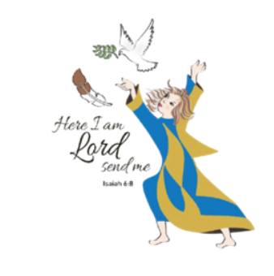
Here I Am Lord, Send Me!
If you have any questions about the Catholic Women’s League, have other concerns or need help, but don’t know who to ask, please don’t hesitate to reach out to me and I will try to help if I can.
If you have a prayer request that you would like sent out to our CWL members or if you have a celebration that you would like to share with your sisters in the League let me know.
I can be reached at 519-381-3129 or cwlsmbg@gmail.com.

Our Lady of Good Counsel, Pray for Us and Bless Us in All We Do
Stefanie Hammond
CWL President – St. Michael Council

