CWL Newsletter #45 – November 22nd, 2025
Happy Saturday my fellow CWL Sisters!

As we close the liturgical year this weekend with the Solemnity of Christ the King, the Church reminds us that Jesus is the one true King, and his kingdom and rule is not about power or dominance, but is one that is centred on love, forgiveness, and service. He is a different kind of king – His throne is the Cross, and His crown is made of thorns. This is the kind of King we are called to follow.

This weekend also marks a joyful milestone for our Family of Parishes, as 80 candidates from across the city will be gathering at St. Michael Church tomorrow afternoon to receive the Sacrament of Confirmation – including my son – Nathan. How fitting that this celebration coincides with the Solemnity of Christ the King, because it is in Confirmation that the Holy Spirit strengthens us to live as witnesses to Christ’s kingdom. These young men and women are not simply completing a rite of passage - they are being anointed, like David, to share in Christ’s mission and to bring His light to our world. They are being called to say ‘Yes’ and to let Jesus into their hearts and bring His love, compassion and mercy to those around them.

And the readings this weekend speak powerfully to this call.

In the first reading from 2 Samuel, David is anointed as King, and Israel is united under David’s rule. David is the shepherd - chosen to unite God’s people - which foreshadows Jesus as the Good Shepherd for us, who gathers us all into His kingdom.
This theme continues into the second reading of St. Paul to the Colossians where St. Paul proclaims that Jesus is everything – He is the true head of the Church and the one who holds all things together. He reminds us to keep Christ at the center our lives, even when the world wants to pull us in other directions.

This feast and sacramental weekend invite a personal reflection for us - we are continually called to examine our own lives and to ask ourselves who truly rules my life - Jesus or the pressures around me? This weekend’s readings challenge us to set aside our own fears, uncertainties and ambitions and surrender them to Jesus and to model His compassion in our homes, workplaces, and within our broader community. This also extends to encouraging those newly confirmed to live boldly in their faith by supporting them through prayers and example.

So, as we celebrate the Solemnity of Christ the King and the beautiful sacrament of Confirmation this weekend, may we renew our resolve to place Jesus at the very centre of our lives. Let us invite Him to reign in our hearts to guide our thoughts, words and actions. May His kingdom of love and mercy begin and shine through us, so that others may encounter His presence through the way we live and love.

🎄 Our Christmas Market Recap

After months of preparation and joyful collaboration, the St. Michael CWL Christmas Market that took place last weekend was another resounding success! So many accolades were received around how beautiful everything was and how friendly and welcoming our volunteers were. This message is just one of the many I received:

“Many thanks to you and the other talented ladies for putting on such a lovely Christmas Market. Everyone was so welcoming, helpful, and especially kind and generous to my two grandchildren. The atmosphere was festive and colourful. Definitely something for everyone. Lots of variety. I managed to purchase many gifts for teachers etc. at a very reasonable price. I also shopped for myself! My grandkids each selected a quilt which I will wrap for Christmas. They somehow have to forget they picked them out! Thank you for all of your hard work and planning. It takes a very cooperative group to follow the leader in such a successful endeavour. Blessings to all.”

So again, a heartfelt thank you to everyone who contributed their time, talents, and generosity to making our Christmas Market such a success.

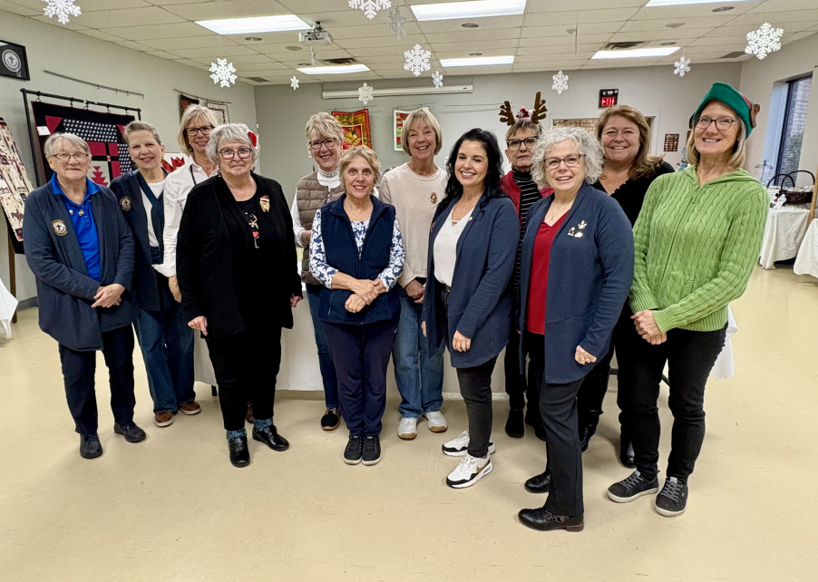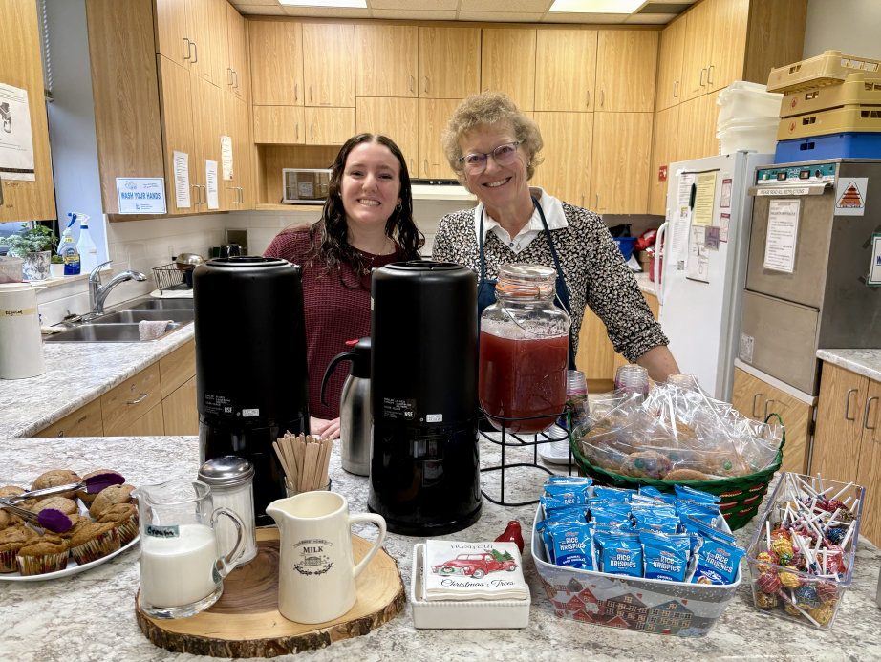
This is only a very small handful of the number of volunteers from the Christmas Market! I wasn’t quick enough to grab a bigger group picture in the morning before we opened – so my apologies!

2026 CWL Membership Dues – Time to Renew!

This will be an ongoing reminder for the next few weekends that it is time to renew your St. Michael CWL Membership for 2026!

Annual dues are $40.00, and there are several convenient ways to submit your payment:
- Cash or cheque in a clearly marked envelope with your name, email, address, and phone number, placed in the weekly collection basket
- Mail or drop off at the parish office
- E-transfer to: cwlsmbgdues@gmail.com (please note in the message: St. Michael CWL Membership)

Thank you so much to those who have already renewed. Your commitment helps us continue the important work of the CWL.

December General Meeting & Christmas Dinner - Tickets Go On Sale Tomorrow After Mass

The time has come! Tickets for our December 10th General Meeting & Christmas Dinner go on sale tomorrow, after the 10:30am Mass.

The evening will begin at 6:00 PM at the Church with a short prayer, reflection, and a Memorial Service honouring those CWL members from our Council who have passed away this year. Following the service, we’ll gather at Huron Oaks for a festive dinner and a brief business meeting.

Dinner tickets are $30 (includes taxes & gratuity), and you’ll have your choice of:
- Traditional Turkey Dinner
- 1-piece Pickerel Dinner served with greens
- Portabella Stuffed Mushroom Caps served with greens
- Plus a Festive Dessert to finish

We will also be selling tickets next weekend as well after Mass as final numbers must be submitted to Huron Oaks by December 2nd, so don’t delay!

If you know already that you won’t be at Mass and would still like to purchase a ticket, please reach out to me by email: cwlsmbg@gmail.com and we will work to get you all sorted!

And, as a reminder for any of our events, you are encouraged and invited to bring a friend to share in the spirit of our amazing CWL council! There will be lots of room at Huron Oaks for everyone!

Supporting New Moms in Our Community

And at our December meeting, we’ll also be collecting donations for St. Vincent de Paul’s “Newborn Gift Bag” Program, lovingly led by our own council member Valerie Barcroft. This initiative provides essential items to new mothers who visit the Food Bank and Help Centre.

Valerie assembles each gift bag with care, and the following items are especially appreciated:
- Baby blankets
- Socks
- Newborn & Size 1 diapers and wipes
- Sleepers (Size 0–3 months — urgently needed)
- Onesies (Size 0–3 months)
- Bibs
- Bath towels, washcloths, baby soap & body wash
- A small toy or book
- Or a monetary donation, which Valerie will use to purchase needed items
(Please indicate that your donation is for the SSVP “Newborn Gift Bag Program”)

Valerie has shared that many women are expecting babies in the coming months, so your generosity will make a meaningful difference. Thank you in advance for supporting this beautiful and compassionate cause.
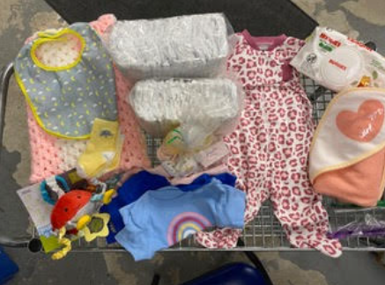
A sample gift bag that Valeries assembles and distributes.

Advent Resources From our Faith Pillar Lead – Christine Bresette

And - as we approach the quiet grace of Advent, Christine has provided our members with a few resources to help you ready your heart to welcome Jesus this season.
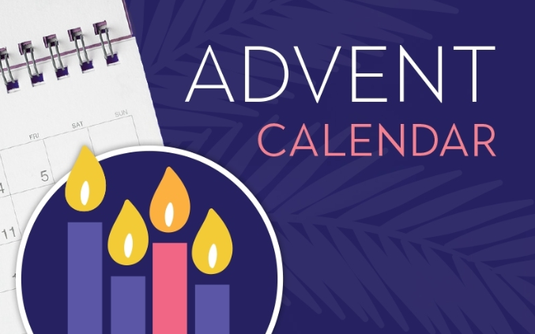
﻿
- ﻿ https://www.loyolapress.com/catholic-resources/liturgical-year/advent/calendars/advent-calendar-for-adults/?utm_source=ActiveCampaign&utm_medium=email&utm_content=E-Magis%20November%3A%20Gratitude%20and%20Advent&utm_campaign=emagis-1124-9141
﻿
- ﻿ https://www.ignatianspirituality.com/advent/

- ﻿ https://cwl.on.ca/wp-content/uploads/2021/05/Advent-Novena-The-O-Antiphons.pdf

- https://click.email.dynamiccatholic.com/?qs=eb145df9f8ab38744ac698642d7cd904113e3b19bbec56e40d6de790bcf3cca651cbebccedfe51d90e4817ab1eeb87ead12dc921288cda17267b75949714d118

- https://click.praymorenovenas.com/f/a/zLPebqzggvXIXp4vW5H5nQ~~/AAH-WxA~/QleIaI--ouCUStz60w24TsIB8joz3rKS0eM2kbfMF0cM5b5i9hgPcxKyw2NmO4PDkTsuOhzKOcoX9g4kwCmtxd_n2MS65OynYJA4RhmMfOvS9YmBOlaJ-BKOin3WyKYY

- https://catholicclimatecovenant.org/resources/advent-resources-2025/

You Are Cordially Invited to a Ladies Only Night Out!

The Watford CWL would like to invite all ladies in our community to come and enjoy a night out at their Annual Christmas Dinner, Penny Sale & Skit Night. This legendary event is taking place on Thursday, December 4th, 2025 at East Lambton Community Complex/Hall, 61 Centennial Ave. Watford, ON.
Admission is $20.00 and doors open at 5:30pm sharp. There will be a Buffet Style Supper at 6:30pm, with entertainment to follow. Advance tickets not required.


Honour Guard Request for the Feast of the Immaculate Conception

We are honoured to once again be invited to participate in the Honour Guard for the upcoming Feast of Immaculate Conception that is taking place on Monday December 8th at 7pm at Our Lady of Mercy Church. If you are planning to attend and would like to participate in the Honour Guard and procession, please let me know as soon as possible so I can advise the organizers and ensure sufficient seating is reserved for our council members. Following the Mass, there will also be a social gathering taking place in the OLM Hall.
Thank you to those that have already messaged me that they are interested in participating – your presence and support is greatly appreciated.

Noteworthy Events from Our National, Provincial and Diocesan Councils:
To remain up to date on National, Provincial and Diocesan news and events, I encourage everyone to regularly check out the CWL National, Provincial and Diocesan websites.

November’s ON-Line Newsletter has been published: https://cwl.on.ca/wp-content/uploads/2025/10/NOV-2025-NEWSLETTER.pdf

Upcoming Events
- November 25th – CWL Regional Meeting – St. Ben’s – 7pm **All CWL members are welcome to attend
- December 1st - CWL Executive Meeting – St. Michael Meeting Room – 6:30pm - **All CWL members are invited to attend Executive Leadership Meetings
- December 10th – CWL General Christmas Meeting – St. Michael Church & Dinner at Huron Oaks – 6pm-9pm – tickets go on sale November 23rd
- March 6th – World Day of Prayer hosted by St. Michael CWL – more details to come
- April 20-21, 2026 - London Diocesan Convention & Annual Meeting of Members – Chatham - more details to come
- June 6th – St. Michael CWL Spring Retreat – more details to come

- Link to St. Michael CWL page on the Family of Parishes website St. Michael.

- To check out all upcoming events taking place within the Family of Parishes, you can check out the weekly Bulletin HERE

Prayers
- For Pope Leo’s special intention for November - inspired by Pope Francis - For the prevention of suicide. Let us pray that those who are struggling with suicidal thoughts might find the support, care and love they need in their community, and be open to the beauty of life.

- For our monthly CWL Mass Intention for November: For the repose of the souls of our deceased CWL members.

- For the candidates and their sponsors who are participating in Confirmation this Sunday at St. Michael Church. May the Holy Spirit fill their hearts with wisdom, courage, and joy as they deepen their commitment to Christ. We also pray for their sponsors, that they may continue to guide and support these candidates with faith and love.

- For God’s blessings across our St. Michael CWL Sister Membership. May the Holy Spirit continue to be with us and support us as we work to fulfil our mandate to promote the teachings of the Catholic Church, uphold Christian values, and advocate for social justice and human rights.

- For the intentions of our CWL members and their families especially those who are sick, undergoing treatments, or requiring surgery that they will be given the comfort, strength and the grace they need to face their challenges and be returned to good health and for their caregivers.

- For the intentions held within our St. Michael Parish Prayer Intention Book.

- For the land on which we gather, that is part the ancestral land of the Chippewa, Odawa, and Potawatomi peoples, referred to collectively as the Anishinaabeg. We pray that together – as a treaty people – we respect the environment that sustains all life, protecting the future for those generations to come.

- For peace in our world.

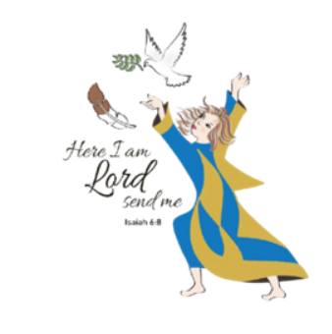
Here I Am Lord, Send Me!
If you have any questions about the Catholic Women’s League, have other concerns or need help, but don’t know who to ask, please don’t hesitate to reach out to me and I will try to help if I can.
If you have a prayer request that you would like sent out to our CWL members or if you have a celebration that you would like to share with your sisters in the League let me know.
I can be reached at 519-381-3129 or cwlsmbg@gmail.com.

Our Lady of Good Counsel, Pray for Us and Bless Us in All We Do
Stefanie Hammond
CWL President – St. Michael Council

