CWL Newsletter #13 – March 29, 2025
Happy Saturday my fellow CWL Sisters!
Blessings for this 4th Sunday of Lent.
My apologies in advance if the next few weekends of newsletters are a bit sparse! I have some personal and work-related trips that are taking me out of town (and away from my computer) starting this weekend, so the time I typically dedicate during the week to writing this weekly newsletter will be limited. So please forgive the brevity in the newsletters this month!

4th Sunday of Lent
The 4th Sunday of Lent offers lessons about God’s mercy and love and calls us to reconcile with Him and each other. Through the stories of the Israelites’ first Passover in the Promised Land, the parable of the Prodigal Son, and Paul’s teaching on becoming a new creation in Christ, we learn about God’s constant care and call to reconciliation. These readings remind us of the importance of gratitude, forgiveness, and embracing a renewed life in Christ.
Prayer: Dear Lord, thank You for Your constant care and mercy. Help us to seek new beginnings in You and to forgive others as You forgive us. Guide us to live in peace and love. Amen.

Sarnia Pregnancy Options & Support Centre Baby Shower Drive
Again this weekend, the Knights of Columbus are continuing to host their Baby Shower Drive to support the Sarnia Pregnancy Options & Support Centre. They kindly request donations of essential baby items, Walmart gift cards, or monetary contributions to help meet urgent care needs. We are invited to bring these donations to Mass on Sunday. Monetary donations can be placed in an envelope labeled 'Pregnancy Centre Support,' and cheques should be made payable to the 'Sarnia Pregnancy Options & Support Centre.' Both can be left in the Church collection basket. Thank you for your continued generosity and support.

Jubilee and Lenten Resources
We are blessed to have a large number of events happening at St. Michael and within our Family of Parishes this Lent that can assist us in our own Lenten and faith journey:
- March 10th – April 15th – St. Michael - Stations of the Cross beginning at 6pm (before the 6:30pm Mass).

- March 31st – St. Michael - Jubilee Lenten Mission – 6pm. Includes Mass, Confession, and a talk on a particular Jubilee theme. By attending, this is another opportunity to qualify to obtain a Plenary Indulgence, fulfilling all the necessary requirements such as: praying for the Holy Father’s intention, receiving Holy Communion and celebrating the Sacrament of Reconciliation. This is a beautiful way to gather in faith during this Lenten season. And be sure to attend our CWL-sponsored coffee reception afterward the Lenten Mission.

Muskoka Woods Pasta Fundraiser in Partnership with The Dante Club
PASTAFEST is here! Grab a super tasty meal and help support a great cause. This delicious fundraiser will help send our Grade 7 students and High School Leaders to Muskoka Woods Leadership Camp, organized by the Family of Parishes, taking place in May. There are only 300 meals available, so don’t wait to order! Order by April 17th and pickup curbside on April 24th at the Dante Club. For just $15, you get penne pasta with Dante sauce, two meatballs, and focaccia bread. Eat well, all while supporting your local elementary Grade 7 students and leaders. To place your order: https://sbrcfop-pastafest.pllenty.com/

Did You Know??? And you thought you were just wearing a CWL cardigan…
Your support in purchasing and wearing a CWL-branded cardigan is helping to support projects and initiatives at the Diocesan level. Since cardigan sales began in late 2023, we have been able to donate $150 to our London Diocesan CWL to help in their communication efforts. Just a reminder that cardigan sales are ongoing - so if anyone is interested in purchasing a cardigan, please let me know.
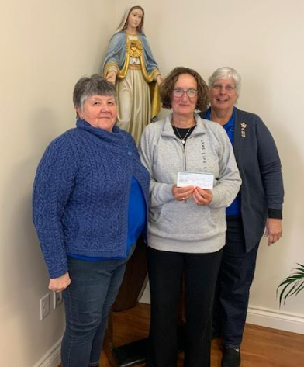

May General Meeting – May 13th @ Huron Oaks – Save the Date!
Mark your calendars! Save the evening of May 13th for our next CWL General Meeting. The evening will begin with a reflection in the Church at 6 p.m., followed by dinner and the Business Meeting at Huron Oaks. The Executive Team is still in the process of finalizing the dinner details, which will be shared shortly. PLEASE NOTE: Tickets will be required to be purchased in advance for this event, and ticket sales will begin after Easter.

Year of Jubilee Events In And Around Our Diocese
Virtual Pilgrimage On-demand Recordings Now Available
Were you unable to join the Ontario Provincial Council's Virtual Pilgrimage that took place from March 10th to 12th, 2025? Don't despair! The spirit of pilgrimage and connection remains alive and well. Copies of the recordings from the 3-day Virtual Pilgrimage are now available to all to listen to and can be accessed here: https://cwl.on.ca/wp-content/uploads/2025/03/OPC-VIRTUAL-PILGRIMAGE-LETTER-WITH-LINKS-FROM-OPC-COLLEEN-MARTIN.pdf

Noteworthy Events from Our National, Provincial and Diocesan Councils:
To remain up to date on National, Provincial and Diocesan news and events, I encourage everyone to regularly check out the CWL National, Provincial and Diocesan websites.

Spring Edition of League Lingo is now available
This year, our council has purchased 5 paper subscriptions of League Lingo for our members. If you are not familiar with what ‘League Lingo’ is, it’s our London Diocesan Newsletter that is lovingly and meticulously put together by our own Nelly Kelders, who is the Editor. You can access the online edition HERE. Or if you prefer a paper copy, I have copies available at the Welcome Desk and on our CWL Bulletin Board. Great job Nelly!

CWL Provincial Convention
The Ontario Provincial Council of the Catholic Women's League of Canada will be holding its annual convention in London, Ontario – July 6-9th. It is taking place at the Four Points Sheraton – 1150 Wellington Road South, London. All Convention Details & Registration Information can be found at: https://cwl.on.ca/conventions/
Convention Registration Deadline is May 31st. Register HERE.
Meals and Special Events Registration Form HERE
This convention promises to be a powerful opportunity for spiritual growth, meaningful fellowship, and the renewal of our shared mission.
If you are planning on attending all or parts of the Provincial Convention, please let me know.

Upcoming Events
- March 31st – Family of Parishes Jubilee Lenten Mission - St. Michael – 6pm with Coffee Reception afterwards
- April 26th – Feast of Our Lady of Good Counsel
- April 27th – Divine Mercy Sunday
- April 28-30th – CWL Diocesan Convention - Stratford – Information HERE
- May 13th – CWL General Meeting @ Huron Oaks – 6pm-9pm – Tickets to be sold after Easter
- May 24-25th – Women’s New Life retreat – Our Lady of Mercy – Information HERE
- May 27th – CWL Regional Meeting POTLUCK – 5:30pm – St. Michael - All members are welcome to attend!
- June 7th – St. Michael CWL Eucharist Retreat – Lead by Faith Pillar, Christine Bresette
- July 5-9th - Provincial CWL Convention – London, On – Information HERE
- Vacation Bible School – August 4-8th – Registration Details HERE
- August 10–13th - National Convention – Toronto

- Link to St. Michael CWL page on the Family of Parishes website St. Michael.

- To check out all upcoming events taking place within the Family of Parishes, you can check out the weekly Bulletin HERE

Prayers
- For Pope Francis’ intention for March: FOR FAMILIES IN CRISIS
“Let us pray that broken families might discover the cure for their wounds through forgiveness, rediscovering each other’s gifts, even in their differences.”

- For our monthly CWL Mass Intention – For the intentions of those discerning a calling to the priesthood and religious life.

- For Pope Francis – May the Lord, through Our Lady’s powerful intercession, grant Pope Francis renewed strength, health and energy in his vocation to serve the Church as the Successor of Peter and the Vicar of Christ on Earth.

- For God’s blessing as we journey through this season of Lent. May this time of reflection and sacrifice transform our hearts, and strengthen our relationship with you, so we can better serve You and others.

- For our Family of Parishes and for our priests and deacons as we continue to grow together as a faith community.

- For God’s blessings across our St. Michael CWL Sister Membership. May the Holy Spirit continue to be with us and support us as we work to fulfil our mandate to promote the teachings of the Catholic Church, uphold Christian values, and advocate for social justice and human rights.

- For the intentions of our CWL members and their families especially those who are sick, undergoing treatments, or requiring surgery that they will be given the comfort, strength and the grace they need to face their challenges and be returned to good health and for their caregivers.

- For the intentions held within our St. Michael Parish Prayer Intention Book.

- For the land on which we gather, that is part the ancestral land of the Chippewa, Odawa, and Potawatomi peoples, referred to collectively as the Anishinaabeg. We pray that together – as a treaty people – we respect the environment that sustains all life, protecting the future for those generations to come.

- For peace in our world.
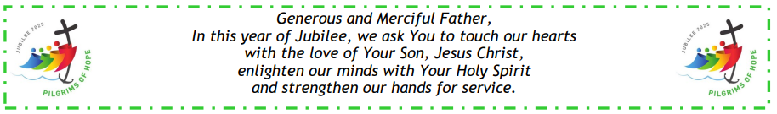

Here I Am Lord, Send Me!
If you have any questions about the Catholic Women’s League, have other concerns or need help, but don’t know who to ask, please don’t hesitate to reach out to me and I will try to help if I can.
If you have a prayer request that you would like sent out to our CWL members or if you have a celebration that you would like to share with your sisters in the League let me know.
I can be reached at 519-381-3129 or cwlsmbg@gmail.com.

Our Lady of Good Counsel, Pray for Us and Bless Us in All We Do
Stefanie Hammond
CWL President – St. Michael Council
