CWL Newsletter #14 – April 5th, 2025
Happy Saturday my fellow CWL Sisters!
Blessings for this 5th Sunday of Lent.
This week, we joyfully commenced the first of three Jubilee Lenten Missions within our Family of Parishes at St. Michael. It was a heartwarming event that began with the Stations of the Cross, followed by opportunities for Confession, and the celebration of Mass. Father Brian then delivered an inspiring talk on the rich history of pilgrimages. The evening concluded with a delightful coffee reception hosted by the CWL, providing a wonderful chance for us to gather and strengthen our community bonds. It was yet another beautiful occasion for us to prepare our hearts and minds during this Lenten season. And I wish to thank everyone that assisted with setup, serving and the cleanup after the reception – it was greatly appreciated!

5th Sunday of Lent
The 5th Sunday of Lent calls us to embrace God’s mercy and strive for holiness. We are reminded to let go of our past mistakes and failures. We should not dwell on what we cannot change. Instead, we should focus on the new opportunities God is giving us. By trusting in His promise, we can move forward with hope and confidence in His plans for us.
Prayer: Dear Lord, help us embrace new beginnings, strive toward our goals in Christ, and show mercy to others. Guide us to trust in Your promises and grow in our faith. Amen.

Jubilee and Lenten Resources
- March 10th – April 15th – St. Michael - Stations of the Cross beginning at 6pm (before the 6:30pm Mass).

- Lent Day of Confessions – Wednesday April 9th
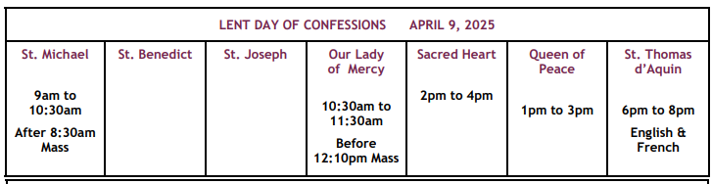

- Lenten Webinar: Hope in the Midst of Turmoil
Members are invited to be pilgrims of hope in a one-hour Lenten Webinar: Hope in the Midst of Turmoil. A time of prayer and reflection as we celebrate Jubilee 2025 and share in spiritual preparation for Passion Sunday, the Pascal Triduum and Easter with:
Shari Guinta, National President
Bishop Wayne Lobsinger, National Spiritual Advisor
Rolande Chernichan, National Chairperson of Faith
WHEN: Sunday, April 6, 2025 at 2:30 p.m. (CDT)
HOW TO REGISTER: You can register for the webinar at:
https://register.gotowebinar.com/register/266942

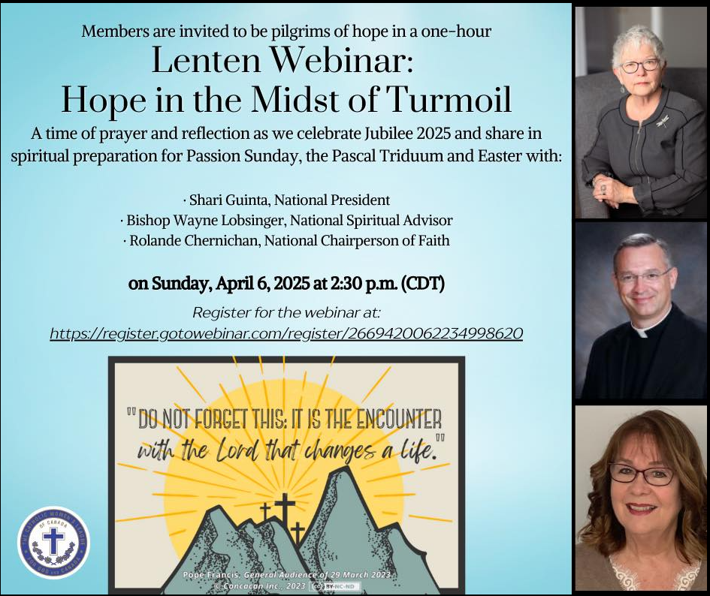

Holy Thursday Mass – Volunteers Needed!
I have received a request from Linda Kensley. She is looking for 2 volunteers from our CWL to volunteer for foot washing during the mass. If you are planning on attending Holy Thursday mass and would be willing to assist, please let me know by April 9th. I will then forward your name onto Linda.

A ‘Thank You’ From Francien Arts…
Francien would like to extend a special ‘thank you’ to our CWL members for the many prayers and birthday wishes she received last week. It was so special to her.

Baby News!
Last week, I received an update from proud grandmother Cathy Cimetta, informing me that her daughter, Amanda, and her husband Matt have welcomed a baby girl into their family!! Alina Catherine Ann Rankin was born on Saturday, March 22nd, and I have been told that all family members are adjusting well to this new chapter in their lives. Congratulations Amanda, Matt and Cathy and Tom!
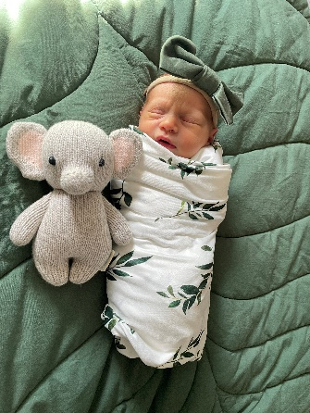

Solidarity Soup Lunch
Soup with a purpose! The Social Justice & Missions Team invites everyone to their Solidarity Soup Lunch taking place tomorrow – April 6th – at St. Michael Church, following the 10:30am Mass. Come enjoy a large variety of delicious homemade soup, hot dogs, rolls, cookies, juice, tea and coffee, all while supporting Development & Peace!
COST: Adults $12 & Children $6

Coffee Sunday – April 13th
I’m putting out the call early for helpers for our next CWL-sponsored Coffee Sunday that is taking place Sunday April 13th. I will be away that weekend, and won’t be able to attend, so I’m looking for a few members to help with serving and clean up. And of course, we will gladly accept all donations of tasty treats! If you are available to assist that weekend, please let me know and I will keep our CWL Executive team apprised. Thank you in advance for everyone’s continued support!

An Update From Our CWL Service Pillar Lead – Lizzie Cyr
Have you noticed something new in the narthex of the church? Yes, that's right—books! We are thrilled to announce the opening of our CWL-sponsored Spiritual Library! Feel free to borrow any book from the shelves with no due dates. Return them whenever you're done, no rush! There are fantastic books to choose from, so let the Holy Spirit guide you in picking one. Nourish your soul with a good read today! If you have any Christian books, especially children’s books, that you’d like to donate to the library, please give them to Lizzie Cyr.

Muskoka Woods Pasta Fundraiser in Partnership with The Dante Club
PASTAFEST is here! Grab a super tasty meal and help support a great cause. This delicious fundraiser will help send our Grade 7 students and High School Leaders to Muskoka Woods Leadership Camp, organized by the Family of Parishes, taking place in May. There are only 300 meals available, so don’t wait to order! Order by April 17th and pickup curbside on April 24th at the Dante Club. For just $15, you get penne pasta with Dante sauce, two meatballs, and focaccia bread. Eat well, all while supporting your local elementary Grade 7 students and leaders. To place your order: https://sbrcfop-pastafest.pllenty.com/

Are You Following our Sarnia Bluewater Roman Catholic Family of Parishes on Social?
Do you like pizza? Are you craving a world-famous Giresi’s pizza?
Are you interested in supporting the communication efforts of our Family of Parishes so you can keep up to date on all the events and activities taking place each week?
If you said YES to both, then check out this new contest that has been announced by our Social Media Manager – Alyssa Minten!
Starting April 1, everyone has the opportunity to enter to win $25 to Giresi’s Pizza just by engaging with the sbrcfp on social media!
Here’s how you’ll earn entries:
✅ Follow sbrcfp on Instagram or Facebook – 5 entries per follow!
🔄 Share a sbrcfp post – 3 entries per share!
💬 Comment on a sbrcfp posts – 1 entry per comment!
The contest runs April 1 – April 30, and the lucky winner will be drawn on May 1!


Year of Jubilee Events In And Around Our Diocese
Virtual Pilgrimage On-demand Recordings Now Available
Were you unable to join the Ontario Provincial Council's Virtual Pilgrimage that took place from March 10th to 12th, 2025? Don't despair! The spirit of pilgrimage and connection remains alive and well. Copies of the recordings from the 3-day Virtual Pilgrimage are now available to all to listen to and can be accessed here: https://cwl.on.ca/wp-content/uploads/2025/03/OPC-VIRTUAL-PILGRIMAGE-LETTER-WITH-LINKS-FROM-OPC-COLLEEN-MARTIN.pdf

Noteworthy Events from Our National, Provincial and Diocesan Councils:
To remain up to date on National, Provincial and Diocesan news and events, I encourage everyone to regularly check out the CWL National, Provincial and Diocesan websites.

Spring Edition of League Lingo is now available
This year, our council has purchased 5 paper subscriptions of League Lingo for our members. If you are not familiar with what ‘League Lingo’ is, it’s our London Diocesan Newsletter that is lovingly and meticulously put together by our own Nelly Kelders, who is the Editor. You can access the online edition HERE. Or if you prefer a paper copy, I have copies available at the Welcome Desk and on our CWL Bulletin Board. Great job Nelly!

Ontario Provincial CWL – April’s On-line Newsletter Is Now Available
The April edition of the OPC Online Newsletter is now available. This month's edition is filled with inspiring content, including insightful articles from each of the three Executive Pillars – Service, Social Justice, and Faith. Additionally, you'll find details about upcoming virtual events, including a wonderful write-up by our own Nelly Kelders about this summer’s Provincial Convention taking place in London, Ontario! Don't miss out on the opportunity to stay informed and connected.

CWL Provincial Convention
The Ontario Provincial Council of the Catholic Women's League of Canada will be holding its annual convention in London, Ontario – July 6-9th. It is taking place at the Four Points Sheraton – 1150 Wellington Road South, London. All Convention Details & Registration Information can be found at: https://cwl.on.ca/conventions/
Convention Registration Deadline is May 31st. Register HERE.
Meals and Special Events Registration Form HERE
This convention promises to be a powerful opportunity for spiritual growth, meaningful fellowship, and the renewal of our shared mission.
If you are planning on attending all or parts of the Provincial Convention, please let me know.

Upcoming Events
- April 26th – Feast of Our Lady of Good Counsel
- April 27th – Divine Mercy Sunday
- April 28-30th – CWL Diocesan Convention - Stratford – Information HERE
- May 13th – CWL General Meeting @ Huron Oaks – 6pm-9pm – Tickets to be sold after Easter
- May 24-25th – Women’s New Life retreat – Our Lady of Mercy – Information HERE
- May 27th – CWL Regional Meeting POTLUCK – 5:30pm – St. Michael - All members are welcome to attend!
- **NEW** June 2nd – CWL Executive Meeting at St. Joseph’s Hospice, Sarnia – All members are welcome to attend
- June 7th – St. Michael CWL Eucharist Retreat – Lead by Faith Pillar, Christine Bresette
- July 5-9th - Provincial CWL Convention – London, On – Information HERE
- Vacation Bible School – August 4-8th – Registration Details HERE
- August 10–13th - National Convention – Toronto

- Link to St. Michael CWL page on the Family of Parishes website St. Michael.

- To check out all upcoming events taking place within the Family of Parishes, you can check out the weekly Bulletin HERE

Prayers
- For Pope Francis’ intention for APRIL: FOR THE USE OF THE NEW TECHNOLOGIES
“Let us pray that the use of new technologies will not replace human relationships, will respect the dignity of the person and will help us face the crises of our times.”

- For our monthly CWL Mass Intention – For the intentions of the children and families preparing for the sacraments this spring. This intention was made during the Wednesday morning – April 2nd – mass so the students of St. Michael Catholic School would be in attendance to hear it.

- For Pope Francis – May the Lord, through Our Lady’s powerful intercession, grant Pope Francis renewed strength, health and energy in his vocation to serve the Church as the Successor of Peter and the Vicar of Christ on Earth.

- For God’s blessing as we journey through this season of Lent. May this time of reflection and sacrifice transform our hearts, and strengthen our relationship with you, so we can better serve You and others.

- For our Family of Parishes and for our priests and deacons as we continue to grow together as a faith community.

- For God’s blessings across our St. Michael CWL Sister Membership. May the Holy Spirit continue to be with us and support us as we work to fulfil our mandate to promote the teachings of the Catholic Church, uphold Christian values, and advocate for social justice and human rights.

- For the intentions of our CWL members and their families especially those who are sick, undergoing treatments, or requiring surgery that they will be given the comfort, strength and the grace they need to face their challenges and be returned to good health and for their caregivers.

- For the intentions held within our St. Michael Parish Prayer Intention Book.

- For the land on which we gather, that is part the ancestral land of the Chippewa, Odawa, and Potawatomi peoples, referred to collectively as the Anishinaabeg. We pray that together – as a treaty people – we respect the environment that sustains all life, protecting the future for those generations to come.

- For peace in our world.
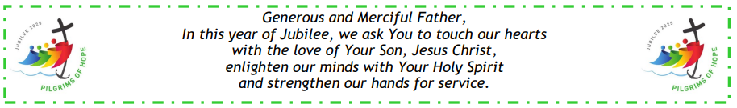

Here I Am Lord, Send Me!
If you have any questions about the Catholic Women’s League, have other concerns or need help, but don’t know who to ask, please don’t hesitate to reach out to me and I will try to help if I can.
If you have a prayer request that you would like sent out to our CWL members or if you have a celebration that you would like to share with your sisters in the League let me know.
I can be reached at 519-381-3129 or cwlsmbg@gmail.com.

Our Lady of Good Counsel, Pray for Us and Bless Us in All We Do
Stefanie Hammond
CWL President – St. Michael Council


