CWL Newsletter #18 – May 3rd, 2025
Happy Saturday my fellow CWL Sisters,

The CWL Diocesan Convention took place in Stratford this week. Past President Mary van Delft attended the full convention with CWL Secretary, Debra Hoek, attending the business day on Wednesday, and Gen Kennedy and Linda Kensley attending the Gala Banquet on Tuesday and part of the business day on Wednesday.

Mary was kind enough to assemble her thoughts and provide us with some of highlights so that I could include them in this weekend’s newsletter:
- The convention was attended by 290 CWL members from across the Diocese, as well as our Provincial President, Colleen Martin. It is always a privilege to represent our Council at our Diocesan Convention.
- As always, the Masses each day were beautiful celebrations of our faith, with Bishop Fabbro celebrating the Gala Mass on Tuesday, along with 18 priests. The sound of almost 300 women singing and praying together is truly beautiful.
- Monday began with two workshops: Engaging Members and Creating Resolutions, followed on Monday evening with fun night - “Prom Through the Ages”. We were required to bring a stuffed animal as our “date”, which were then collected and donated to Children’s Hospital in London.
- Tuesday was an Educational Day filled with excellent speakers, presentations and sharing. Linda Staudt, a life long educator, spoke on her experience as a lay participant and one of seven lay people from North America selected by Pope Francis to participate in the Synod of Bishops in Rome. This was followed by presentations on Truth and Reconciliation, Mental Health in Elders, a CWL panel discussion/question and answer period, Mass and the Gala Banquet.
- Wednesday was a Business Day that included the Annual Meeting of Members, election of our new Diocesan Executive, presentation of two social justice awards, and an address by our Provincial President Colleen Martin.
- Congratulations to St. Michael CWL member, Linda Kensley, who was recognized as one of two CWL members receiving this year’s social justice award for her work with the Society of St. Vincent de Paul and Migrant Worker Ministry.
- Welcome and Congratulations to our new CWL Diocesan Executive for 2025-2027:
  - President: Denise Lalonde-Morris
  - Vice-President: Nelly Kelders
  - Secretary: Vacant (to be appointed by the President)
  - Treasurer: Mary Clare Latimer
  - Faith, Service & Social Justice Pillar Chairs: Shirley Ann Beecroft, Bea Taylor, Linda VanRaay

It was an excellent convention filled with faith, fellowship and fun.
-Mary

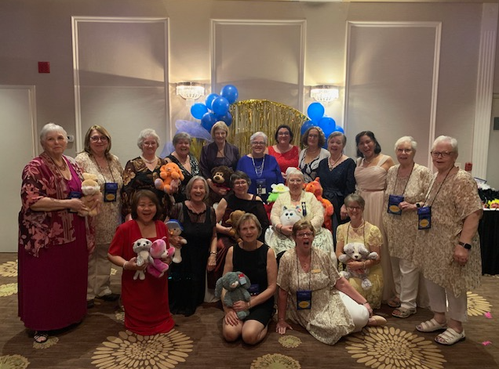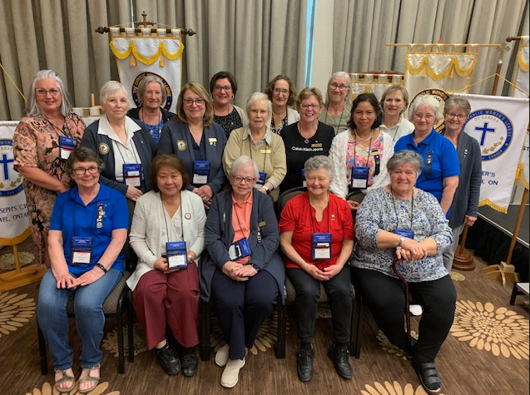

Ontario Provincial Council Annual Convention – London
Now that our spring Diocesan Convention has wrapped, this is a good reminder that registration is now open for the Ontario Provincial Council Annual Convention that is taking place July 6-9 in London. Convention schedule and details can be found at: https://cwl.on.ca/conventions/

The registration deadline is May 31st and you can register HERE.
You can access the Meals and Special Events Registration Form HERE
If there are members that are interested in attending, please let me know so I can track registrations. Depending on who is interested in attending, we may be able to arrange carpooling.

﻿National Hospice Palliative Care Week - May 4th-10th

National Hospice Palliative Care Week is a time to celebrate and highlight the incredible work being done to provide quality palliative care across the country. Join us in recognizing the impact of palliative care on individuals and families, and to pray for better access to this care for all.

A Prayer for Palliative Care:

Good and gracious God, you have been so good to us. We come to you in our great need, trusting in your Divine Mercy. We ask St Joseph, patron of Canada, and our patroness, Our Lady of Good Counsel, to intercede on our behalf, to move the hearts of parliamentarians to improve and initiate good palliative care for those nearing the end of their life.
Heavenly Father, bless those responsible for providing health care in our country. May they continue to serve with a generous heart, inspired by the merciful example of the Great Physician—Our Saviour himself. Amen.

The Catholic Women’s League of Canada: 12 Hours of Prayer for Palliative Care
I have also attached an extensive guide I received from our Regional Chair, Carol Hall, to be used any day during National Hospice Palliative Care Week.

To accompany our prayers, there is a special webinar series taking place May 6th & 7th and May 13th & 14th called the “Horizons of Hope-Palliative Care Toolkit for Parishes.”

TO REGISTER: https://us02web.zoom.us/meeting/register/tO2TWlXpSiSW8NJH_fvhWw#/registration

FUN FACT!
One of the hosts of this webinar series - Shirley Cristo - happens to be the sister-in-law of our own CWL member – Theresa van Koeverden. Theresa says that Shirley is an ardent nurse, who is passionate about this work and she encourages us to circulate this registration information to anyone who might be able to benefit from this event.

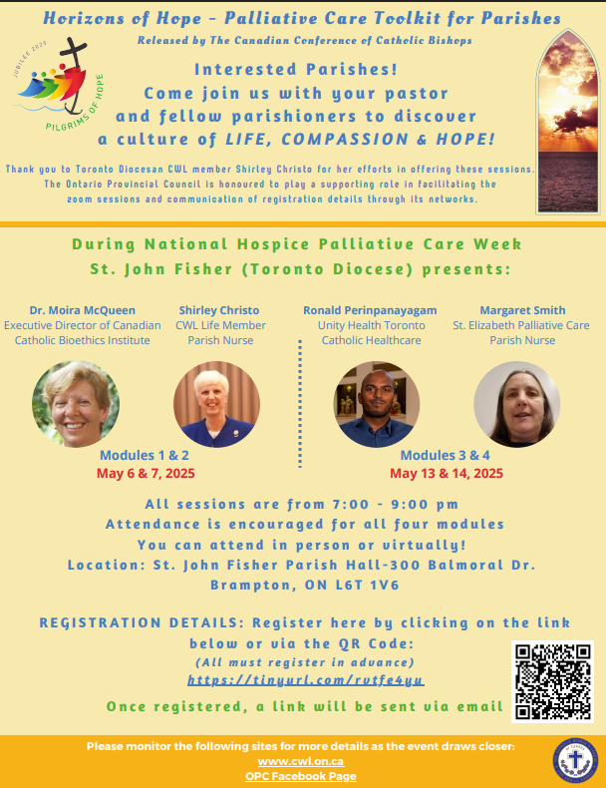

Additional Prayers:
During our recitation of the Rosary, we place our petition for increased palliative care and hospice care, and for the renewed protection of the rights of conscience for individuals and faith-based institutions, in Our Blessed Mother’s hands, to present to her Son, who promised that He would not deny anything that His Mother asks of Him.
- Baptism of the Lord: Spiritual Fruit: Gratitude for the Gift of Faith; God will hear our prayers for Palliative Care.
- The Wedding at Cana: Spiritual Fruit: Fidelity; for continued commitment to the Sanctity of Life from conception to natural death.
- The Proclamation of the Kingdom: Spiritual Fruit: Desire for holiness; moving us to action in support of access to palliative care and protection of rights of conscience for individuals and faith-based institutions.
- The Transfiguration: Spiritual Fruit: Spiritual courage; to support the Sanctity of Life despite contrary public opinion.
- The Institution of the Eucharist: Spiritual Fruit: Love of our Eucharistic Lord; providing strength to continue to speak for the vulnerable facing end of life.

Beatitudes for Caregivers
- Blessed are those who sleep poorly because they’re worried about their loved one or because their loved one wakes in the middle of the night and needs help, for theirs is the kingdom of heaven.
- Blessed are those who mourn because their loved one, though still alive, is slipping away because of dementia, for they will be comforted.
- Blessed are the meek who force themselves to speak up and speak out to make sure their loved one receives the help he or she needs, for they will inherit the land.
- Blessed are those who hunger and thirst for answers to why this is happening to their loved one and how much longer it will go on, for they will be satisfied.
- Blessed are those who show mercy, kindness, and compassion to their loved one, for they will be shown mercy, kindness, and compassion.
- Blessed are those who keep clean a loved one who is physically or mentally unable to keep himself or herself clean, for they will see God.
- Blessed are those who help their loved one find moments of peace, for they will be called children of God.
- Blessed are those who are misunderstood, not appreciated, and taken for granted in their role as caregiver, for theirs is the kingdom of heaven.
- Blessed are those whose caregiving efforts are unjustly criticized—or who are falsely accused of not caring about others—because of your love for your care-receiver and your love for God, who has asked you to help his beloved son or daughter. Rejoice and be glad, for your reward will be great in heaven.

As published by: https://www.catholicherald.com/article/local/the-beatitudes-and-a-prayer-for-caregivers/

Fr. Vince Gulikers 40th Anniversary Celebration - May 4, 2025 Grand Bend
Fr. Vince is sending out a warm welcome to any parishioner that would like to attend the afternoon Open House that is being held in his honour in celebration of the 40th Anniversary of his Ordination. His years spent as a Pastor in Sarnia / Bright’s Grove still hold a warm place in his heart and he would love to reconnect with his former parishioners. It is set to be a casual afternoon celebration. All are welcome!
WHERE: Immaculate Heart of May Church, 337 Ontario Street S, Grand Bend, ON
TIME: 1:30 – 4:00pm.

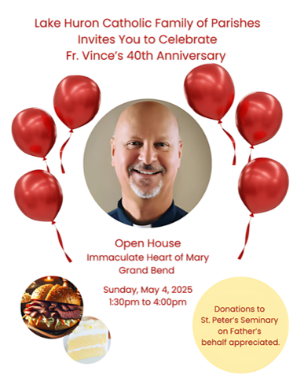

FINAL REMINDER TO PURCHASE YOUR TICKETS for our CWL May General Meeting – May 13th
Tomorrow is the final day to purchase your dinner ticket to attend next week’s CWL General Meeting. The evening will begin at 6pm with a spiritual reflection in the Church led by our Faith Pillar lead, Christine Bresette, followed by dinner and the Business Meeting at Huron Oaks starting at 6:45pm. The Executive Team will again be selling tickets after mass tomorrow. The cost of the dinner is $32 and can be paid via cash, cheque or e-transfer to cwlsmbgdues@gmail.com (please indicate dinner option in message box).
Dinner options include:
- Pasta Primavera - Penne with fresh vegetables (tomato, zucchini, peppers, red onion) and basil, served with focaccia - topped with parm (optional - vegan)

- Chicken Di Parma - Chicken breast stuffed with prosciutto, roasted red pepper and provolone cheese breaded and baked served on tomato sauce with mashed potatoes and green beans.

- Broasted Pickerel served with mashed potatoes and green beans

All meals include salad, dessert, tea & coffee. If you would like a glass of wine or other drink with dinner, these will be available for purchase.

We hope you can join us in sisterhood and fellowship in our final General Meeting before the summer break.

Save the Date! Passion, Death & Resurrection Cantata – Sunday May 18th

Join us for an unforgettable afternoon of music, reflection and celebration at the Passion, Death & Resurrection of Christ. This powerful Cantata will be hosted by Fr. Joseph, with special guests, Film Triumphant Canada and is taking place at St. Michael Parish on Sunday May 18th, from 2-4pm. This will be an incredible event and a freewill offering would be graciously accepted to help offset costs. Come and experience the story of hope and new life.

Upcoming Jubilee Events

Public Rosary for Peace
A reminder about this afternoon’s gathering with Bishop Fabbro to pray the Rosary for peace.
DATE: TODAY – Saturday Mary 3rd
TIME: 1:00 PM
WHERE: St Peter's Seminary (front lawn by the statue of Mary)

Bring a chair, your rosary, your prayerful heart and some water, to make the most of this first Saturday in May (the month of Mary!)L. et’ us all pray for peace as we are Jubilee Pilgrims of Hope!

Our Lady of Mercy Jubilee Pilgrimage
Jubilee pilgrimage sites have chosen the dates they will be welcoming pilgrims. The hosting Families and the Shrine are finalizing their schedule of events, with possible combinations of: Mass, adoration, tours, rosary, prayer time, devotions and Jubilee services. Our Lady of Mercy, Sarnia has been chosen as our Family of Parishes’ designated Jubilee pilgrimage site and will be hosting events this summer - July 17-19th. The schedule of events will be announced soon – so save the dates and stay tuned.

Noteworthy Events from Our National, Provincial and Diocesan Councils:
To remain up to date on National, Provincial and Diocesan news and events, I encourage everyone to regularly check out the CWL National, Provincial and Diocesan websites.

The May Edition of the Ontario CWL online newsletter is now available for your reading pleasure.

Upcoming Events
- May 5th – CWL Executive Meeting – 6:30pm-9pm – All members are welcome to attend.
- May 13th – CWL General Meeting – 6pm-9pm
- May 18th - Passion, Death & Resurrection Cantata – 2-4pm - St. Michael Church
- May 24-25th – Women’s New Life retreat – Our Lady of Mercy – Information HERE
- May 27th – CWL Regional Meeting POTLUCK – 5:30pm – St. Michael - All members are welcome to attend!
- **CHANGE OF DATE & LOCATION** - May 30th - Jubilee Mass for Mary – 6:30pm at Sacred Heart. More information to follow soon.
- June 2nd – CWL Executive Meeting at St. Joseph’s Hospice including presentation and tour of the Hospice. All members welcome.
- June 7th – St. Michael CWL Eucharist Retreat – Lead by Faith Pillar, Christine Bresette
- July 5-9th - Provincial CWL Convention – London, On – Information HERE
- July 17-19th – Jubilee of Hope – Our Lady of Mercy Church Pilgrimage Site – information can be found HERE
- Vacation Bible School – August 4-8th – Registration Details HERE
- August 10–13th - National Convention – Toronto

- Link to St. Michael CWL page on the Family of Parishes website St. Michael.

- To check out all upcoming events taking place within the Family of Parishes, you can check out the weekly Bulletin HERE

Prayers
- For Pope Francis’ intention for MAY: FOR WORKING CONDITIONS
“Let us pray that through work each person might find fulfilment, families might be sustained in dignity, and that society might be humanized.”

- For our monthly CWL Mass Intention – For the repose of the soul for Pope Francis – St. Michael Church - June 2nd – 6:30pm mass

- For an increase of faith, and for each one of us to model God’s abundant and generous love in our lives. May our hearts be filled with the spirit of joy and hope this Easter and be witnesses to the Resurrection.

- For our Family of Parishes and for our priests and deacons as we continue to grow together as a faith community.

- For God’s blessings across our St. Michael CWL Sister Membership. May the Holy Spirit continue to be with us and support us as we work to fulfil our mandate to promote the teachings of the Catholic Church, uphold Christian values, and advocate for social justice and human rights.

- For the intentions of our CWL members and their families especially those who are sick, undergoing treatments, or requiring surgery that they will be given the comfort, strength and the grace they need to face their challenges and be returned to good health and for their caregivers.

- For the intentions held within our St. Michael Parish Prayer Intention Book.

- For the land on which we gather, that is part the ancestral land of the Chippewa, Odawa, and Potawatomi peoples, referred to collectively as the Anishinaabeg. We pray that together – as a treaty people – we respect the environment that sustains all life, protecting the future for those generations to come.

- For peace in our world.

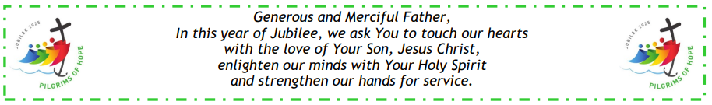


Here I Am Lord, Send Me!
If you have any questions about the Catholic Women’s League, have other concerns or need help, but don’t know who to ask, please don’t hesitate to reach out to me and I will try to help if I can.
If you have a prayer request that you would like sent out to our CWL members or if you have a celebration that you would like to share with your sisters in the League let me know.
I can be reached at 519-381-3129 or cwlsmbg@gmail.com.

Our Lady of Good Counsel, Pray for Us and Bless Us in All We Do
Stefanie Hammond
CWL President – St. Michael Council

