CWL Newsletter #24 – June 14th, 2025
Happy Saturday my fellow CWL Sisters!

This Sunday we celebrate Trinity Sunday. Trinity Sunday helps us to understand the deep connection between the Father, Son, and Holy Spirit. Jesus teaches us that everything the Father has also belongs to the Son. This shows their unity and shared mission. They work together perfectly, showing us what true harmony looks like. The Father, Son, and Holy Spirit are not separate in their actions. They are always united in their purpose. When Jesus came to earth, he did the will of the Father. When the Holy Spirit came, it was to continue the work of Jesus. This unity helps us see how closely they are connected. We can learn from this unity in our own lives. As followers of Christ, we are called to work together in love and purpose. Just as the Father, Son, and Holy Spirit share everything, we should share our gifts and talents with others. This strengthens our community and helps us fulfill God’s mission.

Prayer: Holy Trinity, help us embrace your truth and love. Guide our actions and decisions through the Holy Spirit. May we reflect your unity and share your love with all we meet. Amen.

Trending Now! Eucharistic Retreat Recap: CWL Holy Moments, Sour Puss Face, Eucharistic Miracles, Intentional Preparation, The Great Commission Mission
Last Saturday morning, 30 members of our St. Michael CWL were blessed to take part in our very first Eucharistic Retreat, led by our Faith Pillar, Christine Bresette, and our Spiritual Advisor, Father Joseph. It was a truly enriching experience, guiding us on a journey to deepen our discipleship and to recognize the profound significance of the Eucharist in our faith and daily lives.
During the retreat, Father Joseph shared a powerful reminder: "Your life is possibly the only scripture that someone will ever read." His words encouraged us to live out Christ’s teachings with intention, embodying His love and lessons beyond the walls of our parish. We also took time to reflect on important questions surrounding our faith, and how we can better prepare—physically, mentally, and spiritually—for the sacredness of Mass. I have attached this document to today’s newsletter if you are interested in reviewing it yourself before mass this weekend.
Post-retreat, I received a few kind emails from participants that expressed how much they enjoyed their retreat experience:

“I send this heartfelt thanks to the CWL Executive for organizing a beautiful retreat yesterday. Christine is a true gift to our council and our parish. Thanks for a delicious lunch and coffee and muffins.”

“What a beautiful way to spend a Saturday morning. I wasn’t going to come because I can usually find a million things to do, but I am so glad I came.”

On behalf of our CWL Executive Council, we extend heartfelt gratitude to everyone who said YES and joined us in this meaningful retreat. In the midst of our busy lives, it was a beautiful reminder of the importance of pausing, reflecting, and sharing time—not only with ourselves, but with our CWL sisters as well.

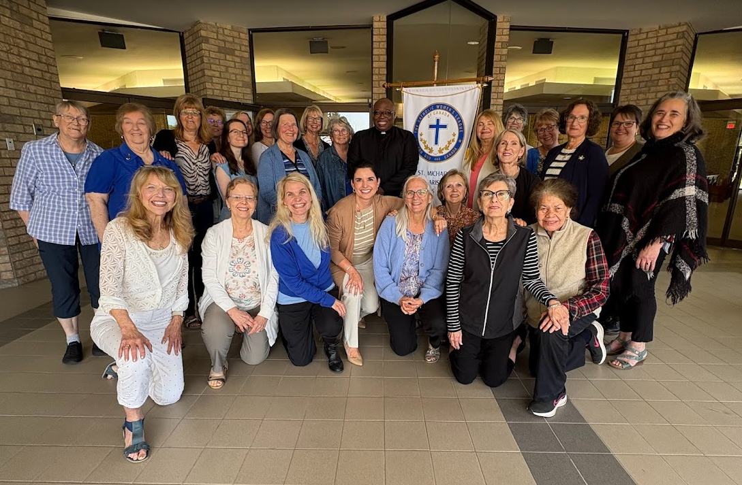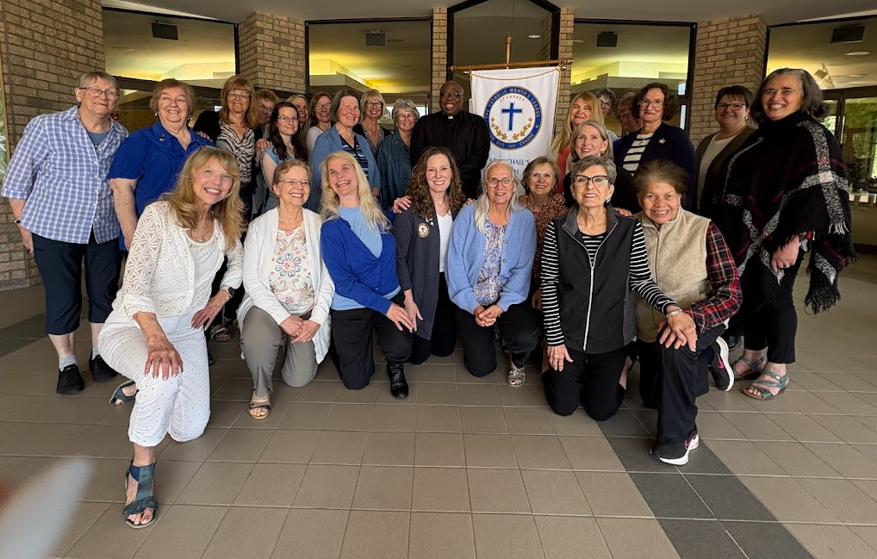
(Two pictures of Eucharistic Retreat Members, as our Treasurer – Mary Grace Craievich – took the first picture, so we wanted to take a 2nd picture to ensure she was included in the group photo as well! )
This summer - we would love to keep the conversation going and would like to know if you do too!
ALL MEMBERS of our CWL Council are invited to participate in our next steps - which could include the option of:
- Completing your own Independent Study based on the book: 33 Days to Eucharistic Glory by Matthew Kelly OR
- Participating in an 8-week group study starting July 5th, led by our Faith Pillar - Christine Bresette.

In order for Christine to start her preparations, please let me know by Sunday June 22nd if you are interested in either study option, and I will forward your intention along to Christine. If there is sufficient interest, Christine will follow-up and coordinate directly with those who have expressed a desire to meet over the summer. If you are interested in previewing a promo video of the Consecration to the Eucharistic, you can find it HERE.

Summer Kitchen Clean-Up
A “spring cleaning” of the kitchen is planned for Friday, June 20th beginning at 9:00am. We are looking for a few volunteers to help. It should only take a few hours. Please let Mary van Delft, mary.vandelft55@gmail.com, know if you would like to help.

Reminder for Milk Bag Donations
If you’re saving milk bags for St. Christopher’s mat-making ministry in Forest and dropping them off at our parish, please ensure they are clean, dry, and neatly folded before placing them in the designated donation box located by the coat rack near the Meeting Room.
Recently, several unclean and empty milk bags were left at the Welcome Desk. Unfortunately, these couldn’t be used and had to be discarded. Thank you for your continued support and care…your cooperation helps keep this initiative running smoothly.
Have You Read This Month’s Family of Parishes Newsletter???
Just a follow-up reminder that if you haven’t read this month’s Family of Parishes Newsletter, our St. Michael CWL is proudly featured in it. You can check out the article HERE if you are interested in giving it a read and seeing what we have been up to the last 6 months.

Noteworthy Events from Our National, Provincial and Diocesan Councils:
To remain up to date on National, Provincial and Diocesan news and events, I encourage everyone to regularly check out the CWL National, Provincial and Diocesan websites.

***NEW*** The June Edition of the Ontario CWL online newsletter is now available for your reading pleasure.

105th Annual National Convention Registration

There is now the ability to register to virtually attend the 105th CWL National Convention taking place August 10-13th in Toronto. To register yourself, please visit: www.cwl.ca/category/conventions/
The cost to register is $20.
PLEASE NOTE: Registration will only allow members to view sessions in the main meeting room, as there will be no video from any of the break-out sessions.

Upcoming Events
- July 5-9th - Provincial CWL Convention – London, On – Information HERE
- OLM Jubilee Pilgrimage Celebrations – July 17-19th – Details HERE
- July 23rd – CWL Day at the Shrine in Merlin, On – 10am – 2pm
- August 4-9th - Vacation Bible School – Holy Trinity – Registration Details HERE
- August 10–13th - National Convention – Toronto
- September 18th – St. Michael CWL General Meeting – 6pm – St. Michael Hall – Father Dan Vere Guest Speaker **more details to come
- September 23rd - CWL Regional Meeting – St. Benedict’s - 7pm All CWL members are welcome to attend
- October 18th –Development Day in the Diocese (formerly Fall Regional Day) – St. Ben’s – 9am
- October 20, 27 – Tourtiere Workshops
- November 15th – CWL Christmas Market
- November 25th – CWL Regional Meeting – St. Ben’s – 7pm

- Link to St. Michael CWL page on the Family of Parishes website St. Michael.

- To check out all upcoming events taking place within the Family of Parishes, you can check out the weekly Bulletin HERE

Prayers
- For Pope Francis’ special intention for June: That the world might grow in compassion. Let us pray that each one of us might find consolation in a personal relationship with Jesus, and from his Heart, learn to have compassion on the world.

- For our monthly CWL Mass Intention – June 4, 2025 - For the intentions of the St. Michael School staff and students (Wednesday Mass)

- For CWL Mass Intention – June 2nd - For the repose of the soul of His Holiness Pope Francis

- For all biological fathers, adoptive fathers, stepfathers, grandfathers, godfathers, spiritual fathers, and all men who nurture, protect, guide, and love with a father’s heart - As we celebrate Father’s Day this weekend, may God bless them abundantly with grace, good health, and peace and may they continue to be inspired by the example of St. Joseph, a man of faith, humility and quiet strength. And for those who have gone before us, we pray for their eternal rest in God’s loving embrace.

- For our Family of Parishes and for our priests and deacons as we continue to grow together as a faith community.

- For God’s blessings across our St. Michael CWL Sister Membership. May the Holy Spirit continue to be with us and support us as we work to fulfil our mandate to promote the teachings of the Catholic Church, uphold Christian values, and advocate for social justice and human rights.

- For the intentions of our CWL members and their families especially those who are sick, undergoing treatments, or requiring surgery that they will be given the comfort, strength and the grace they need to face their challenges and be returned to good health and for their caregivers.

- For the intentions held within our St. Michael Parish Prayer Intention Book.

- For the land on which we gather, that is part the ancestral land of the Chippewa, Odawa, and Potawatomi peoples, referred to collectively as the Anishinaabeg. We pray that together – as a treaty people – we respect the environment that sustains all life, protecting the future for those generations to come.

- For peace in our world.

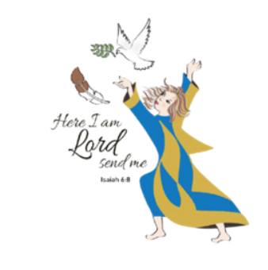
Here I Am Lord, Send Me!
If you have any questions about the Catholic Women’s League, have other concerns or need help, but don’t know who to ask, please don’t hesitate to reach out to me and I will try to help if I can.
If you have a prayer request that you would like sent out to our CWL members or if you have a celebration that you would like to share with your sisters in the League let me know.
I can be reached at 519-381-3129 or cwlsmbg@gmail.com.

Our Lady of Good Counsel, Pray for Us and Bless Us in All We Do
Stefanie Hammond
CWL President – St. Michael Council

