CWL Newsletter #26 – June 28th, 2025
Happy Saturday my fellow CWL Sisters!

We’ve officially entered summer vacation mode here at the Hammond home! High school exams are behind us, and the students at St. Michael’s School have wrapped up another successful academic year. Spirits are high, and the sunshine is certainly helping!
While many of us are easing into the slower pace of summer (at least for now 😊), the life of our parish community remains vibrant and active. There are still many opportunities to lend a hand and support the wonderful work happening at St. Michael and throughout our Family of Parishes. Please take a moment to review the key events listed below. If you’re able to assist in any way, your help would be greatly appreciated!

This Sunday, we come together to celebrate the Saints Peter and Paul. Saints Peter and Paul are two of the most important figures in the history of the Church. They were leaders who spread the message of Jesus and helped build the early Christian community. Both are remembered as apostles who gave their lives for their faith. The Church celebrates them together because of their deep connection in spreading the Gospel. Peter was one of the twelve apostles chosen by Jesus. He became the leader of the apostles and is known as the first Pope. Jesus called Peter “the rock” on which He would build His Church. Peter’s role was to guide and strengthen the early Christians. Paul was not one of the twelve apostles, but he became an important leader. At first, Paul persecuted Christians, but he had a powerful experience of Jesus and became a believer. Paul traveled far and preached to people who had never heard about Jesus. He wrote letters that helped explain the teachings of the Church.
The legacy of Peter and Paul lives on in the Church. Peter represents the foundation and leadership of the Church while Paul represents its mission to reach all people. Together, they remind us that the Church is built on faith and is called to share the Gospel with the world. The Church celebrates their feast day on June 29 to honour their work and their sacrifices. Peter and Paul remind us that God can work through anyone to share His message.
Congratulations to Doug & Pam Robinson on Their Golden Anniversary!
Today, Doug and Pam Robinson are celebrating an incredible milestone—50 years of marriage! May the Lord continue to bless them with abundant health, lasting joy, and many more beautiful years together.
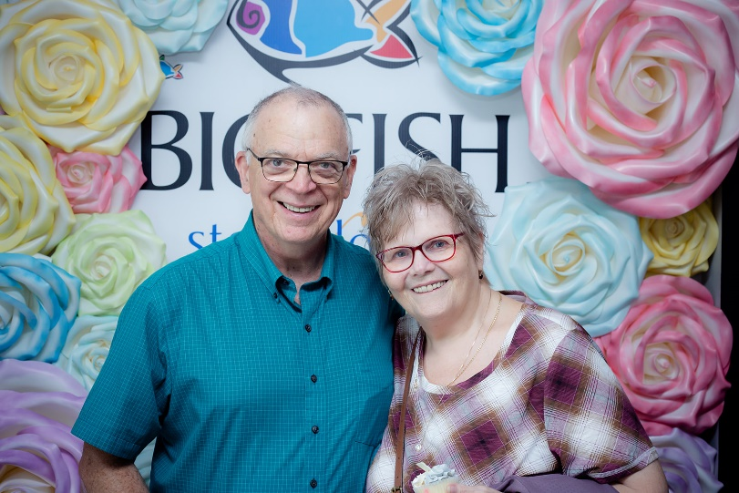

LAST CALL to Sign Up For Our CWL Summer Study Program
On June 7th, we had 30 members of our St. Michael CWL take part in our very first Eucharistic Retreat, led by our Faith Pillar, Christine Bresette, and our Spiritual Advisor, Father Joseph. It was a truly enriching experience, guiding everyone on a journey to deepen our discipleship and to recognize the profound significance of the Eucharist in our faith and daily lives.
This summer – Christine would love to keep the conversation going and she would like to know if you do too!
ALL MEMBERS of our CWL Council are invited to participate in our next steps - which could include the option of:
- Completing your own Independent Study based on the book: 33 Days to Eucharistic Glory by Matthew Kelly OR
- Participating in an 8-week group study starting July 5th, led by our Faith Pillar - Christine Bresette.

Registration is still open for anyone that would like to participate in our Summer Study that begins the week of July 5th. If you are interested please let me know and I will forward your intention along to Christine who will follow-up and coordinate directly.

Our Lady of Mercy Jubilee Pilgrimage Site – Volunteers Needed!
Our Lady of Mercy Church has been designated as a Jubilee Pilgrimage Site, welcoming pilgrims during this Jubilee year. On Thursday, Friday and Saturday, July 17, 18, 19, Our Lady of Mercy will open its doors all day to offer visitors times of Adoration, Reconciliation, Prayer and Mass.
On Saturday, July 19th, all are invited to participate in a pilgrimage walk from parishes across the city, to Our Lady of Mercy. Pilgrims can start from any of our churches.
For those that are looking to make the pilgrimage from St. Michael Parish to Our Lady of Mercy, our St. Michael CWL will be stationed at several rest stops along the trail to offer snacks and refreshments. Planning is underway, but tentatively the plans include:
- Assembling at St. Michael Church between 7:30am-8am to check in.
- Begin Camino walk at 8am
- Walk duration is estimated to be approximately 3 hours – the goal is for pilgrims to arrive at Our Lady of Mercy in time to participate in the Noon (12pm) Mass.
- Upon arrival, pilgrims will then check in at Our Lady of Mercy to receive their certificate. Additional light lunch/refreshments will be available to pilgrims after Mass in the Parish Hall.

How Can You Help? At this time, we are looking for 10-12 volunteers to help setup and man each of our designated refreshment stations to hand out snacks and water. We are anticipating setting up 4 refreshment stations in total along the trail:
- 1 at St. Michael Church to check everyone in and cheer everyone off
- 3 more along the Camino trail (the ideal trail map is still to be decided and will be communicated shortly)
If you are interested in volunteering to help man one of our refreshment stations, please let me know as soon as possible!

Honour Guard: We are also being asked to be part of the Deanery-wide CWL Honour Guard for the 4pm Mass that is taking place on July 19th at Our Lady of Mercy. Again, if you are planning on attending that mass and would like to participate in the CWL Honour Guard, please let me know.

Other Volunteering Opportunities: There is also going to be a number of other opportunities for our CWL members to serve throughout the July Jubilee Event, either as welcomers at the church/hall, ambassadors, or assisting with serving refreshments throughout the three days at the OLM Parish Hall. While these will NOT BE St. Michael CWL sponsored volunteering events, everyone is encouraged to choose and sign up individually for any activity that suits their personal schedule and availability. Please contact the Parish Office directly to let them know what events you are able to assist at.

Strawberries and Fruit Pie Workshops
A message from Mary van Delft – St. Michael CWL Past-President:
Strawberry season is here. The season to get fresh strawberries right from the field or fruit market never lasts long enough, so get them soon. If you are getting strawberries for yourself, consider getting some extra to donate to the pie workshops for our delicious strawberry rhubarb pies. They are always so good!
We have had to change the date for our fruit pie workshops. The new dates are:
Wednesday, September 3
Monday, September 8, and
Tuesday, September 30
All workshops begin at 9:00am and we try to be done by noon. Please mark these dates on your calendar and come out and join your CWL sisters at these productive and fun workshops. Don’t hesitate to come if you have never made pies before, you can learn, or you can help out with one of the other duties involved in the production of our pies. Pie Sales are one of our biggest fundraisers.
The sign-up sheets are at the Welcome Desk, along with the list of items we are hoping to have donated.

Noteworthy Events from Our National, Provincial and Diocesan Councils:
To remain up to date on National, Provincial and Diocesan news and events, I encourage everyone to regularly check out the CWL National, Provincial and Diocesan websites.

***NEW*** The June Edition of the Ontario CWL online newsletter is now available for your reading pleasure.

Upcoming Events
- July 5-9th - Provincial CWL Convention – London, On – Information HERE
- OLM Jubilee Pilgrimage Celebrations – July 17-19th – Details HERE
- July 23rd – CWL Day at the Shrine in Merlin, On – 10am – 2pm
- August 4-9th - Vacation Bible School – Holy Trinity – Registration Details HERE
- August 10–13th - National Convention – Toronto
- September 3, 8, 30th – Pie Workshops – St. Michael Meeting Room – 9am-12pm
- September 18th – St. Michael CWL General Meeting – 6pm – St. Michael Hall – Father Dan Vere Guest Speaker **more details to come
- September 23rd - CWL Regional Meeting – St. Benedict’s - 7pm All CWL members are welcome to attend
- October 18th –Development Day in the Diocese (formerly Fall Regional Day) – St. Ben’s – 9am
- October 20, 27 – Tourtiere Workshops
- November 15th – CWL Christmas Market
- November 25th – CWL Regional Meeting – St. Ben’s – 7pm

- Link to St. Michael CWL page on the Family of Parishes website St. Michael.

- To check out all upcoming events taking place within the Family of Parishes, you can check out the weekly Bulletin HERE

Prayers
- For Pope Francis’ special intention for June: That the world might grow in compassion. Let us pray that each one of us might find consolation in a personal relationship with Jesus, and from his Heart, learn to have compassion on the world.

- For our monthly CWL Mass Intention – June 4, 2025 - For the intentions of the St. Michael School staff and students (Wednesday Mass)

- For the staff and students within the St. Clair Catholic District School Board - As we come to the close of another school year, may the summer months ahead be a time of rest, renewal and joyful memories and may God grant them safety in their travels, peace in their hearts, and continued growth in mind, body, and spirit.

- For CWL Mass Intention – June 2nd - For the repose of the soul of His Holiness Pope Francis

- For our Family of Parishes and for our priests and deacons as we continue to grow together as a faith community.

- For God’s blessings across our St. Michael CWL Sister Membership. May the Holy Spirit continue to be with us and support us as we work to fulfil our mandate to promote the teachings of the Catholic Church, uphold Christian values, and advocate for social justice and human rights.

- For the intentions of our CWL members and their families especially those who are sick, undergoing treatments, or requiring surgery that they will be given the comfort, strength and the grace they need to face their challenges and be returned to good health and for their caregivers.

- For the intentions held within our St. Michael Parish Prayer Intention Book.

- For the land on which we gather, that is part the ancestral land of the Chippewa, Odawa, and Potawatomi peoples, referred to collectively as the Anishinaabeg. We pray that together – as a treaty people – we respect the environment that sustains all life, protecting the future for those generations to come.

- For peace in our world.

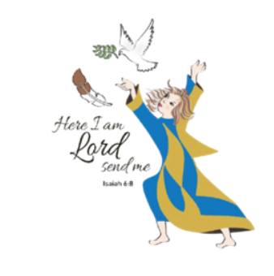
Here I Am Lord, Send Me!
If you have any questions about the Catholic Women’s League, have other concerns or need help, but don’t know who to ask, please don’t hesitate to reach out to me and I will try to help if I can.
If you have a prayer request that you would like sent out to our CWL members or if you have a celebration that you would like to share with your sisters in the League let me know.
I can be reached at 519-381-3129 or cwlsmbg@gmail.com.

Our Lady of Good Counsel, Pray for Us and Bless Us in All We Do
Stefanie Hammond
CWL President – St. Michael Council

