CWL Newsletter #28 – July 12th, 2025
Happy Saturday my fellow CWL Sisters!

On the 15th Sunday in Ordinary Time, we are reminded through the readings and the gospel, that God’s law calls us to love, and we are asked to live our faith through love in action and to serve others with compassion and care.
In the Gospel of Luke (10:25–37), we are presented with the parable of the Good Samaritan, a story that shows us what true compassion looks like and redefines what it means to be a good neighbor. Although the Samaritan is considered an outsider, the Gospel calls us to love anyways, and that true love for God means caring for others, and showing kindness and mercy to those in need or for those we find hard to love.
And in Deuteronomy (30:10–14), Moses reminds us that God’s commandments are not distant or mysterious, but are written on our hearts. We are reminded that compassion isn’t just reserved for the saints or the scholars—it’s a daily choice available to each of us, and that following God’s will is not beyond our reach if only we choose to listen and follow it.
And in Paul’s letter to the Colossians (1:15–20), we are reminded that Jesus is the foundation of creation and our faith - everything exists through Him and is united in Him. Jesus is the one who holds all things together, and our faith unites us with Him and with one another.
As we reflect on this weekend’s readings, we are asked to put our faith into action. Faith is not just about knowing God’s Word, but we are challenged to live it out through our actions. The readings show us how love for God and love for others cannot be separated, and they encourage us to look more closely at how we can live out God’s word in simple, everyday ways.
Prayer: Lord, open my heart to see those who need my care. Teach me to love without hesitation or judgment. Help me to live your word through simple acts of kindness and mercy. May I become a neighbor to everyone I meet. Amen.

CWL Coffee Sundays – A Summer Pause
Just a friendly note to let everyone know that our CWL Coffee Sundays will be taking a break for the summer months and will resume in September. A heartfelt thank you to all who generously lend a hand each month—whether it’s setting up, serving, cleaning up, or bringing delicious treats to share. Your time, effort, and kindness are what make these gatherings such a success and a true reflection of our CWL spirit. We couldn’t do it without you — thank you for making it all possible!

78th CWL Provincial Convention and Annual Meeting of Members Recap & Reflections
**Thank you to Past President – Mary van Delft – and CWL Secretary - Deb Hoek – for taking the time to attend the convention in London this week and contributing their feedback for this weekend’s newsletter – their updates beautifully capture the spirit of this year’s Provincial convention.
Each year, representatives from our St. Michael CWL have the privilege of attending the CWL Diocesan Convention— the last one held this past spring in Stratford. With the Ontario Provincial CWL Convention close to home in London this year, a few council members embraced the opportunity to attend that gathering as well.
Nelly Kelders attended as a member of our Diocesan Executive, and I (Mary van Delft) served as the parish voting delegate, and attended all 4 days. Joining us were Executive members Deb Hoek, Maria Do Rego, and Stefanie Hammond, who participated in Tuesday’s sessions and banquet. For most of us, it was our first Provincial Convention—a beautiful celebration of faith and sisterhood in the League and a powerful reminder of the greater CWL mission in our province. The theme, “Here I am Lord, Send me, Joyfully!”, set the tone for an inspiring convention. As we gathered with our CWL sisters from across Ontario, it was clear: God was present, working, and moving among us.
The convention opened Sunday with a reverent Mass con-celebrated by Bishop Fabbro of London and Bishop Alan Campeau of Thunder Bay, joined by Diocesan and Parish Spiritual Advisors. (You may recall our council’s earlier Mass intention for Bishop Campeau following his appointment by Pope Francis.) We were blessed to have him, along with spiritual advisors, accompany us throughout the convention, alongside the 284 CWL members in attendance.
Monday began with Mass, followed by a joyful and creative update from Provincial CWL officers—presented as a “news broadcast”. Shari Guinta, our National President, brought greetings, and each Diocesan President shared updates from their respective regions. The day continued with the crowning of Mary, a meaningful spiritual reflection, dinner, and a peaceful twilight retreat—a full day of learning, fellowship, and renewal.
Tuesday began again with Holy Mass, followed by a workshop presentation by guest speaker, Dr. Josephine Lombardi, an award-winning author and educator and a documentary filmmaker, who is presently assistant dean of academic affairs and an associate professor of pastoral and systematic theology for St. Augustine’s Seminary in Scarborough, ON. Dr. Lombardi spoke on ‘Marian Approaches to Synodality’, based on her book of the same name. In her workshop, Dr. Lombardi focused on three key areas:
- She unpacked the Synod on Synodality, describing that “Synodality can be understood as a symphony of charisms or missions given by the Holy Spirit and flowing from the unique and universal mission of Christ the personal Way to the Father.” And when we serve through our charisms, the Church grows and flourishes.
- What it means to be Marion and like Our Lady. Human effort can only take us so far, so we need to rely on the help of God as we can’t do it alone. Mary is the ‘mirror’ of the Church and tells us what it means to be created in the image of God.
- Marion Approaches to Synodality. Dr. Lombardi referred to Mary as a ‘Synodal Way’. The Church (teacher and mother) is the Way to the Way. We have mastered the model of Church as teacher but we need to master the model of Church as Mother, and Mary teaches us how to listen, dialogue and discern. Marian Approaches to Synodality tells us to listen to her son, to the spirit--essential for discerning topics like the role of women in the Church.
In the afternoon, Karen McDonald (Vice-President, Ontario Provincial Council) and Lisa Henry (Secretary/Communications, Ontario Provincial Council) presented, ‘Igniting the League’, leading with the song, ‘Are You Having Any Fun?’. Group discussions followed to brainstorm ideas around: How to ignite the joy and spark of councils from within and encourage recruitment and retention of members? A sense of community, the ‘Three F’s’ of ‘friendship, faith and fun’, and love were some of the reasons expressed that drew members to the CWL. The presentation was dotted with humour throughout, with CWL referenced by someone unfamiliar with the ‘Catholic Women’s League’ as ‘Caring and Wise Ladies’! It was also shared that the Ontario Provincial Council is in the very early phases of a website redesign, with the goal that parish, diocesan and provincial council information will all be found in one place, for ‘one-stop shopping’. Following the updates and closing prayer, Tuesday ended with the culmination of the Banquet and Social, where a delicious meal was served to members.
On Wednesday, the Annual Meeting of Members was held. Three proposed resolutions and briefs were presented; two will proceed to the national convention, while one was not adopted. We concluded with a closing Mass at St. Peter’s Cathedral Basilica, and witnessed the recommissioning of the Provincial CWL Executive.
Generosity flowed throughout the convention, with donations collected for St. Peter’s Seminary and Karen’s Place—a transitional housing initiative for women over 50 experiencing homelessness or precarious housing. Each charity received over $1,100 in support.
There was also a raffle table and daily “Share the Wealth” draws that were wonderfully organized and carried out by CWL members from Sarnia-Lambton. Special thanks are extended towards our own St.Michael CWL sisters - Annette Procunier and Maureen Crichton - for their amazing gift-basket wrapping skills, and to Joanne Minnis for designing and printing the raffle tickets—your behind-the-scenes help made all the difference, and your support was greatly appreciated.
A few pictures from the Convention:
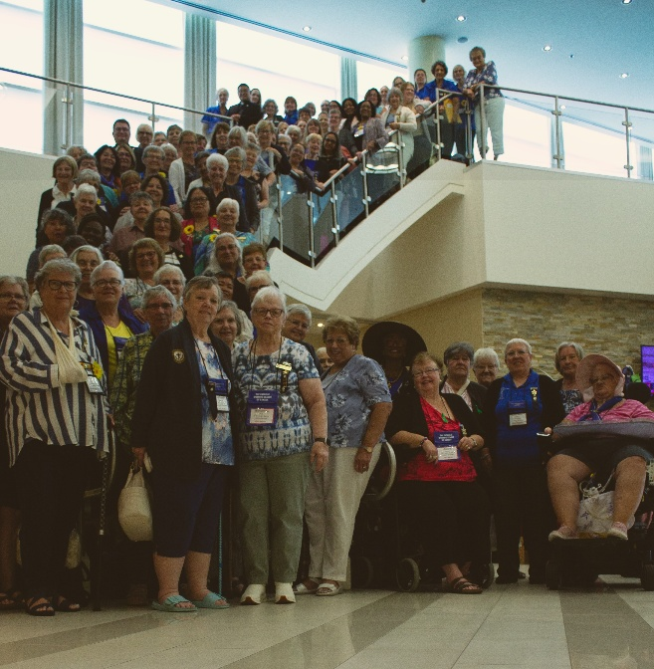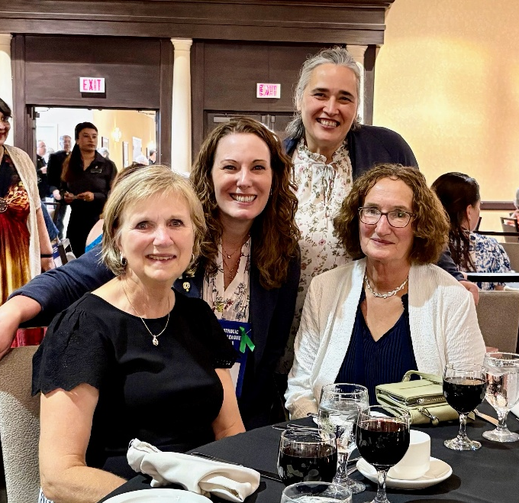
LEFT: London Diocesan Delegates – Local CWL Sisters showed up and we were a huge crowd!
RIGHT: Tuesday Evening’s Banquet Dinner – Mary van Delft, Stefanie Hammond, Maria Do Rego, Nelly Kelders

Our Lady of Mercy Jubilee Pilgrimage – Saturday July 19th – UPDATE!
For those that are intending on participating in the pilgrimage from St. Michael Church to Our Lady of Mercy, we have 2 pilgrimage options to choose from, depending on your time and endurance levels!
OPTION #1 – START FROM ST.MICHAEL CHURCH, BRIGHT’S GROVE
START TIME: 7:30am (please arrive at St. Michael Church by 7:15am)
PILGRIMAGE:
- Leave church – North towards Hamilton Road -> Left to Kenwick St -> Left on Old Lakeshore to Mike Weir Park.
- Leave Park through crosswalk to the Howard Watson Trail and stay on the trail to Cathcart Park – this is the 1st Rest Stop and this rest stop will be staffed by CWL volunteers to hand out refreshments
- Head west -> Follow Cathcart Rd to Colborne Road
- At Cathcart Rd & Colborne Road, St.Michael Pilgrims will meet up with Sacred Heart Pilgrims at approximately 10:15am
- If another break is needed, pilgrims will be able to use Tim Horton’s or Starbucks at Cathcart & Colborne Road area

OPTION #2 – START FROM THE REST STOP AT CATHCART PARK, SARNIA
For those that are looking for a shorter trek, there will be a 2nd option to meet up with St. Michael Pilgrims at Cathcart Park in Sarnia (Cathcart & Modeland Road), and begin the pilgrimage from there. This walk would be approximately 7 km.
START TIME: appoximately 9:30am

Although volunteers from our St. Michael CWL council will be serving refreshments at the Rest Stop at Cathcart Park, it is recommended that Pilgrims carry a day pack with some essentials for their journey: water, snacks, sunscreen, wet wipes, lip balm, Kleenex, band-aids, phone, money, and a change of shoes for Mass.
And - since the St. Vincent de Paul will be collecting canned goods - pilgrims could also bring a few canned goods or money to donate once they reach Our Lady of Mercy Church.
Our leaders – Helen Ross and Donna Stewart – will be carrying a light crucifix along the way, and will be leading pilgrims in praying the rosary.
For those that are interested in completing the pilgrimage, please contact the Parish Office to register. For complete Pilgrimage details and directions of the Camino Walk, please refer to the bulletin.

CWL Day at the Shrine in Merlin – July 23rd
The Catholic Women’s League of the London Diocesan Council will be holding their annual Day at the Shrine in Merlin, Ontario on Wednesday July 23rd. The event will take place at St. Patrick’s Church, located at 5773 Tenth Line, Merlin, Ontario, N0P 1W0. This event is open to all members and will include a meet and greet, prayer reflection, Mass and a rosary procession at the Our Lady of the Rosary Shrine. Coffee, tea and water will be available but bring your own picnic lunch and a lawn chair.
If you are interested in attending and/or are able to drive and help with carpooling, please let me know. The plan would be to leave from St. Michael Church at 8:15am.
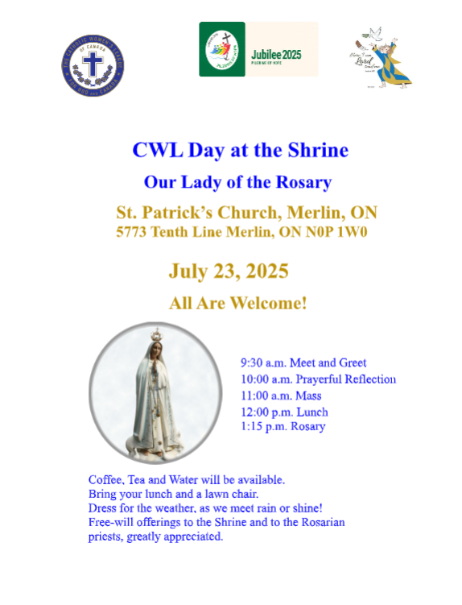
Noteworthy Events from Our National, Provincial and Diocesan Councils:
To remain up to date on National, Provincial and Diocesan news and events, I encourage everyone to regularly check out the CWL National, Provincial and Diocesan websites.

Upcoming Events
- OLM Jubilee Pilgrimage Celebrations – July 17-19th – Details HERE
- July 23rd – CWL Day at the Shrine in Merlin, On – 10am – 2pm
- August 4-9th - Vacation Bible School – Holy Trinity
- August 10–13th - National Convention – Toronto
- September 3, 8, 30th – Pie Workshops – St. Michael Meeting Room – 9am-12pm
- September 18th – St. Michael CWL General Meeting – 6pm – St. Michael Hall – Father Dan Vere Guest Speaker **more details to come
- September 23rd - CWL Regional Meeting – St. Benedict’s - 7pm All CWL members are welcome to attend
- October 18th – Development Day in the Diocese (formerly Fall Regional Day) – St. Ben’s – 9am
- October 20, 27 – Tourtiere Workshops
- November 15th – CWL Christmas Market
- November 25th – CWL Regional Meeting – St. Ben’s – 7pm

- Link to St. Michael CWL page on the Family of Parishes website St. Michael.

- To check out all upcoming events taking place within the Family of Parishes, you can check out the weekly Bulletin HERE

Prayers
- For the late Pope Francis’ special intention for July: For formation in discernment. Let us pray that we might again learn how to discern, to know how to choose paths of life, and reject everything that leads us away from Christ and the Gospel.

- For our monthly CWL Mass Intention – July 7, 2025 - For the intentions of those experiencing injustice

- For Pikangikum and Northern Communities as they grapple with forest fires that threaten homes, trapping camps, hydro lines, and access roads. Please pray for rain across the North and for the continued strength and protection of firefighters and first responders.

- For our Family of Parishes and for our priests and deacons as we continue to grow together as a faith community.

- For God’s blessings across our St. Michael CWL Sister Membership. May the Holy Spirit continue to be with us and support us as we work to fulfil our mandate to promote the teachings of the Catholic Church, uphold Christian values, and advocate for social justice and human rights.

- For the intentions of our CWL members and their families especially those who are sick, undergoing treatments, or requiring surgery that they will be given the comfort, strength and the grace they need to face their challenges and be returned to good health and for their caregivers.

- For the intentions held within our St. Michael Parish Prayer Intention Book.

- For the land on which we gather, that is part the ancestral land of the Chippewa, Odawa, and Potawatomi peoples, referred to collectively as the Anishinaabeg. We pray that together – as a treaty people – we respect the environment that sustains all life, protecting the future for those generations to come.

- For peace in our world.

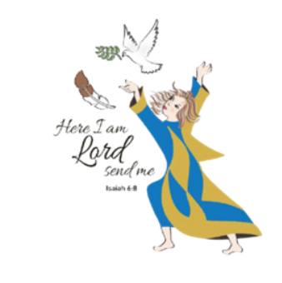
Here I Am Lord, Send Me!
If you have any questions about the Catholic Women’s League, have other concerns or need help, but don’t know who to ask, please don’t hesitate to reach out to me and I will try to help if I can.
If you have a prayer request that you would like sent out to our CWL members or if you have a celebration that you would like to share with your sisters in the League let me know.
I can be reached at 519-381-3129 or cwlsmbg@gmail.com.

Our Lady of Good Counsel, Pray for Us and Bless Us in All We Do
Stefanie Hammond
CWL President – St. Michael Council

