CWL Newsletter #34 – September 6th, 2025
Happy Saturday my fellow CWL Sisters!

Welcome to a New Season! What a whirlwind this week has been! As the kids return to school and routines begin to take shape again, many of us are finding our footing in this new rhythm after the summer break. The shift back into packed schedules, commitments, and volunteer community life, while energizing, is also a bit of an adjustment for me. As we embrace the start of this new month and new season, I’d like to wish everyone a heartfelt “Happy New Year” - because in so many ways, September always feels like a fresh beginning for me. May this time be filled with purpose, connection, and grace for all!

New Member Alert! A Warm Welcome to Laura Swift

I’m thrilled to share that Laura Swift has recently joined our vibrant St. Michael CWL Council! Laura brings enthusiasm and a heartfelt desire to contribute to our mission, and she’s eager to get involved in the many activities and initiatives that make our council so special. Let us extend a joyful and sincere welcome to Laura as she begins her journey with us. We look forward to the energy, ideas, and fellowship she’ll bring to our CWL Council.

Fruit Pie Workshops – One Down, Two to Go!

Our first Pie Workshop of the season was a sweet success! This week, 25 amazing volunteers rolled up their sleeves to make an incredible 129 blueberry pies. After the summer break, it was wonderful to see members laughing and reconnecting, as they worked side by side. We were especially blessed to have Mary van Delft’s son, Mark, and her three grandchildren visiting from Australia join us for the morning. Their helping hands and cheerful energy added something truly special to the day. They were amazed by the smooth operation, the number of pies produced in such a short time, and how everyone had a role to play.
Our next Pie Workshop will be taking place Monday, September 8th – starting at 9am - where we’ll be making strawberry rhubarb and rhubarb pies, and we’d love to see you there! If you're available, please come lend a hand as some of this week’s volunteers won’t be able to attend, so every bit of extra help counts.
Let’s keep the momentum going and make the next workshop just as joyful and delicious!

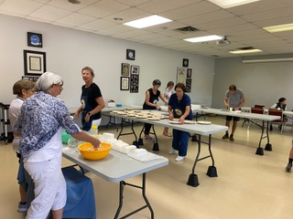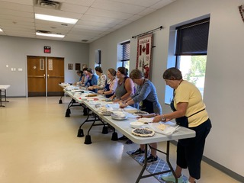
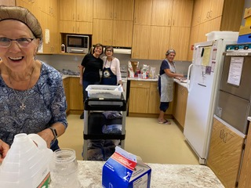

Some photos from the first Pie Workshop

Reminder - CWL Christmas Market & Quilt Committee Meeting
Our 2025 Christmas Market is just around the corner - happening on Saturday, November 15th, which is less than three months away!
This is a reminder that the Christmas Market Committee will be holding a Kick-off Meeting on Wednesday September 10th, from 7:00 PM to 9:00 PM in the St. Michael Church meeting room. We’ll be reviewing notes and suggestions from last year’s market to help guide our planning for this year’s event. If you’re interested in joining the Committee or lending a hand, we’d love to have you! Let’s make this year’s market the best one yet!

CWL General Meeting - Thursday, September 18th

Our CWL Executive Council is delighted to invite all council members to our upcoming General Meeting that will be taking place Thursday, September 18th, starting at 6:30pm. We’re especially pleased to announce that Father Dan Vere will be joining us as our special guest speaker to open the evening. Father Dan will share reflections from his current Hospital Ministry in London, offering a glimpse into “a day in the life” of his pastoral work. His talk will explore the Sacrament of the Sick, and how moments of pain and loss become profound sources of grace, strength, and spiritual renewal.
Following the presentation, we’ll gather in the Meeting Room for a Wine & Cheese Social, where we will provide a brief overview of the exciting initiatives the St. Michael CWL will be undertaking this fall. This promises to be a meaningful and inspiring evening of fellowship, faith, and connection. We hope you’ll join us - and feel free to bring a friend as all women of the parish are welcome to attend.

Noteworthy Events from Our National, Provincial and Diocesan Councils:
To remain up to date on National, Provincial and Diocesan news and events, I encourage everyone to regularly check out the CWL National, Provincial and Diocesan websites.

Upcoming Events
- September 8th – CWL Executive Meeting – St. Michael Meeting Room – 6:30pm - **All CWL members are invited to attend Executive Leadership Meetings
- September 8 &30th – Pie Workshops – St. Michael Meeting Room – 9am-12pm
- September 14th – St. Michael Coffee Sunday at 10:30am Mass
- September 18th – St. Michael CWL General Meeting – 6:30pm – St. Michael Hall – Father Dan Vere Guest Speaker
- September 23rd - CWL Regional Meeting – St. Benedict’s - 7pm **All CWL members are welcome to attend
- October 6th - CWL Executive Meeting – St. Michael Meeting Room – 6:30pm - **All CWL members are invited to attend Executive Leadership Meetings
- October 12th – St. St. Michael Coffee Sunday at 10:30am Mass
- October 18th – Development Day in the Diocese (formerly Fall Regional Day) – St. Ben’s – 9am - **All CWL members are invited to attend and participate
- October 20, 27 – Tourtiere Workshops
- November 3rd - CWL Executive Meeting – St. Michael Meeting Room – 6:30pm - **All CWL members are invited to attend Executive Leadership Meetings
- November 15th – CWL Christmas Market
- November 25th – CWL Regional Meeting – St. Ben’s – 7pm **All CWL members are welcome to attend
- London Diocesan Convention & Annual Meeting of Members – Chatham – April 20-21, 2026 – More details to come

- Link to St. Michael CWL page on the Family of Parishes website St. Michael.

- To check out all upcoming events taking place within the Family of Parishes, you can check out the weekly Bulletin HERE

Prayers
- For Pope Leo’s special intention for September - For our relationship with all of creation. Let us pray that, inspired by Saint Francis, we might experience our interdependence with all creatures who are loved by God and worthy of love and respect.

- For our monthly CWL Mass Intention for September: For the intentions of the indigenous communities

- For all students, teachers, and staff within our Family of Parishes who have returned to school this week - May God pour out His blessings of wisdom, strength, and joy as they embark on a new academic journey. May the Holy Spirit kindle in every heart a spirit of curiosity, compassion, and courage, guiding all who teach, learn, and serve throughout the year.

- For God’s blessings across our St. Michael CWL Sister Membership. May the Holy Spirit continue to be with us and support us as we work to fulfil our mandate to promote the teachings of the Catholic Church, uphold Christian values, and advocate for social justice and human rights.

- For the intentions of our CWL members and their families especially those who are sick, undergoing treatments, or requiring surgery that they will be given the comfort, strength and the grace they need to face their challenges and be returned to good health and for their caregivers.

- For the intentions held within our St. Michael Parish Prayer Intention Book.

- For the land on which we gather, that is part the ancestral land of the Chippewa, Odawa, and Potawatomi peoples, referred to collectively as the Anishinaabeg. We pray that together – as a treaty people – we respect the environment that sustains all life, protecting the future for those generations to come.

- For peace in our world.

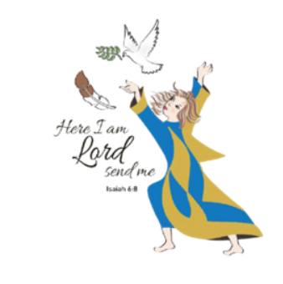
Here I Am Lord, Send Me!
If you have any questions about the Catholic Women’s League, have other concerns or need help, but don’t know who to ask, please don’t hesitate to reach out to me and I will try to help if I can.
If you have a prayer request that you would like sent out to our CWL members or if you have a celebration that you would like to share with your sisters in the League let me know.
I can be reached at 519-381-3129 or cwlsmbg@gmail.com.

Our Lady of Good Counsel, Pray for Us and Bless Us in All We Do
Stefanie Hammond
CWL President – St. Michael Council

