CWL Newsletter #10 – Saturday March 7th, 2026
Happy Saturday my fellow CWL Sisters!

On this Third Sunday of Lent, we are invited to reflect on the significance of thirst. Not just our natural human need for water when our body requires it, but also our deepest longings for meaning, hope, healing, and renewal - and how God faithfully meets us in that need. Tomorrow also marks the global recognition of International Women’s Day, promoting the theme, “Give to Gain”. While reflecting on this weekend’s readings, it is remarkable how the “Give to Gain” theme of International Women’s Day is mirrored so beautifully in the readings – especially in the Gospel. Together, they reveal a timeless truth: to gain true growth and transformation, it often comes through self-giving, generosity, and a trust in God.

For example - In the first reading from Exodus, the Israelites are weary, fearful, and desperate for water. Their journey through the desert has demanded much of them – their patience, trust, and perseverance. Though they complain and grumble, God responds not with punishment, but with abundance. Moses is instructed to strike the rock, and life-giving water flows freely. What is remarkable here is that God asks Moses to act in faith before the people see the result. Something must be given - obedience, trust, leadership - before the blessing of life-giving water is gained. This reflects a truth many Christian women know well: the seeds of faith and service often come long before the visible rewards are experienced.

The Gospel of John offers perhaps the most powerful example of the “Give to Gain” theme in Jesus’ encounter with the Samaritan woman at the well. She comes seeking ordinary water but leaves profoundly transformed. In her conversation with Jesus, she gives honesty, vulnerability, and openness - even when it is uncomfortable and exposes her shame.
Yet Jesus does not judge her. He sees beyond her past, beyond her sins and broken story, and embraces her as a unique and beloved person of God.
In return for what she offers, the Samaritan woman receives something far greater: living water, restored dignity, and a renewed sense of purpose. She runs from the well to share her testimony, leaving her water jar behind - symbolic of old burdens, limitations, and concerns. It was through her witness that others also came to believe. By giving her story, she gained a new identity as a disciple and evangelizer.

As I prayed on this Gospel - while also reflecting on the “Give to Gain” theme of International Women’s Day - I was struck by how deeply spiritual this message truly was. While the theme is currently being marketed in more secular settings as ‘empowering women around the globe’, it carries an even deeper meaning when viewed through the lens of our Catholic faith. It challenged me to examine my own heart:
How often do I judge others and withhold friendship or kindness from them?
How often do I assume I know someone’s story - perhaps shaped by gossip or hearsay - rather than truly seeing them and accepting them for who they are - a son or daughter of God?
How have my actions or inactions rippled outwards and impacted others?

This is not how Jesus calls us to live. Jesus KNEW the Samaritan woman’s entire sordid history and still chose to meet her at the well, speak with her, and even reveal Himself to her. He openly and freely gave friendship, compassion, and mercy, and in return she was transformed. Incredible how such small seeds of grace - when given - can lead to such extraordinary change.

The example of the Samaritan women reminds us that when we learn to ‘see’ others as Jesus sees them, and freely extend our compassionate graces as Jesus does, entire communities can be transformed.

As members of the Catholic Women’s League, we are called to live in this spirit of “Give to Gain” daily. Whether through prayer, service, leadership, or quiet acts of compassion, love and mercy, we give - not because it is easy - but because Christ gave to us first. We need to emulate Him, and in doing so, we will gain a deeper faith, and a stronger community rooted in Christ.

As we continue our journey through Lent, and as we commemorate International Women’s Day tomorrow, may we place our trust in God and offer Him all that we are. In doing so, may we gain His gifts of grace and renewal, and receive abundant blessings through the living water Jesus provides to forever quench our thirst.

John 4:13-14 - “Everyone who drinks this water will be thirsty again; but whoever drinks the water I shall give will never thirst; the water I shall give will become in him a spring of water welling up to eternal life.”

REMINDER: February Volunteer Hours

This is your monthly reminder to submit all of your volunteer hours this week, as part of our CWL Volunteers Hours Tracking initiative.
As a recap, we are being asked to record any volunteer activity that you completed in the month of February that aligns with the Gospel’s call to serve “the poor,” understood in the broad sense outlined by Pope Leo:
- Those lacking material means
- Those who are socially marginalized or unable to express their dignity and abilities
- Those experiencing moral or spiritual poverty
- Those facing cultural poverty
- Those living with personal or social fragility
- Those without rights, space, or freedom

If your volunteer work this month touched any of these forms of poverty, it counts.

Submission Example Format:
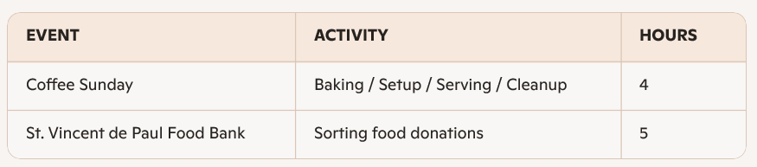

If everyone could submit their hours by Sunday March 8th, I would be most grateful.

CWL- Sponsored Coffee Sunday – Tomorrow – March 8th

On the heels of our World Day of Prayer hosting duties, tomorrow is our next CWL-sponsored Coffee Sunday.
As always, we’re grateful for donations of delicious homemade or store-bought treats to help fill our hospitality table.
Thank you to all who continue to make our Coffee Sundays such a warm, joyful, and welcoming gathering for our parish family.

It’s a ‘Blue Sunday’ Tomorrow as Well!

To complement our monthly CWL Coffee Sundays, a reminder that tomorrow is also our monthly ‘Blue Sunday’. While November has traditionally been our month to highlight the CWL within our parish, I believe our vibrant council deserves to be celebrated and visible all year long. One simple and meaningful way to do this is by showcasing our CWL pride each month.
So in this spirit, I invite all CWL members to attend Mass tomorrow wearing their CWL Blue - whether that’s your CWL cardigan, scarf, or simply a blue sweater or jacket.
The hope is that by making our presence visible, the women of St. Michael will more easily recognize who is part of our council, feel comfortable asking questions, and perhaps feel inspired to join us.

Save the Date - Stations of the Cross – Monday March 9th

Every Monday throughout Lent, the Stations of the Cross will be prayed at St. Michael Parish prior to the 6:30 p.m. Mass.
Our CWL Council has the privilege of leading the Stations on Monday March 9th. If you feel called to participate as one of the readers, please plan to arrive by 5:45 p.m. so we can organize roles and prepare together.

The Pregnancy Options & Support Centre

On March 22nd and 29th, the Knights of Columbus will be collecting baby items in support of their Baby Shower 2026 initiative, benefiting The Pregnancy Options & Support Centre. This is an organization that our CWL proudly to supports each year as well, through a charitable donation.

For this year’s Baby Shower collection, the following items are especially needed:
- Newborn diapers
- Newborn scratch mittens
- Diaper bags
- Car seat covers
- Baby monitors
- Gift cards (used to purchase urgent Care Closet needs)

Financial donations are also gratefully accepted. Gifts of $20 or more are eligible for a tax receipt.
As The Pregnancy Options & Support Centre is a charity that is 100% donor funded, your generosity and support of this initiative are truly appreciated.

Divine Mercy Sunday – April 12th

All St. Michael CWL members are invited to attend this year’s Divine Mercy Celebration at Sacred Heart Church on Sunday, April 12, from 2:00–4:00 p.m. A reception will follow the service. The Liturgy Team has asked if our members could attend and wear their sashes. If you are interested in attending, please let me know.

Noteworthy Events from Our National, Provincial and Diocesan Councils:
To remain up to date on National, Provincial and Diocesan news and events, I encourage everyone to regularly check out the CWL National, Provincial and Diocesan websites.

The Winter 2026 Copy of The Canadian League magazine is out! https://www.cwl.ca/the-canadian-league-winter-2026/


***If you have not received your physical copy of The Canadian League magazine in the mail, it could be that we don’t have your correct address on file. If you have recently moved and have not received the Winter 2026 edition of The Canadian League magazine, please let me know so we can ensure we have your proper address on file.

Also, the new Provincial CWL ON-LINE Newsletter for March is available as well.

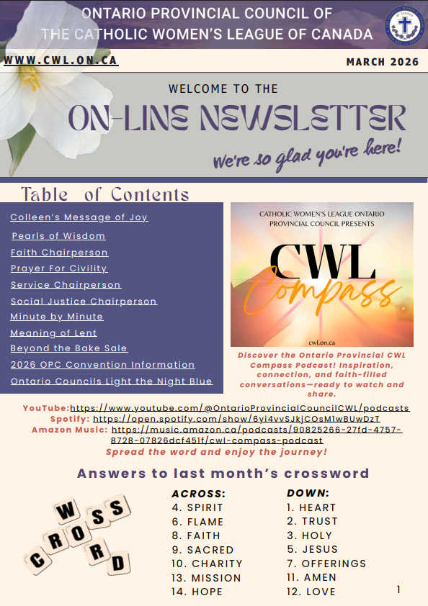

Upcoming Events
- March 9th – CWL-led Stations of the Cross – St. Michael – 6pm
- March 24th - CWL Regional Meeting – St. Ben’s – 7pm - **Any CWL member is invited to attend Regional Meetings
- April 6th - CWL Executive Meeting – St. Michael Meeting Room – 6:30pm - **All CWL members are invited to attend Executive Leadership Meetings
- April 20-21 - London Diocesan Convention & Annual Meeting of Members – Chatham
- May 4th - CWL Executive Meeting – St. Michael Meeting Room – 6:30pm - **All CWL members are invited to attend Executive Leadership Meetings
- May 12th - CWL General Meeting - Huron Oaks - more details to come
- June 1st - CWL Executive Meeting – St. Michael Meeting Room – 6:30pm - **All CWL members are invited to attend Executive Leadership Meetings
- June 6th – St. Michael CWL Spring Retreat – Theme: ‘Women of the Word’ - an exploration of the witness of biblical women and how they model faith for us today - more details to come
- July 22nd – Day at the Shrine – Merlin – more details to come

- Link to St. Michael CWL page on the Family of Parishes website St. Michael.

- To check out all upcoming events taking place within the Family of Parishes, you can check out the weekly Bulletin HERE

Prayers
- For Pope Leo’s special intention for March - For Disarmament And Peace. Let us pray that nations move to effective disarmament, particularly nuclear disarmament and that world leaders choose the path of dialogue and diplomacy instead of violence.

- For our monthly CWL Mass Intention for March: For the intentions of those discerning a calling to the priesthood and religious life.

- For those CWL members celebrating a birthday in March. May God bless you with joy, good health, and the gentle guidance of the Holy Spirit in the year ahead. May Our Lady of Good Counsel watch over you always.

- For the intentions of our CWL members and their families especially those who are sick, undergoing treatments, or requiring surgery that they will be given the comfort, strength and the grace they need to face their challenges and be returned to good health and for their caregivers.

- For the intentions held within our St. Michael Parish Prayer Intention Book.

- For the land on which we gather, that is part the ancestral land of the Chippewa, Odawa, and Potawatomi peoples, referred to collectively as the Anishinaabeg. We pray that together – as a treaty people – we respect the environment that sustains all life, protecting the future for those generations to come.

- For peace in our world.

If you have any questions about the Catholic Women’s League, have other concerns or need help, but don’t know who to ask, please don’t hesitate to reach out to me and I will try to help if I can.
If you have a prayer request that you would like sent out to our CWL members or if you have a celebration that you would like to share with your sisters in the League let me know.
I can be reached at 519-381-3129 or cwlsmbg@gmail.com.

Our Lady of Good Counsel, Pray for Us and Bless Us in All We Do
Stefanie Hammond
CWL President – St. Michael Council


