Holy Infant Catholic Church, Durham, NC
Celebration of Matrimony ╬ Date & Time
Name of Bride
&
Name of Groom
Father of the Groom Mother of the Groom
Name Name
Father of the Bride Mother of the Bride
Name Name
Presider
Name of Priest or Deacon
Introductory Rites
Wedding Party Procession Music Selection
Groomsmen Bridesmaids
Name Name
Name Name
Name Name
Name Name
Best Man
Name
Maid/Matron of Honor
Name
Ring Bearer Flower Girls
Name Name
Bridal Procession Music Selection
Greeting and Welcome
Collect Prayer

Liturgy of the Word
First Reading Scripture Citation Read by Name
Responsorial Psalm #
All respond in song, “Response to Responsorial Psalm”
Second Reading Scripture Citation Read by Name
Alleluia
Gospel Reading Scripture Citation
Homily
Rite of Marriage
Statement of Intentions
Consent
Priest: Let us bless the Lord ╬ All respond: Thanks be to God
Blessing & Exchange of Rings
Universal Prayer
All respond, “Lord, hear our prayer.”
The Lord’s Prayer (Our Father)
The Nuptial Blessing
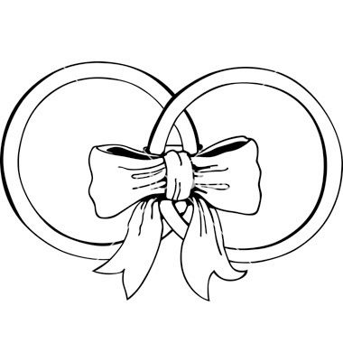
Concluding Rite
Blessing & Dismissal
Recessional Music Selection

