Supply List for Grade 6

- 1 package of plastic spoons or 1 package of spoons and forks
- Blue or black pens and red pens (bring in only 2 of each and replenish as needed) & 1 pack of black pens for ELA
- Pencils (bring in only 2- 3 and replenish as needed) & 1 pack number 2 pencils for ELA
- Extra erasers
- 1 package loose leaf notebook paper - 3 hole punched- For ELA

- 1 pack of 3 hole punched white printer paper- For ELA

- Highlighters (bring in 1 or 2 and refill as needed throughout the year)
- Scissors
- Glue stick
- Colored pencils (at least 8 colors)
- Markers (at least eight colors)
- Ruler
- Cloth book covers, 2 large (Books may be covered with paper if preferred)
- Headphones or earbuds for Chromebooks
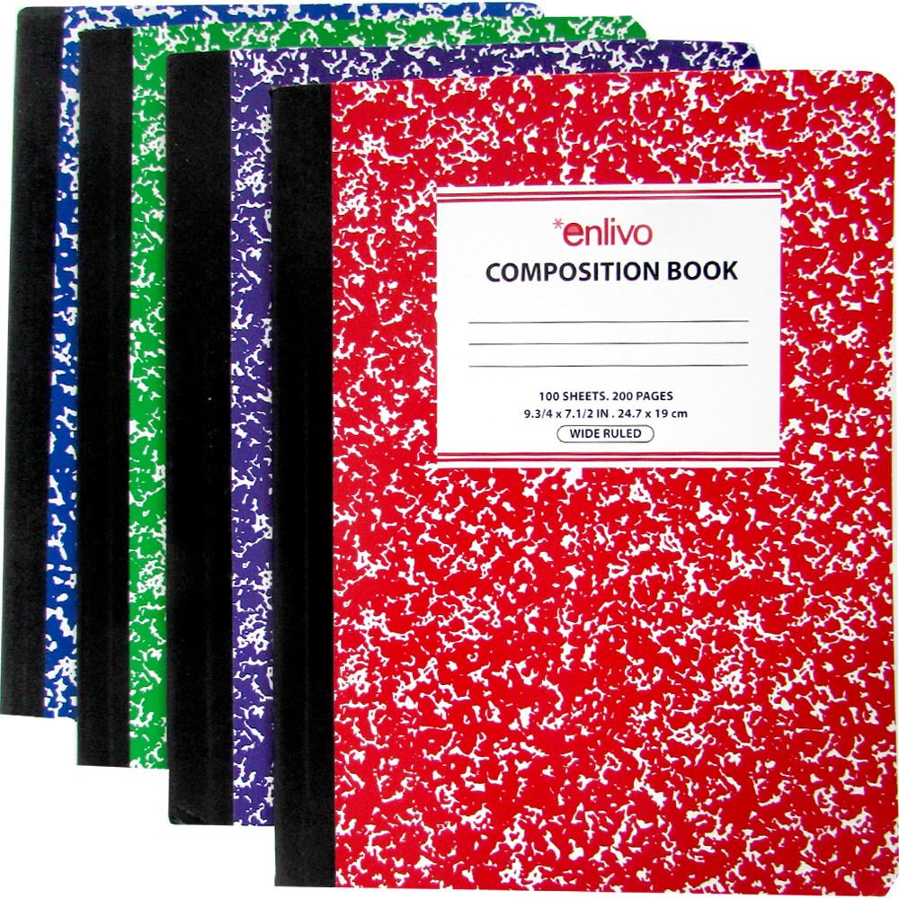
- Calculator optional
- Novel for independent reading (on going)
- 1 pack of multi-color highlighters (yellow, pink, blue, green, orange)- Amazon has BIC Brite Liner Highlighters 5 count pack of assorted colors for $1.99)- For ELA

- 1 pack of notecards- For ELA

Notebooks and Folder(s):
- 6 Composition notebooks (Labeled: Science, English, Reading, Religion, Math, and French; also be sure to write your name on the front of each)
- One 3-subject notebook for Social Studies
- Expandable Accordion File Folder for organizing papers from each class. (As an alternative you may use a binder with vinyl pocket folders for each subject, but an accordion file folder is more compact and secure. You should have one folder or section of your accordion file labeled “Homework” where all assigned work should be kept and a section for each subject.)

